**Recursion II**

Introduction

Prerequisites: [Stack](https://leetcode.com/explore/learn/card/queue-stack/), [Recursion I](https://leetcode.com/explore/learn/card/recursion-i/)

We have discussed about the basic concepts and techniques about the recursion in the previous explore card called [Recursion I](https://leetcode.com/explore/learn/card/recursion-i/).

In this card, we will dive deeper into the theme of recursion. In particular, we will cover some paradigms that are often applied together with the recursion to solve some problems.

Here are list of topics that we will cover in this card:

1. Divide and Conquer
2. Backtracking
3. master theorem

Divide and Conquer

 D&C Introduction

 Merge Sort

 Sort an Array

 D&C Template

 Validate Binary Search Tree

 Search a 2D Matrix II

 Quick Sort

 Master Theorem

Backtracking

 Backtracking

 N-Queens II

 Backtracking Template

 Robot Room Cleaner

 Sudoku Solver

 Combinations

Recursion to Iteration

 Unfold Recursion

 Same Tree

 Generate Parentheses

 Binary Tree Inorder Traversal

 Binary Tree Level Order Traversal

Conclusion

 Beyond Recursion

 Convert Binary Search Tree to Sorted Doubly Linked List

 Largest Rectangle in Histogram

 Permutations

 Letter Combinations of a Phone Number

 The Skyline Problem

Divide and Conquer

In this chapter, we will discuss a paradigm called divide and conquer, which often occurs together with the recursion technique.

After going through the chapter, you should be able to:

* know some classical examples of divide-and-conquer algorithms, *e.g.* merge sort and quick sort .
* know how to apply a [pseudocode template](https://leetcode.com/explore/learn/card/recursion-ii/470/divide-and-conquer/2869/) to implement the divide-and-conquer algorithms.
* know a theoretical tool called [master theorem](https://leetcode.com/explore/learn/card/recursion-ii/470/divide-and-conquer/2871/) to calculate the time complexity for certain types of divide-and-conquer algorithms.

**D&C Introduction**

**Divide and conquer (D&C)** is one of the most important paradigms in algorithm design and is widely used.

A divide-and-conquer algorithm works by ***recursively*** breaking the problem down into **two** or more subproblems of the same or related type, until these subproblems become simple enough to be solved directly [**[1]**](http://en.wikipedia.org/wiki/Divide-and-conquer_algorithm). Then one combines the results of subproblems to form the final solution.

As you can see, divide-and-conquer algorithm is naturally implemented in the form of recursion. Another subtle difference that tells a divide-and-conquer algorithm apart from other recursive algorithms is that we break the problem down into **two or more** subproblems in the divide-and-conquer algorithm, rather than a single smaller subproblem. The latter recursive algorithm sometimes is called ***decrease and conquer***instead, such as **Binary Search**.

There are in general three steps that one can follow in order to solve the problem in a divide-and-conquer manner.

1.**Divide.** Divide the problem {S}*S* into a set of subproblems: \{S_1, S_2, ... S_n\}{*S*1​,*S*2​,...*Sn*​} where {n \geq 2}*n*≥2, i.e. there are usually more than one subproblem.

2. **Conquer.** Solve each subproblem recursively.

3.**Combine.**Combine the results of each subproblem.

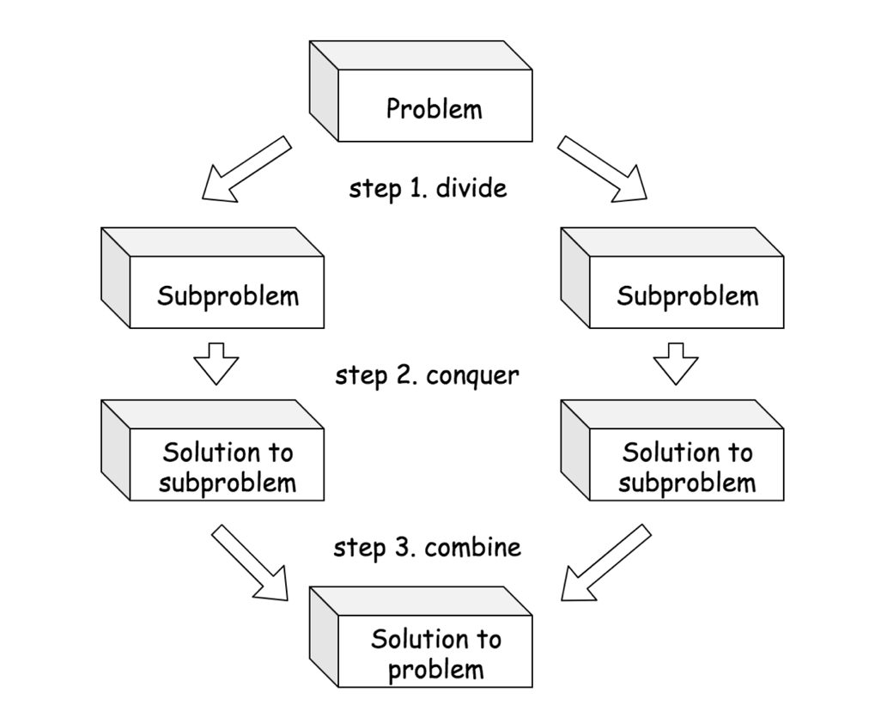

Fig 1. General Steps involved in Divide-and-Conquer Algorithms

In the following articles, we will show you some classic examples of divide-and-conquer algorithms, such as [Merge Sort](https://leetcode.com/explore/learn/card/recursion-ii/470/divide-and-conquer/2868/) and [Quick Sort](https://leetcode.com/explore/learn/card/recursion-ii/470/divide-and-conquer/2870/). We also present a template which could help you design divide-and-conquer algorithm, along with examples on how to apply the template to real problems.

### ***References***

- [1]. [Divide and Conquer](https://en.wikipedia.org/wiki/Divide-and-conquer_algorithm). Wikipedia.

**Merge Sort**

One of the classic examples of the divide-and-conquer algorithm is the merge sort algorithm **[1]**. Merge sort is an efficient and general-purpose sorting algorithm.

### ***Intuition***

There are two approaches to implement the merge sort algorithm: ***top down*** or **bottom up**. Here, we will explain the ***top down*** approach as it can be implemented naturally using recursion.

The merge sort algorithm can be divided into three steps, like all divide-and-conquer algorithms:

1. Divide the given unsorted list into several sublists.  (**Divide**)
2. Sort each of the sublists recursively.  (**Conquer**)
3. Merge the sorted sublists to produce new sorted list.  (**Combine**)

### ***Top-down Approach***

Let us look at a concrete example to see how the top-down merge sort algorithm works. As shown in the figure below, we are given an unordered list with 8 elements. The task is to sort the list in ascending order.

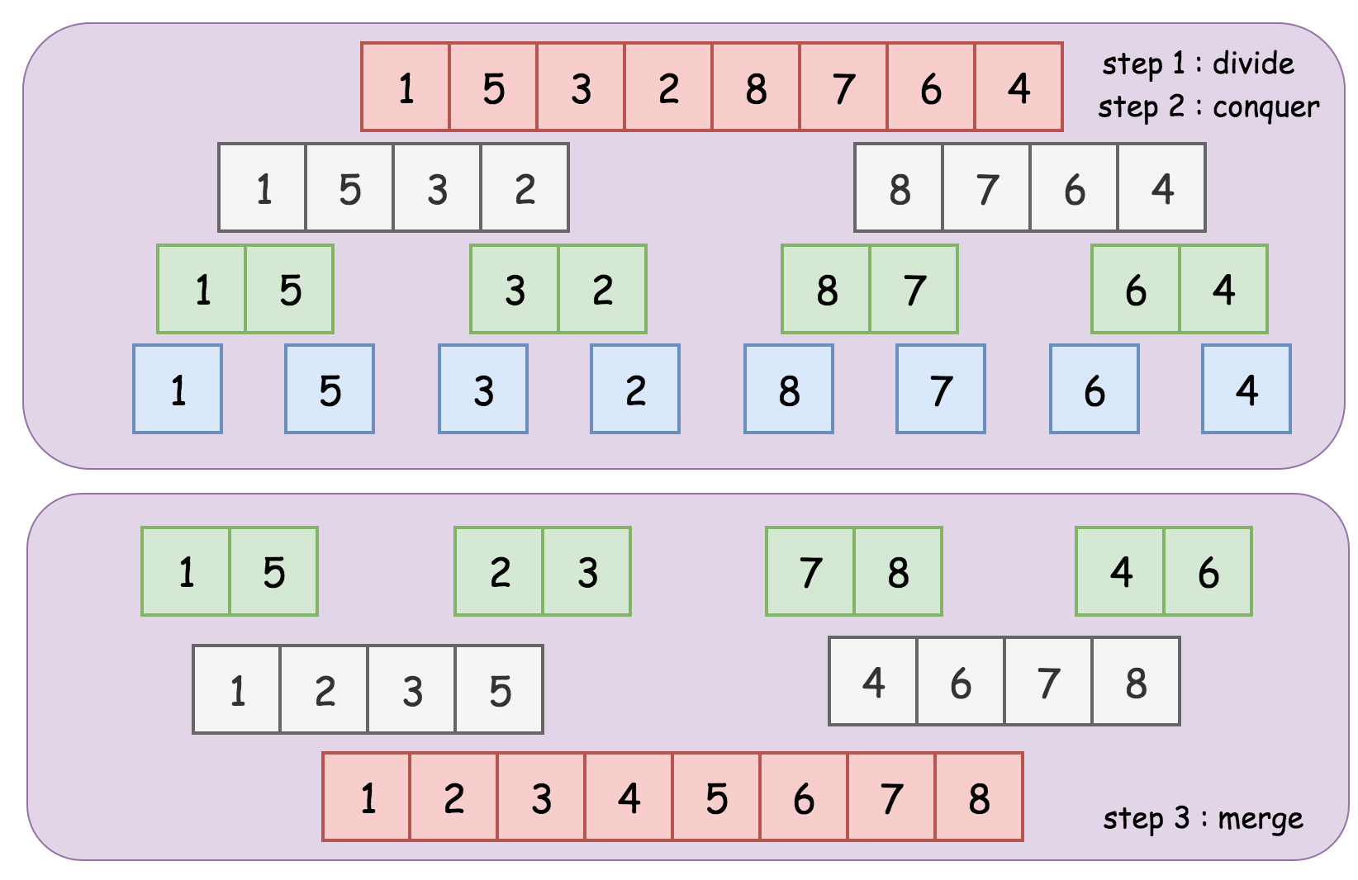

Fig.1  Top-down Merge Sort

1. In the first step, we divide the list into two sublists.  (**Divide**)
2. Then in the next step, we ***recursively*** sort the sublists in the previous step.  (**Conquer**)
3. Finally we merge the sorted sublists in the above step repeatedly to obtain the final list of sorted elements.  (**Combine**)

The recursion in **step (2)** would reach the base case where the input list is either empty or contains a single element (see the nodes in blue from the above figure).

Now, we have reduced the problem down to a merge problem, which is much simpler to solve. Merging two sorted lists can be done in ***linear time*** **complexity** *O*(*N*), where *N* is the total lengths of the two lists to merge.

We demonstrate an example of the merge process as following:



Here is a sample implementation of the top-down merge sort algorithm.

|  |
| --- |
| import java.util.Arrays;  public class Solution {    public int [] merge_sort(int [] input) {  if (input.length <= 1) {  return input;  }  int pivot = input.length / 2;  int [] left_list = merge_sort(Arrays.copyOfRange(input, 0, pivot));  int [] right_list = merge_sort(Arrays.copyOfRange(input, pivot, input.length));  return merge(left_list, right_list);  }    public int [] merge(int [] left_list, int [] right_list) {  int [] ret = new int[left_list.length + right_list.length];  int left_cursor = 0, right_cursor = 0, ret_cursor = 0;  while (left_cursor < left_list.length &&  right_cursor < right_list.length) {  if (left_list[left_cursor] < right_list[right_cursor]) {  ret[ret_cursor++] = left_list[left_cursor++];  } else {  ret[ret_cursor++] = right_list[right_cursor++];  }  }  // append what is remain the above lists  while (left_cursor < left_list.length) {  ret[ret_cursor++] = left_list[left_cursor++];  }  while (right_cursor < right_list.length) {  ret[ret_cursor++] = right_list[right_cursor++];  }  return ret;  }  } |

### ***Bottom-up Approach***

In the **bottom up** approach, we divide the list into sublists of a single element at the beginning. Each of the sublists is then sorted already. Then from this point on, we merge the sublists two at a time until a single list remains.

We illustrate how the bottom up approach works in the below figure. The bottom up approach can be implemented iteratively. Try to implement it yourself! We have an exercise that you can practice following this article.

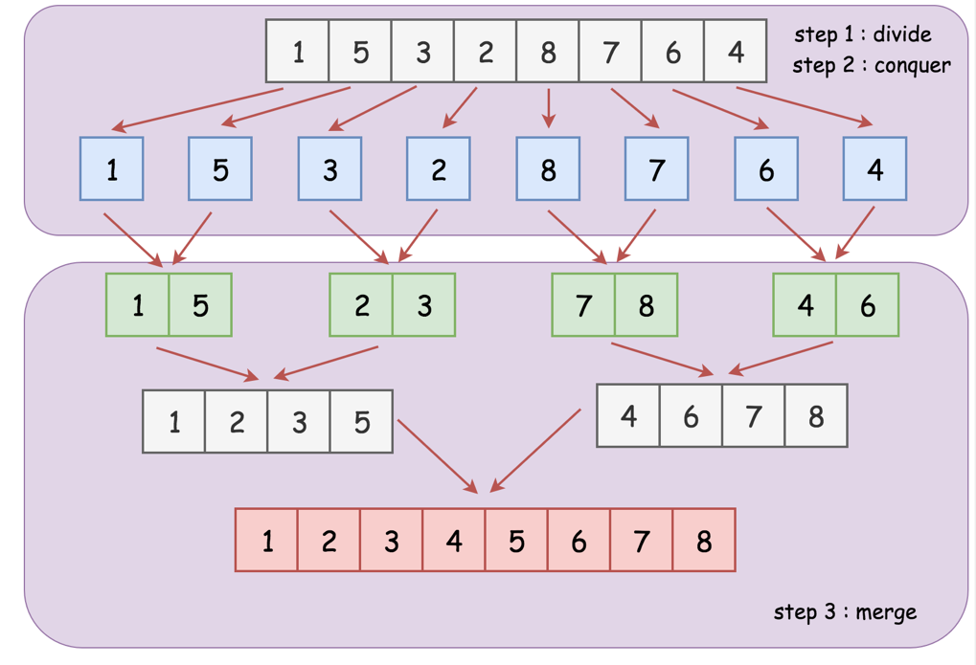

Fig. 2   Bottom-up Merge Sort

### ***Complexity***

The overall **time complexity** of the merge sort algorithm is *O*(*N*log*N*), where *N* is the length of the input list. To calculate the complexity, we break it down to the following steps:

1. We recursively divide the input list into two sublists, until a sublist with single element remains. This dividing step computes the midpoint of each of the sublists, which takes *O*(1) time. This step is repeated *N* times until a single element remains, therefore the total time complexity is *O*(*N*).
2. Then, we repetitively merge the sublists, until one single list remains. The recursion tree in **Fig. 1** or **Fig. 2** above is useful for visualizing how the recurrence is iterated. As shown in the recursion tree, there are a total of N*N* elements on each level. Therefore, it takes *O*(*N*) time for the merging process to complete on each level. And since there are a total of log*N* levels, the overall complexity of the merge process is *O*(*N*log*N*).

Taking into account the complexity of the above two parts in the merge sort algorithm, we conclude that the overall time complexity of merge sort is *O*(*N*log*N*).

The **space** ***complexity*** of the merge sort algorithm is *O*(*N*), where *N* is the length of the input list, since we need to keep the sublists as well as the buffer to hold the merge results at each round of merge process.

### ***References***

- [1]. [Merge Sort algorithm](https://en.wikipedia.org/wiki/Merge_sort). Wikipedia.

**Sort an Array**

Given an array of integers nums, sort the array in ascending order.

**Example 1:**

**Input:** nums = [5,2,3,1]

**Output:** [1,2,3,5]

**Example 2:**

**Input:** nums = [5,1,1,2,0,0]

**Output:** [0,0,1,1,2,5]

**Constraints:**

* 1 <= nums.length <= 50000
* -50000 <= nums[i] <= 50000

**D&C Template**

In the previous article of merge sort, we have introduced the general steps involved in all the divide-and-conquer algorithms. In this article, we will present you a ***pseudocode*** **template** that could help you to structure your code when implementing the algorithm in the divide-and-conquer paradigm. Furthermore, we will demonstrate with some concrete examples on how to apply the template.

### ***Template***

There are in general three steps that one can follow in order to solve the problem in a divide-and-conquer manner.

1.**Divide.** Divide the problem *S* into a set of subproblems: }{*S*1​,*S*2​,...*Sn*​} where *n*≥2, i.e. there are usually more than one subproblem.

2. **Conquer.** Solve each subproblem recursively.

3.**Combine.**Combine the results of each subproblem.

We can summarize the above steps in the following pseudocode template.

|  |
| --- |
| def divide_and_conquer( S ):  # (1). Divide the problem into a set of subproblems.  [S1, S2, ... Sn] = divide(S)  # (2). Solve the subproblem recursively,  # obtain the results of subproblems as [R1, R2... Rn].  rets = [divide_and_conquer(Si) for Si in [S1, S2, ... Sn]]  [R1, R2,... Rn] = rets  # (3). combine the results from the subproblems.  # and return the combined result.  return combine([R1, R2,... Rn]) |

As one can see from the above template, the essential part of the divide and conquer is to figure out the recurrence relationship between the subproblems and the original problem, which subsequently defines the functions of divide() and combine().

In the next sections, we will show you how to apply the above template to implement the algorithms for some concrete examples.

### ***Validate Binary Search Tree***

Sometimes, tree related problems can be solved using divide-and-conquer algorithms.

For example, look at the following problem statement:

Given a binary tree, validate if the given tree is a binary search tree (BST). The BST must meet all of the following properties:

1. All values on the left subtree of a node should be less than the value of the node.
2. All values on the right subtree of a node should be greater than the value of the node.
3. Both the left and right subtrees must also be binary search trees.

Read **point no. 3** above very carefully. The definition of BST is recursive in nature, making this a natural divide and conquer problem.

Below is an example of a BST shown in the following figure.

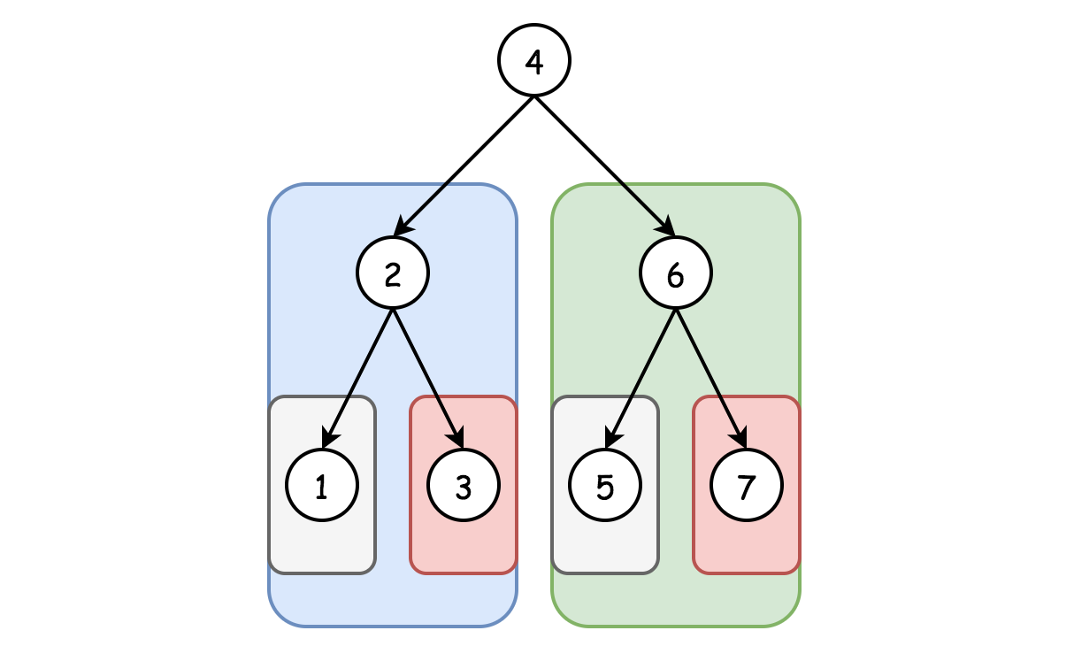

Fig 2. Binary Search Tree

**1.** In the first step, we divide the tree into two subtrees -- its left child and right child.  (**Divide**)

**2.** Then in the next step, we ***recursively*** validate each subtree is indeed a binary search tree.  (**Conquer**)

**3.** Upon the results of the subproblems from Step 2, we return true if and only if both subtrees are both valid BST.  (**Combine**)

The recursion in **Step 2.** would reach the base case where the subtree is either empty or contains a single node, which is a valid BST itself.

Notice some important details are still missing from **Step 2.** above, which are left as an exercise for the reader. For example, how do you verify these two properties which are also required for a BST?

1. All values on the left subtree of a node should be less than the value of the node.
2. All values on the right subtree of a node should be greater than the value of the node.

Following this article you can [try solving this exercise](https://leetcode.com/explore/learn/card/recursion-ii/470/divide-and-conquer/2874/) by yourself. We also provide a [step-by-step solution](https://leetcode.com/explore/learn/card/recursion-ii/470/divide-and-conquer/2875/) if you are still stuck following the exercise.

### ***Search a 2D Matrix II***

Write an efficient algorithm that searches for an integer value in an [*m*×*n*] matrix. This matrix has the following properties:

* Integers in each row are sorted in ascending from left to right.
* Integers in each column are sorted in ascending from top to bottom.

There are several ways to solve the above problem. Here we give an overall idea to solve it in the divide-and-conquer manner.

As one might notice, given the matrix, if we divide it into some sub-matrices by cutting it either by row and/or column, the resulting matrices would still keep the above two properties of the original matrix. Given the above insight, here is how we can apply the template to solve the problem.

***1***. We divide the matrix into 4 sub-matrices by choosing a pivot point based on a row and a column.  (**Divide**)

***2***. Then we ***recursively*** look into each sub-matrix to search for the desired target.  (**Conquer**)

***3***. If we find the target in either of the sub-matrices, we stop the search and return the result immediately.  (**Combine**)

The base cases in the above recursion would be either the input matrix is empty or it contains only a single element. As a simple strategy, one can choose the **middle point** both on the row and column as the pivot points to divide the matrix.

Do we really need to look into each of the divided 4 sub-matrices? Notice that the smallest and the largest element of the input matrix is located in the top left and bottom right corner respectively, which also applies to each of the divided sub-matrices. In fact, we need to only look into 3 of the sub-matrices.

1. If our target is equal to the pivot, we have found our target and immediately return the result.
2. If our target is less than the pivot, we can discard the bottom-right sub-matrix. All elements in that region must be greater or equal than the pivot.
3. If our target is greater than the pivot, we can discard the top-left sub-matrix. All elements in that region must be less than or equal than the pivot.

We have just finished the divide-and-conquer approach, now try to [code the solution](https://leetcode.com/explore/learn/card/recursion-ii/470/divide-and-conquer/2872/) yourself! As a follow up exercise, can you derive the time complexity? At the end of this chapter, we provide [Master Theorem](https://leetcode.com/explore/learn/card/recursion-ii/470/divide-and-conquer/2871/) as an alternative way to derive time complexity like this problem.

The above divide-and-conquer algorithm can still be further improved, which we will provide insights below.

***As an improvement to the above divide-and-conquer algorithm, we could devise a better strategy by choosing the pivot points wisely.***

We illustrate a strategy in the following figure, to reduce the search zones into 2 sub-matrices, instead of 3 sub-matrices.

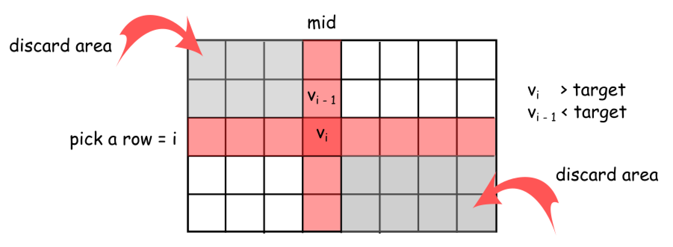

Fig 1. Search 2D Matrix II

First, we choose the middle point on the column which divides the matrix into two sub-matrices. We then fix on this middle column to further determine an optimal row to divide the matrix. We scan the elements along the chosen middle column, to locate the boundary where the value of the element just goes beyond the target value, i.e.  {*Vi*−1​<target<*Vi*​}. From this point, we divide the original matrix into 4 sub-matrices. And we just need to zoom into the bottom left and top right sub-matrices to look for the target value, while ignoring the top left and bottom right sub-matrices.

We ignore the top left sub-matrix that ends with the element *Vi*−1​, because all the elements within this sub-matrix would be less than the target value. Similarly, we ignore the bottom right sub-matrices that starts with the element *Vi*​, because we know that all the elements within this sub-matrix would be greater than the target value.

**Validate Binary Search Tree**

Given the root of a binary tree, *determine if it is a valid binary search tree (BST)*.

A **valid BST** is defined as follows:

* The left subtree of a node contains only nodes with keys **less than** the node's key.
* The right subtree of a node contains only nodes with keys **greater than** the node's key.
* Both the left and right subtrees must also be binary search trees.

**Example 1:**

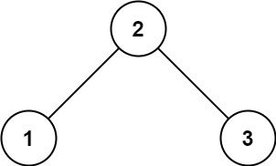

**Input:** root = [2,1,3]

**Output:** true

**Example 2:**

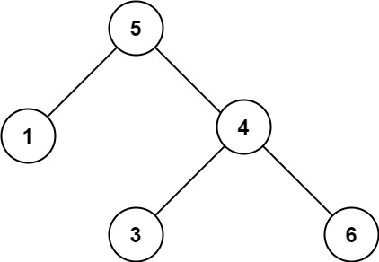

**Input:** root = [5,1,4,null,null,3,6]

**Output:** false

**Explanation:** The root node's value is 5 but its right child's value is 4.

**Constraints:**

* The number of nodes in the tree is in the range [1, 104].
* -231 <= Node.val <= 231 - 1

## Solution Article

#### **Tree definition**

First of all, here is the definition of the TreeNode which we would use.

|  |
| --- |
| // Definition for a binary tree node.  public class TreeNode {  int val;  TreeNode left;  TreeNode right;  TreeNode(int x) {  val = x;  }  } |

#### **Intuition**

On the first sight, the problem is trivial. Let's traverse the tree and check at each step if node.right.val > node.val and node.left.val < node.val. This approach would even work for some trees 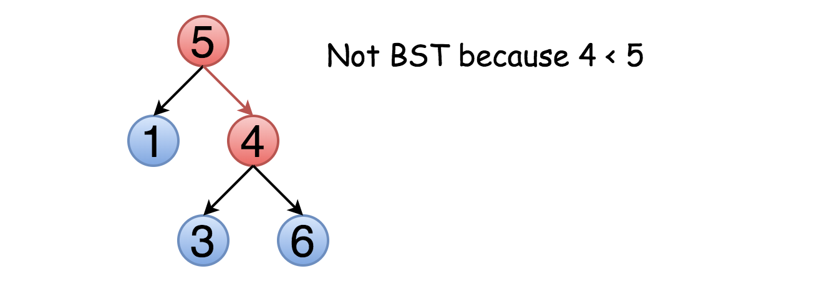

The problem is this approach will not work for all cases. Not only the right child should be larger than the node but all the elements in the right subtree. Here is an example :

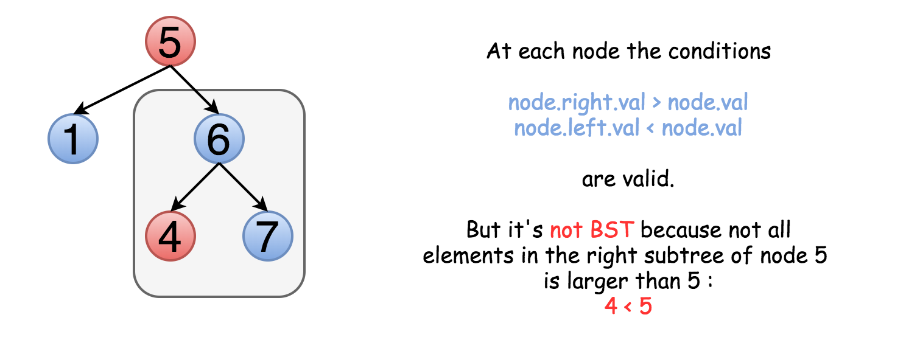

That means one should keep both upper and lower limits for each node while traversing the tree, and compare the node value not with children values but with these limits.

#### **Approach 1: Recursive Traversal with Valid Range**

The idea above could be implemented as a recursion. One compares the node value with its upper and lower limits if they are available. Then one repeats the same step recursively for left and right subtrees.

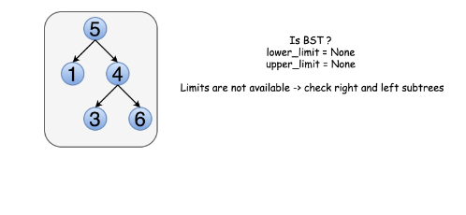

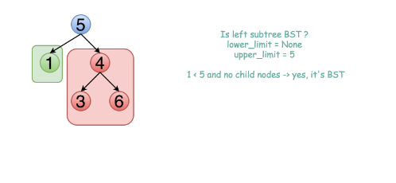

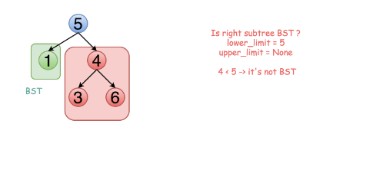

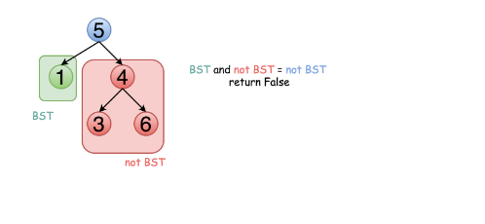

|  |
| --- |
| class Solution {  public boolean validate(TreeNode root, Integer low, Integer high) {  // Empty trees are valid BSTs.  if (root == null) {  return true;  }  // The current node's value must be between low and high.  if ((low != null && root.val <= low) || (high != null && root.val >= high)) {  return false;  }  // The left and right subtree must also be valid.  return validate(root.right, root.val, high) && validate(root.left, low, root.val);  }  public boolean isValidBST(TreeNode root) {  return validate(root, null, null);  }  } |

**Complexity Analysis**

* Time complexity : O(*N*) since we visit each node exactly once.
* Space complexity :  O(*N*) since we keep up to the entire tree.

#### **Approach 2: Iterative Traversal with Valid Range**

The above recursion could be converted into iteration, with the help of an explicit stack. DFS would be better than BFS since it works faster here.

|  |
| --- |
| class Solution {  private Deque<TreeNode> stack = new LinkedList();  private Deque<Integer> upperLimits = new LinkedList();  private Deque<Integer> lowerLimits = new LinkedList();  public void update(TreeNode root, Integer low, Integer high) {  stack.add(root);  lowerLimits.add(low);  upperLimits.add(high);  }  public boolean isValidBST(TreeNode root) {  Integer low = null, high = null, val;  update(root, low, high);  while (!stack.isEmpty()) {  root = stack.poll();  low = lowerLimits.poll();  high = upperLimits.poll();  if (root == null) continue;  val = root.val;  if (low != null && val <= low) {  return false;  }  if (high != null && val >= high) {  return false;  }  update(root.right, val, high);  update(root.left, low, val);  }  return true;  }  } |

**Complexity Analysis**

* Time complexity :  O(*N*) since we visit each node exactly once.
* Space complexity :  O(*N*) since we keep up to the entire tree.

#### **Approach 3: Recursive Inorder Traversal**

**Algorithm**

Let's use the order of nodes in the [inorder traversal](https://leetcode.com/articles/binary-tree-inorder-traversal/) Left -> Node -> Right.

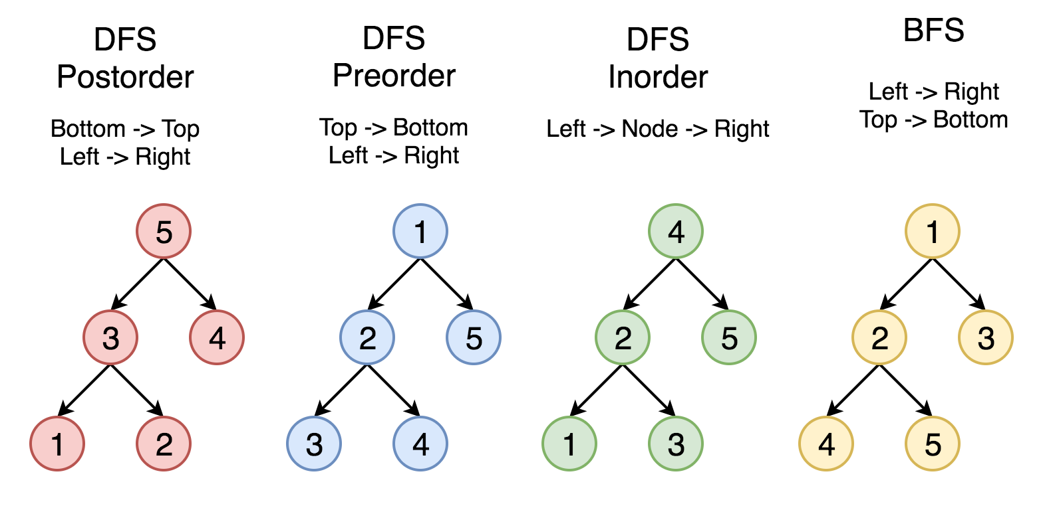

Here the nodes are enumerated in the order you visit them, and you could follow 1-2-3-4-5 to compare different strategies.

Left -> Node -> Right order of inorder traversal means for BST that each element should be smaller than the next one.

Hence the algorithm with O(*N*) time complexity and O(*N*) space complexity could be simple:

* Compute inorder traversal list inorder.
* Check if each element in inorder is smaller than the next one.

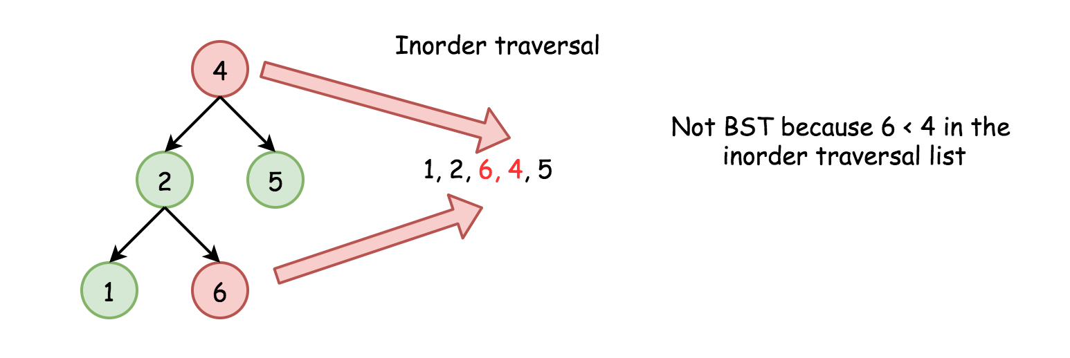

Do we need to keep the whole inorder traversal list?

Actually, no. The last added inorder element is enough to ensure at each step that the tree is BST (or not). Hence one could merge both steps into one and reduce the used space.

**Code**

We can implement the algorithm recursively.

|  |
| --- |
| class Solution {  // We use Integer instead of int as it supports a null value.  private Integer prev;  public boolean isValidBST(TreeNode root) {  prev = null;  return inorder(root);  }  private boolean inorder(TreeNode root) {  if (root == null) {  return true;  }  if (!inorder(root.left)) {  return false;  }  if (prev != null && root.val <= prev) {  return false;  }  prev = root.val;  return inorder(root.right);  }  } |

**Complexity Analysis**

* Time complexity : O(*N*) in the worst case when the tree is a BST or the "bad" element is a rightmost leaf.
* Space complexity : O(*N*) for the space on the run-time stack.

#### **Approach 4: Iterative Inorder Traversal**

Alternatively, we could implement the above algorithm iteratively.

|  |
| --- |
| class Solution {  public boolean isValidBST(TreeNode root) {  Deque<TreeNode> stack = new ArrayDeque<>();  Integer prev = null;  while (!stack.isEmpty() || root != null) {  while (root != null) {  stack.push(root);  root = root.left;  }  root = stack.pop();  // If next element in inorder traversal  // is smaller than the previous one  // that's not BST.  if (prev != null && root.val <= prev) {  return false;  }  prev = root.val;  root = root.right;  }  return true;  }  } |

**Complexity Analysis**

* Time complexity : O(*N*) in the worst case when the tree is BST or the "bad" element is a rightmost leaf.
* Space complexity : O(*N*) to keep stack.

**Search a 2D Matrix II**

Write an efficient algorithm that searches for a target value in an m x n integer matrix. The matrix has the following properties:

* Integers in each row are sorted in ascending from left to right.
* Integers in each column are sorted in ascending from top to bottom.

**Example 1:**

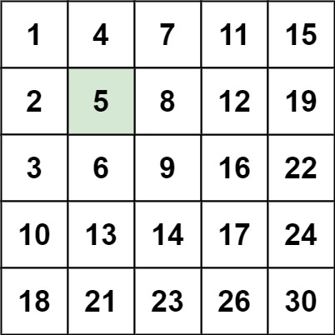

**Input:** matrix = [[1,4,7,11,15],[2,5,8,12,19],[3,6,9,16,22],[10,13,14,17,24],[18,21,23,26,30]], target = 5

**Output:** true

**Example 2:**

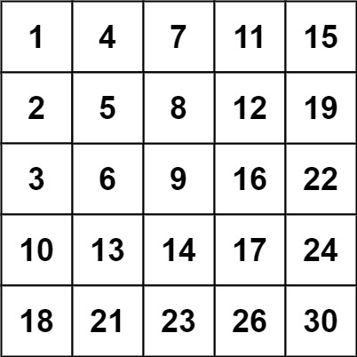

**Input:** matrix = [[1,4,7,11,15],[2,5,8,12,19],[3,6,9,16,22],[10,13,14,17,24],[18,21,23,26,30]], target = 20

**Output:** false

**Constraints:**

* m == matrix.length
* n == matrix[i].length
* 1 <= n, m <= 300
* -109 <= matix[i][j] <= 109
* All the integers in each row are **sorted** in ascending order.
* All the integers in each column are **sorted** in ascending order.
* -109 <= target <= 109

## Solution

#### **Approach 1: Brute Force**

**Intuition**

As a baseline, we can search the 2D array the same way we might search an unsorted 1D array -- by examining each element.

**Algorithm**

The algorithm doesn't really do anything more clever than what is explained by the intuition; we loop over the array, checking each element in turn. If we find it, we return true. Otherwise, if we reach the end of the nested for loop without returning, we return false. The algorithm must return the correct answer in all cases because we exhaust the entire search space.

|  |
| --- |
| class Solution {  public boolean searchMatrix(int[][] matrix, int target) {  for (int i = 0; i < matrix.length; i++) {  for (int j = 0; j < matrix[0].length; j++) {  if (matrix[i][j] == target) {  return true;  }  }  }  return false;  }  } |

**Complexity Analysis**

* Time complexity : O(*nm*) Becase we perform a constant time operation for each element of an *n*×*m* element matrix, the overall time complexity is equal to the size of the matrix.
* Space complexity : O(1) The brute force approach does not allocate more additional space than a handful of pointers, so the memory footprint is constant.

#### **Approach 2: Binary Search**

**Intuition**

The fact that the matrix is sorted suggests that there must be some way to use binary search to speed up our algorithm.

**Algorithm**

First, we ensure that matrix is not null and not empty. Then, if we iterate over the matrix diagonals, we can maintain an invariant that the slice of the row and column beginning at the current (*row*,*col*) pair is sorted. Therefore, we can always binary search these row and column slices for target. We proceed in a logical fashion, iterating over the diagonals, binary searching the rows and columns until we either run out of diagonals (meaning we can return False) or find target (meaning we can return True). The binarySearch function works just like normal binary search, but is made ugly by the need to search both rows and columns of a two-dimensional array.

|  |
| --- |
| class Solution {  private boolean binarySearch(int[][] matrix, int target, int start, boolean vertical) {  int lo = start;  int hi = vertical ? matrix[0].length-1 : matrix.length-1;  while (hi >= lo) {  int mid = (lo + hi)/2;  if (vertical) { // searching a column  if (matrix[start][mid] < target) {  lo = mid + 1;  } else if (matrix[start][mid] > target) {  hi = mid - 1;  } else {  return true;  }  } else { // searching a row  if (matrix[mid][start] < target) {  lo = mid + 1;  } else if (matrix[mid][start] > target) {  hi = mid - 1;  } else {  return true;  }  }  }  return false;  }  public boolean searchMatrix(int[][] matrix, int target) {  // an empty matrix obviously does not contain `target`  if (matrix == null || matrix.length == 0) {  return false;  }  // iterate over matrix diagonals  int shorterDim = Math.min(matrix.length, matrix[0].length);  for (int i = 0; i < shorterDim; i++) {  boolean verticalFound = binarySearch(matrix, target, i, true);  boolean horizontalFound = binarySearch(matrix, target, i, false);  if (verticalFound || horizontalFound) {  return true;  }  }    return false;  }  } |

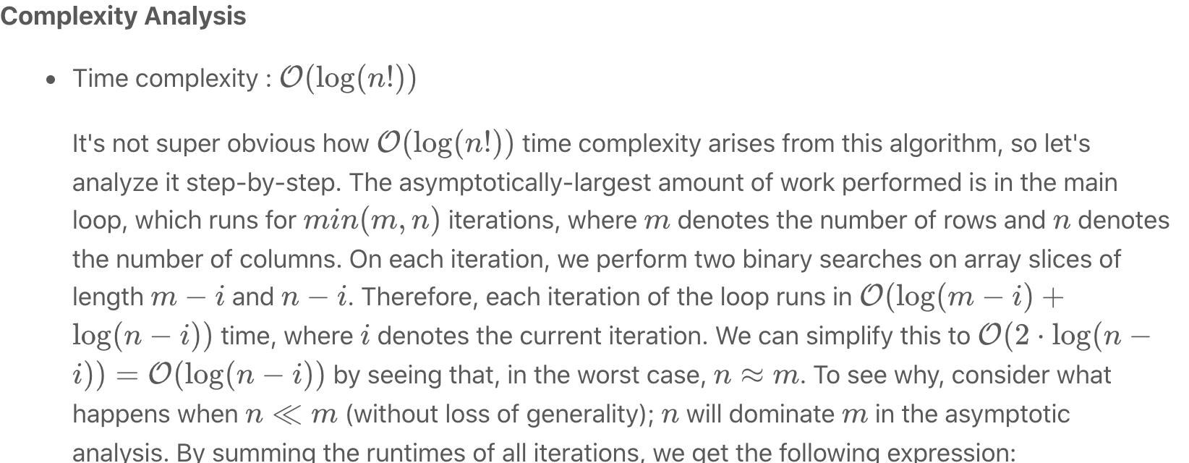



Then, we can leverage the log multiplication rule log(*a*)+log(*b*)=log(*ab*)) to rewrite the complexity as:

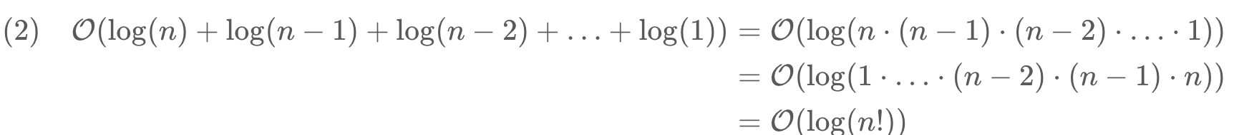

* Because this time complexity is fairly uncommon, it is worth thinking about its relation to the usual analyses. For one, log(*n*!)=O(*n*log*n*). To see why, recall step 1 from the analysis above; there are *n* terms, each no greater than log(*n*). Therefore, the asymptotic runtime is certainly no worse than that of an O(*n*log*n*) algorithm.
* Space complexity : O(1)

Because our binary search implementation does not literally slice out copies of rows and columns from matrix, we can avoid allocating greater-than-constant memory.

#### **Approach 3: Divide and Conquer**

**Intuition**

We can partition a sorted two-dimensional matrix into four sorted submatrices, two of which might contain target and two of which definitely do not.

**Algorithm**

Because this algorithm operates recursively, its correctness can be asserted via the correctness of its base and recursive cases.

Base Case

For a sorted two-dimensional array, there are two ways to determine in constant time whether an arbitrary element target can appear in it. First, if the array has zero area, it contains no elements and therefore cannot contain target. Second, if target is smaller than the array's smallest element (found in the top-left corner) or larger than the array's largest element (found in the bottom-right corner), then it definitely is not present.

Recursive Case

If the base case conditions have not been met, then the array has positive area and target could potentially be present. Therefore, we seek along the matrix's middle column for an index row such that  *matrix*[*row*−1][*mid*]<*target*<*matrix*[*row*][*mid*] (obviously, if we find target during this process, we immediately return true). The existing matrix can be partitioned into four submatrice around this index; the top-left and bottom-right submatrice cannot contain target (via the argument outlined in Base Case section), so we can prune them from the search space. Additionally, the bottom-left and top-right submatrice are sorted two-dimensional matrices, so we can recursively apply this algorithm to them.

|  |
| --- |
| class Solution {  private int[][] matrix;  private int target;  private boolean searchRec(int left, int up, int right, int down) {  // this submatrix has no height or no width.  if (left > right || up > down) {  return false;  // `target` is already larger than the largest element or smaller  // than the smallest element in this submatrix.  } else if (target < matrix[up][left] || target > matrix[down][right]) {  return false;  }  int mid = left + (right-left)/2;  // Locate `row` such that matrix[row-1][mid] < target < matrix[row][mid]  int row = up;  while (row <= down && matrix[row][mid] <= target) {  if (matrix[row][mid] == target) {  return true;  }  row++;  }  return searchRec(left, row, mid-1, down) || searchRec(mid+1, up, right, row-1);  }  public boolean searchMatrix(int[][] mat, int targ) {  // cache input values in object to avoid passing them unnecessarily  // to `searchRec`  matrix = mat;  target = targ;  // an empty matrix obviously does not contain `target`  if (matrix == null || matrix.length == 0) {  return false;  }  return searchRec(0, 0, matrix[0].length-1, matrix.length-1);  }  } |

**Complexity Analysis**

* Time complexity : O(*n*log*n*)

First, for ease of analysis, assume that *n*≈*m*, as in the analysis of approach 2. Also, assign x=n^2=|matrix|; this will make the [master method](https://en.wikipedia.org/wiki/Master_theorem_(analysis_of_algorithms)) easier to apply. Now, let's model the runtime of the divide & conquer approach as a recurrence relation:  
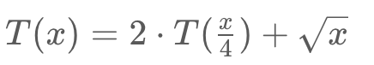

The first term 2⋅*T*(X/4​)) arises from the fact that we recurse on two submatrices of roughly one-quarter size, while sqrt{x}​ comes from the time spent seeking along a *O*(*n*)-length column for the partition point. After binding the master method variables (*a*=2;*b*=4;*c*=0.5) we notice that log*b*​*a*=*c*. Therefore, this recurrence falls under case 2 of the master method, and the following falls out:  
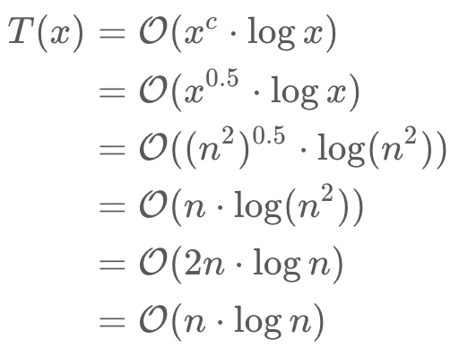

* Extension: what would happen to the complexity if we binary searched for the partition point, rather than used a linear scan?
* Space complexity : O(log*n*)

Although this approach does not fundamentally require greater-than-constant addition memory, its use of recursion means that it will use memory proportional to the height of its recursion tree. Because this approach discards half of matrix on each level of recursion (and makes two recursive calls), the height of the tree is bounded by log*n*.

#### **Approach 4: Search Space Reduction**

**Intuition**

Because the rows and columns of the matrix are sorted (from left-to-right and top-to-bottom, respectively), we can prune O(*m*) or O(*n*) elements when looking at any particular value.

**Algorithm**

First, we initialize a (*row*,*col*) pointer to the bottom-left of the matrix.[[1]](https://leetcode.com/problems/search-a-2d-matrix-ii/solution/#fn1) Then, until we find target and return true (or the pointer points to a (row, col)(*row*,*col*) that lies outside of the dimensions of the matrix), we do the following: if the currently-pointed-to value is larger than target we can move one row "up". Otherwise, if the currently-pointed-to value is smaller than target, we can move one column "right". It is not too tricky to see why doing this will never prune the correct answer; because the rows are sorted from left-to-right, we know that every value to the right of the current value is larger. Therefore, if the current value is already larger than target, we know that every value to its right will also be too large. A very similar argument can be made for the columns, so this manner of search will always find target in the matrix (if it is present).

Check out some sample runs of the algorithm in the animation below:

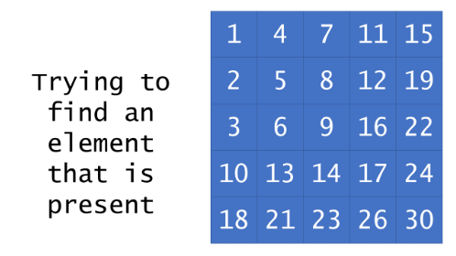

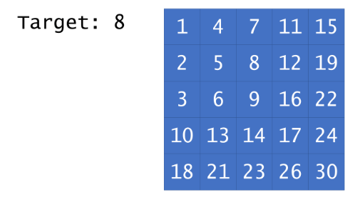

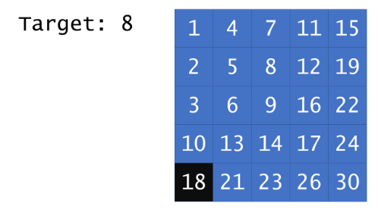

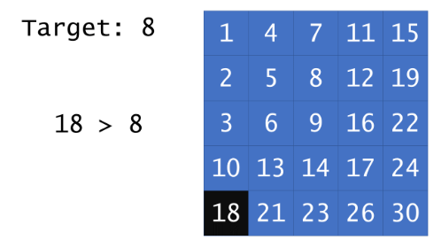

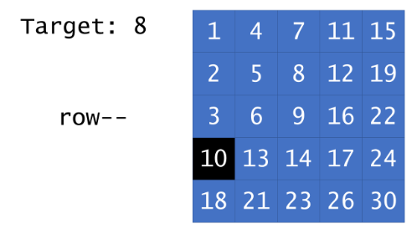

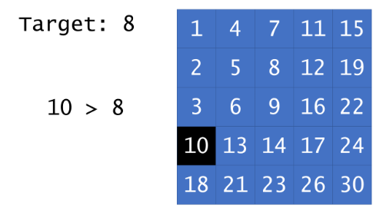

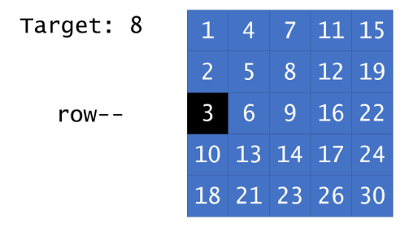

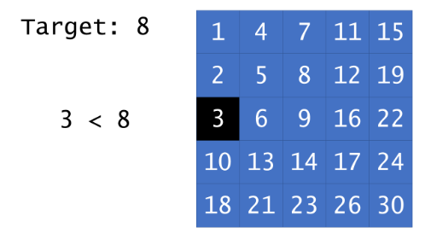

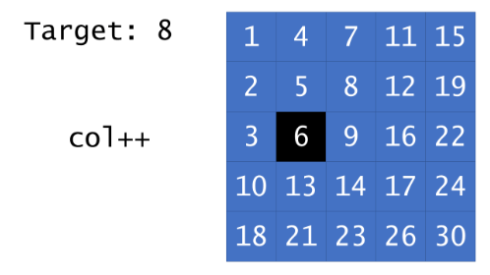

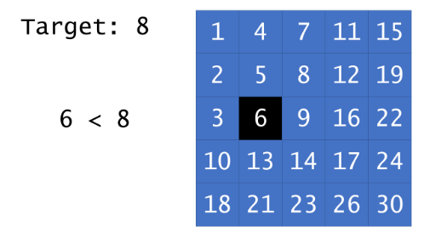

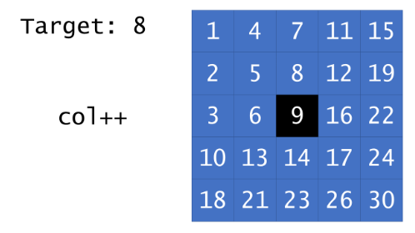

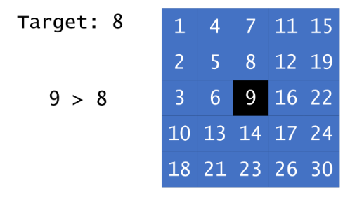

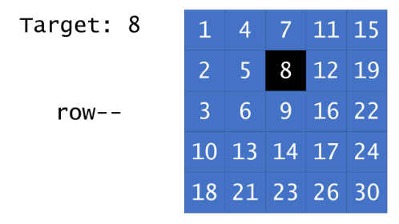

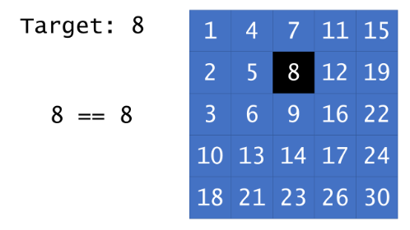

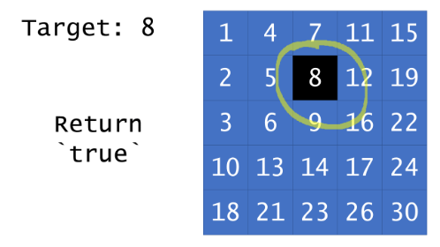

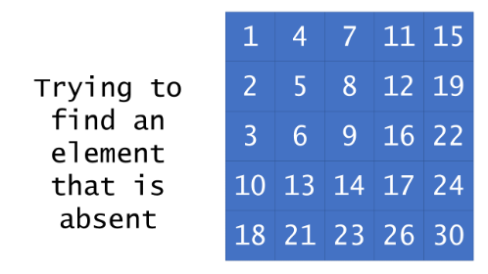

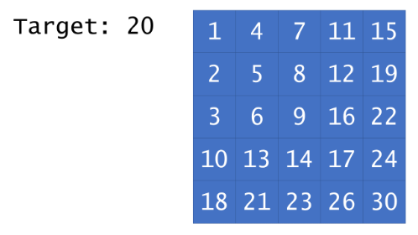

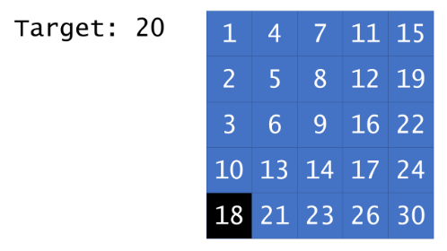

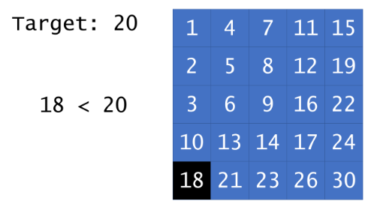

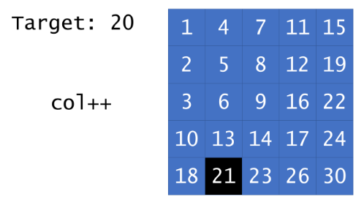

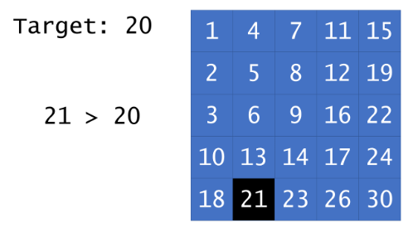

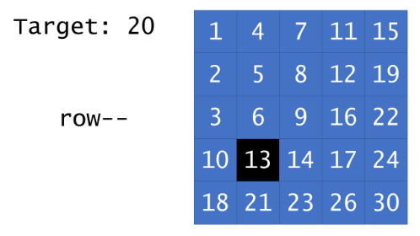

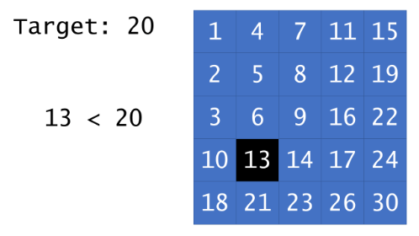

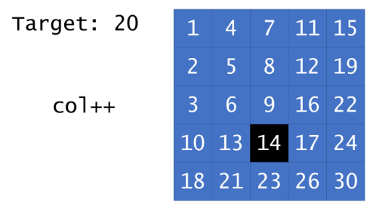

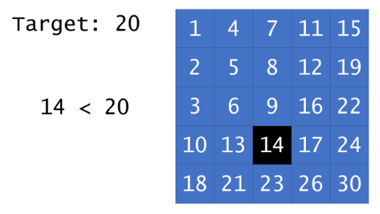

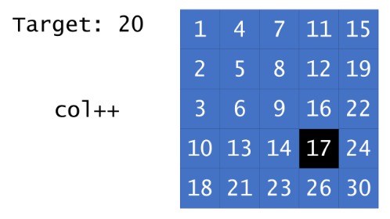

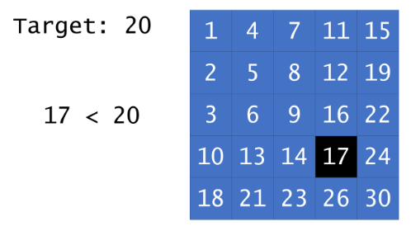

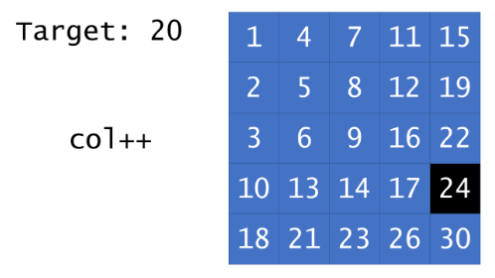

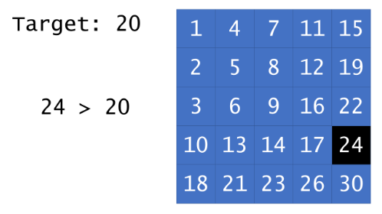

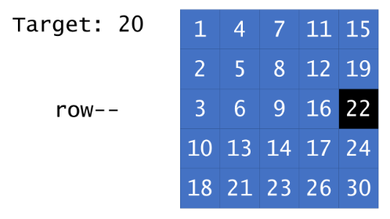

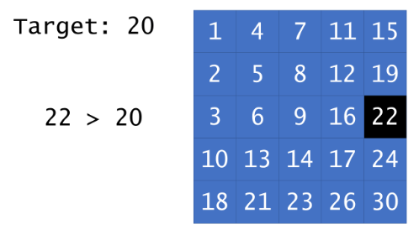

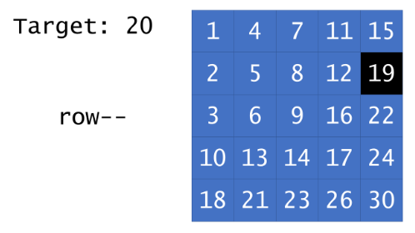

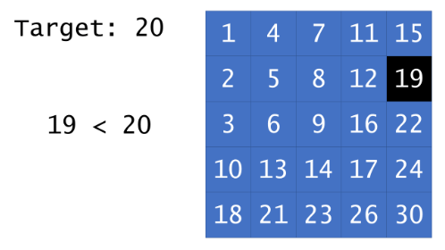

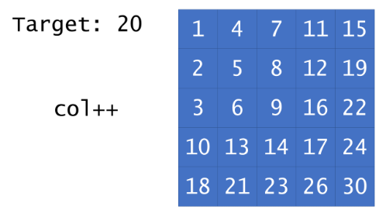

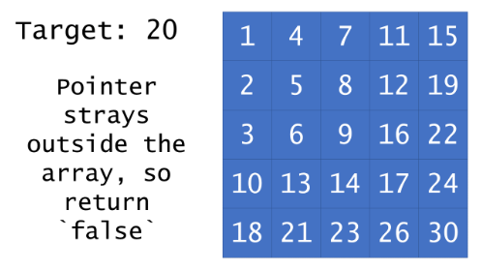

|  |
| --- |
| class Solution {  public boolean searchMatrix(int[][] matrix, int target) {  // start our "pointer" in the bottom-left  int row = matrix.length-1;  int col = 0;  while (row >= 0 && col < matrix[0].length) {  if (matrix[row][col] > target) {  row--;  } else if (matrix[row][col] < target) {  col++;  } else { // found it  return true;  }  }  return false;  }  } |

**Complexity Analysis**

* Time complexity : O(*n*+*m*)

The key to the time complexity analysis is noticing that, on every iteration (during which we do not return true) either row or col is is decremented/incremented exactly once. Because row can only be decremented *m* times and col can only be incremented *n* times before causing the while loop to terminate, the loop cannot run for more than *n*+*m* iterations. Because all other work is constant, the overall time complexity is linear in the sum of the dimensions of the matrix.

* Space complexity : O(1)

Because this approach only manipulates a few pointers, its memory footprint is constant.

#### **Footnotes**

1. This would work equally well with a pointer initialized to the top-right. Neither of the other two corners would work, as pruning a row/column might prevent us from achieving the correct answer. [↩︎](https://leetcode.com/problems/search-a-2d-matrix-ii/solution/#fnref1)

**Quick Sort**

In the previous articles, we explained the [merge sort](https://leetcode.com/explore/learn/card/recursion-ii/470/divide-and-conquer/2868/) algorithm, which is a classical example of the divide-and-conquer algorithm. As a comparison to merge sort algorithm, in this article, we will present you another well-known sorting algorithm called quick sort.

Quick sort **[1]** is another classical divide-and-conquer algorithm for sorting, which was developed by the British computer scientist [Tony Hoare](https://en.wikipedia.org/wiki/Tony_Hoare) in 1959. When implemented well, quick sort algorithm can be two or three times faster than its predecessors and competitors such as merge sort, which is why it gains its name.

### ***Intuition***

Following the [pseudocode template](https://leetcode.com/explore/learn/card/recursion-ii/470/divide-and-conquer/2869/) of the divide-and-conquer algorithm, as we presented before, the quick sort algorithm can be implemented in three steps, namely **dividing the problem**, **solving the subproblems** and **combining the results of subproblems**.

In detail, given a list of values to sort, the quick sort algorithm works in the following steps:

1. First, it selects a value from the list, which serves as a ***pivot*** value to divide the list into two sublists. One sublist contains all the values that are less than the pivot value, while the other sublist contains the values that are greater than or equal to the pivot value. This process is also called **partitioning**. The strategy of choosing a pivot value can vary. Typically, one can choose the first element in the list as the pivot, or randomly pick an element from the list.

1. After the partitioning process, the original list is then reduced into two smaller sublists. We then ***recursively*** sort the two sublists.

1. After the partitioning process, we are sure that all elements in one sublist are less or equal than any element in another sublist. Therefore, we can simply ***concatenate*** the two sorted sublists that we obtain in step [2] to obtain the final sorted list.

The base cases of the recursion in step [2] are either when the input list is empty or the empty list contains only a single element. In either case, the input list can be considered as sorted already.

As one can see, the essential idea of the quick sort algorithm is the partitioning process, which elegantly reduces the problems into smaller scale and meanwhile moves towards the final solution, i.e. after each partitioning, the overall values become more ordered.

### ***Algorithm***

In the following figure, we demonstrate how the quick sort algorithm works to sort a list of integer values. The input list contains 8 elements.

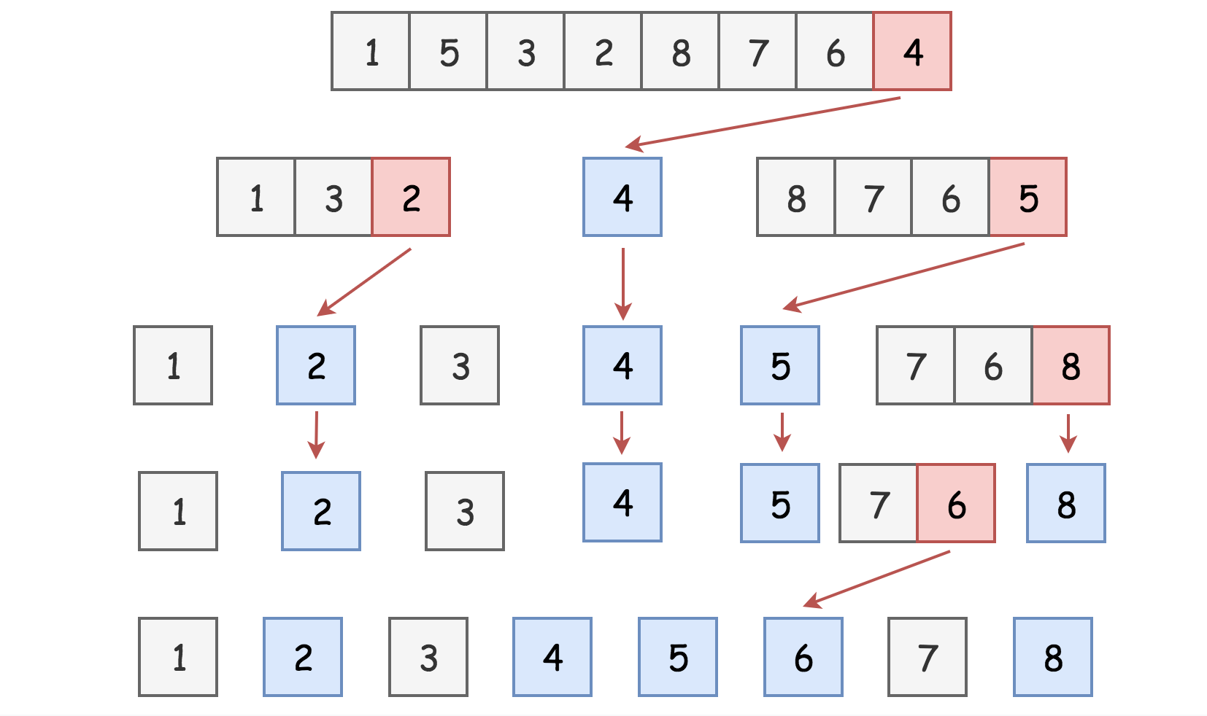

Fig.1 Quick Sort Illustration (elements in color are pivots)

As shown above, in the first round of quick sort, we pick the last element 4 as the pivot, which partitions the original list into two sublists: [1, 3, 2] and [8, 7, 6, 5] respectively.

Next, we recursively sort the above two sublists. For instance, for the sublist [1, 3, 2], again we pick the last element (i.e. 2) as the pivot value. After this partitioning, we obtain two sublists with a single element, which is the base case of the recursion.

Once we sorted the sublists [1, 3, 2] and [8, 7, 6, 5] respectively, we simply concatenate the sorted results together with the pivot value (4) to form the final result, i.e. [1, 2, 3] + [4] + [5, 6, 7, 8].

Here is the sample implementation of the quick sort algorithm.

|  |
| --- |
| public class Solution {  public void quickSort(int [] lst) {  /* Sorts an array in the ascending order in O(n log n) time */  int n = lst.length;  qSort(lst, 0, n - 1);  }  private void qSort(int [] lst, int lo, int hi) {  if (lo < hi) {  int p = partition(lst, lo, hi);  qSort(lst, lo, p - 1);  qSort(lst, p + 1, hi);  }  }  private int partition(int [] lst, int lo, int hi) {  /*  Picks the last element hi as a pivot  and returns the index of pivot value in the sorted array */  int pivot = lst[hi];  int i = lo;  for (int j = lo; j < hi; ++j) {  if (lst[j] < pivot) {  int tmp = lst[i];  lst[i] = lst[j];  lst[j] = tmp;  i++;  }  }  int tmp = lst[i];  lst[i] = lst[hi];  lst[hi] = tmp;  return i;  }  } |

### ***Complexity***

Depending on the pivot values, the time complexity of the quick sort algorithm can vary from *O*(*N*log2​*N*) in the best case and O(N^2) in the worst case, with *N* as the length of the list.

In the best case, if the pivot value happens to be median value of the list, then at each partition the list would be divided into two sublists of equal size. At the end, we actually construct a **balanced** [binary search tree](https://leetcode.com/explore/learn/card/introduction-to-data-structure-binary-search-tree/) (BST) out of the list. One can infer that the height of the tree would be log2​*N*, and at each level of the tree the input list would be scanned once with the complexity *O*(*N*) due to the partitioning process. As a result, the overall time complexity of the algorithm in this case would be *O*(*N*log2​*N*).

While in the worst case, if the pivot value happens to be the extreme value of the list, i.e. either the smallest or the biggest element in the list, then at each partition we end up with only one single sublist (i.e. the other sublist is empty). The reduction of the problem still works, but at a rather slow pace, i.e. one element at a time. The partitioning would then occur *N* times, and each time the partitioning scans at most *N* elements. Therefore, the overall time complexity of the quick sort algorithm in this case would be O(N^2). Actually, in this case, the quick sort algorithm ends up to be exactly as the insertion sort.

On average, as proved mathematically, the time complexity of quick sort is *O*(*N*log*N*).

### ***Next***

There are common patterns while analyzing the time complexity of many divide-and-conquer algorithms. In the next article, we will present a theoretical tool called [master theorem](https://leetcode.com/explore/learn/card/recursion-ii/470/divide-and-conquer/2871/), which can help us to obtain the complexity of certain divide-and-conquer algorithms simply by applying a mathematical formula.

### ***References***

- [1]. [Quick sort.](https://en.wikipedia.org/wiki/Quicksort) Wikipedia.

**Master Theorem**

Other than evaluating the time complexity of recursion algorithms case by case, sometimes you can apply a method called Master Theorem to quickly calculate the time complexity of many recursion algorithms.

[Master Theorem](https://en.m.wikipedia.org/wiki/Master_theorem_(analysis_of_algorithms)), also known as Master Method, provides asymptotic analysis (*i.e.* the time complexity) for many of the recursion algorithms that follow the pattern of divide-and-conquer.

Note that Master Theorem is an *advanced* technique to estimate the time complexity of certain recursive algorithms. It does *not* apply to all recursion algorithms. Certainly, one is not expected to memorize by heart all the formulas involved in Master Theorem during the interviews.

|  |
| --- |
| function dac( n ):  if n < k: // k: some constant  Solve "n" directly without recursion  else:  [1]. divide the problem "n" into "b" subproblems of equal size.  - then the size of each subproblem would be "n/b"  [2]. call the function "dac()" recursively "a" times on the subproblems  [3]. combine the results from the subproblems |

For the recursion algorithms that follow the above pattern, one can apply the master theorem to calculate their time complexity.

If we define the time complexity of the above recursion algorithm as *T*(*n*), then we can express it as follows:   
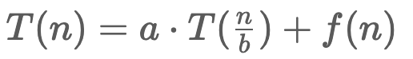

where *f*(*n*) is the time complexity that it takes to divide the problems into subproblems and also to combine the results from the subproblems. We can further represent *f*(*n*) as O(n^d) and *d*≥0.  

Then, Master Theorem provides us three formulas to calculate the time complexity of the recursion algorithm, according to the relationship among *a*,*b*,*d*. They are stated as follows:

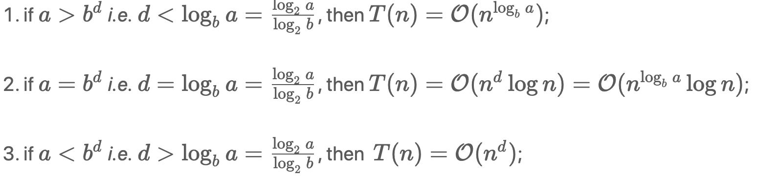

The conditions for each case correspond to the intuition of whether the work to split problems and combine results (i.e. *f*(*n*)) outweighs the work of subproblems (i.e. 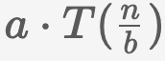.

For example, in case (1), the work to split problems and combine results is ***dwarfed*** by the subproblems. Therefore, the time complexity of the overall recursion algorithm can be reduced to the complexity of the subproblems (i.e. ).

We list a few examples that correspond to each of the above cases in the rest of the article.

### ***Examples***

Binary tree traversal related algorithms are the algorithms where one needs to traverse a binary tree in order to solve the problem. Often you can apply a strategy named Depth-First Search (DFS) to traverse the binary tree, which can be implemented as a recursion algorithm and fits the pattern as we described above. Here is one example, [Maximum Depth of Binary Tree](https://leetcode.com/articles/maximum-depth-of-binary-tree/), where you have to find the maximum depth for a given binary tree.

In a DFS recursion algorithm, first we divide the problem into two halves at each recursion, i.e. left child and right child, then we make a recursion call for each of the two subproblems, and finally, we combine the results from the two recursion calls.

According to the pattern that we describe at the beginning of the article, for DFS recursion algorithms, we then can figure out the values for the parameters in Master Theorem,  i.e. *b*=2 (problem divided into halves), *a*=2 (both subproblems needed to be solved), and *f*(*n*)=O(1) therefore *d*=0. In particular, the reason behind *f*(*n*)=O(1) is twofold: 1). The effort to split the problems in DFS is constant, since the input is already organized as a collection of subproblems, i.e. children subtrees. 2). The effort to combine the results from the recursion calls is also constant.

As a result, by applying the Master Theorem, we can obtain the time complexity of DFS recursion algorithm, as follows:

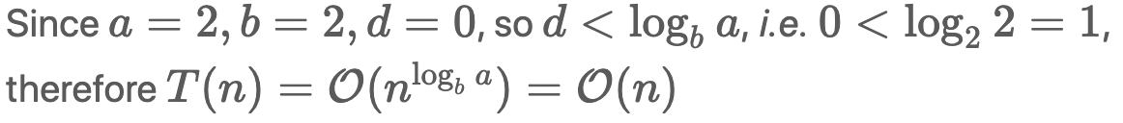

As many of you know, the time complexity for DFS recursion algorithm is indeed O(*n*), since we visit each node in the tree one by one during DFS, which is consistent with the complexity estimation obtained by applying the Master Theorem.

#### **Case 2)**

  
[Binary search](https://en.m.wikipedia.org/wiki/Binary_search_algorithm), is a search algorithm that finds the position of the target value in a ***sorted*** array. The algorithm would divide the size of the problem into halves at each iteration, and then focus on one of the halves subproblems. One can find a [similar problem here](https://leetcode.com/problems/search-in-rotated-sorted-array/).

According to the pattern, for binary search algorithm, we can figure out the values for the parameters in Master Theorem, i.e. *b*=2 (problem divided into halves), *a*=1 (only one of the subproblems needed to be solved), and *f*(*n*)=O(1) therefore *d*=0. The reason why *f*(*n*)=O(1) is twofold: 1). The effort to split the problem into halves could be constant, since the given input is a sorted array and one can refer to a range of elements simply by index without iterating through the array; 2). The effort to combine the results of subproblems is constant as well in this case, since we can simply return the result of subproblem without any further processing.

As a result, by applying the Master Theorem, we can obtain the time complexity of binary search algorithm, as follows:  
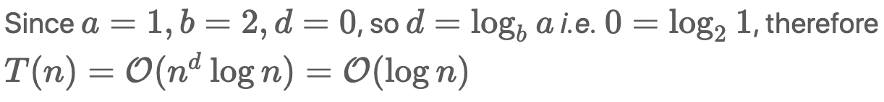  
As many of you know, the time complexity of binary search algorithm is indeed O(log*n*). Once again, the result complies with the Master Theorem.

Another example that falls into this category, is called [merge sort](https://en.m.wikipedia.org/wiki/Merge_sort), whose time complexity is O(*n*log*n*).

#### **Case 3)**

*T*(*n*)=O(*nd*)

This case is a bit tricky. Here, the efforts of dividing problems and aggregating results overweight the efforts of solving subproblems.

One of the examples that fall into this case would be the [quickselect](https://en.wikipedia.org/wiki/Quickselect), which is an algorithm that selects the kth largest/smallest element in an unsorted list (one can also find [the problem here](https://leetcode.com/problems/kth-largest-element-in-an-array/)). Similar to the binary search algorithm, quickselect algorithm partitions the input list with certain pivot, which eventually reduces the problem into a smaller scale.

Let's assume that each time the algorithm partitions the input into halves exactly, i.e. the chosen pivot is the median of the input, so its complexity can be expressed with the Master Theorem as *T*(*n*)=*T*(*n/2*​)+O(*n*), where *a*=1 since we only need to look into one of the partitions and *b*=2 since the input is divided into halves, and finally *d*=1 since it takes O(*n*) complexity to partition the input each time. As a result,  *d*=1>log2​1, it falls into the **case 3** of the Master Theorem. The case where the chosen pivot is the median of the input can be considered as the average case for the quickselect algorithm, which usually selects the pivot by random. Therefore, the expected time complexity of quickselect is O(*nd*)=O(*n*), by applying the Master Theorem.

Other cases, where the sizes of subproblems are different.

Master Theorem has its limitations though, since it only applies to the cases where the subproblems are of equal size. Now as it might come to your mind, we cannot apply the Master Theorem to the recursion algorithm for our Fibonacci number. As a reminder, here is the recurrence relation for Fibonacci number:  *F*(*n*)=*F*(*n*−1)+*F*(*n*−2), where the problem is divided into two subproblems of different size.

In this case, to estimate the time complexity, we can resort to the [Akra-Bazzi Theorem](https://en.m.wikipedia.org/wiki/Akra%E2%80%93Bazzi_method), also known as Akra-Bazzi method, which is a generalization of Master Theorem in order to deal with cases where subproblems are of different size.

### ***Further Readings***

- The original paper of Master Theorem, by [*Bentley, Jon Louis*](https://en.m.wikipedia.org/wiki/Jon_Bentley_(computer_scientist)); [*Haken, Dorothea*](https://en.m.wikipedia.org/wiki/Dorothea_Blostein); [*Saxe, James B.*](https://en.m.wikipedia.org/wiki/James_B._Saxe)(September 1980), [*"A general method for solving divide-and-conquer recurrences"*](http://www.dtic.mil/get-tr-doc/pdf?AD=ADA064294)

- [Akra-Bazzi Theorem](https://en.m.wikipedia.org/wiki/Akra%E2%80%93Bazzi_method), a generalization of Master Theorem, where subproblems can have different sizes.

## Backtracking

In this chapter, we discuss another paradigm called backtracking which is often implemented in the form of recursion.

After going through this chapter, you should be able to:

* recognise some problems that can be solved with the backtracking algorithms.
* know a [pseudocode template](https://leetcode.com/explore/learn/card/recursion-ii/472/backtracking/2793/) that could help you structure the code when implementing the backtracking algorithms.

**Backtracking**

In this article, we introduce another paradigm called backtracking, which is also often implemented in the form of recursion.

Backtracking is a general algorithm for finding all (or some) solutions to some computational problems (notably Constraint satisfaction problems or CSPs), which incrementally builds candidates to the solution and abandons a candidate ("backtracks") as soon as it determines that the candidate cannot lead to a valid solution. **[1]**

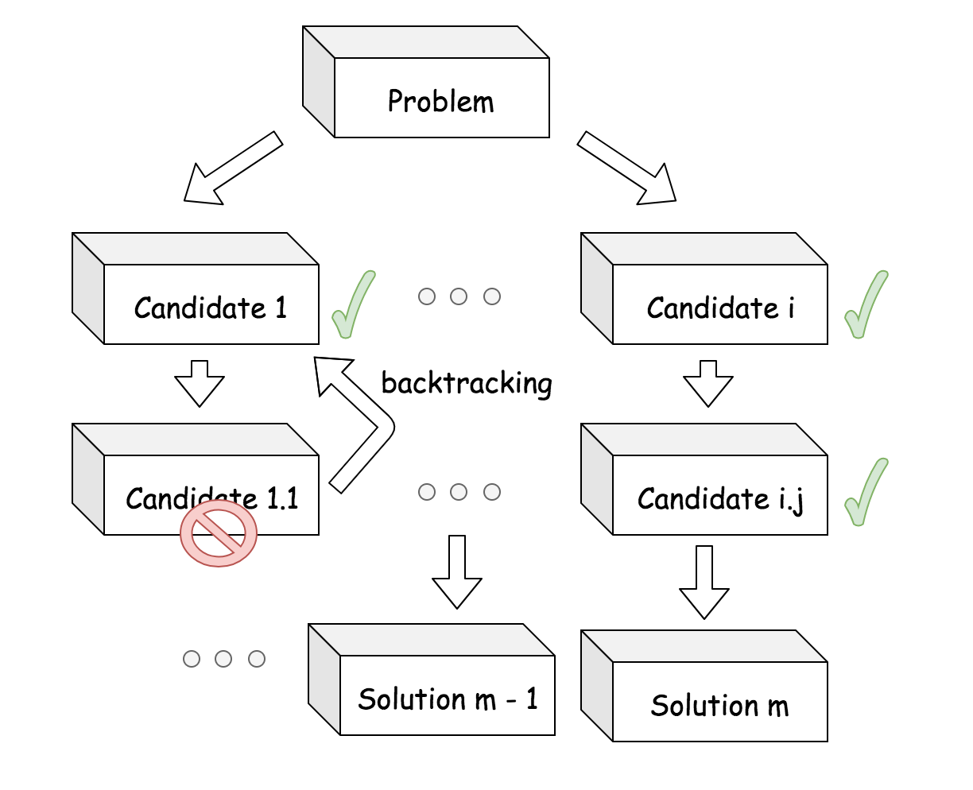

Conceptually, one can imagine the procedure of backtracking as the **tree traversal**. Starting from the root node, one sets out to search for solutions that are located at the leaf nodes. Each intermediate node represents a **partial** candidate solution that could potentially lead us to a final valid solution. At each node, we would fan out to move one step further to the final solution, i.e. we iterate the child nodes of the current node. Once we can determine if a certain node cannot possibly lead to a valid solution, we abandon the current node and **backtrack** to its parent node to explore other possibilities. It is due to this backtracking behaviour, the backtracking algorithms are often much faster than the [***brute-force search***](https://en.wikipedia.org/wiki/Brute-force_search)**[2]** algorithm, since it eliminates many unnecessary exploration.

### ***Example 1***

Let's try to understand the concept of backtracking by a very basic example. We are given a set of words represented in the form of a tree. The tree is formed such that every branch ends in a word.

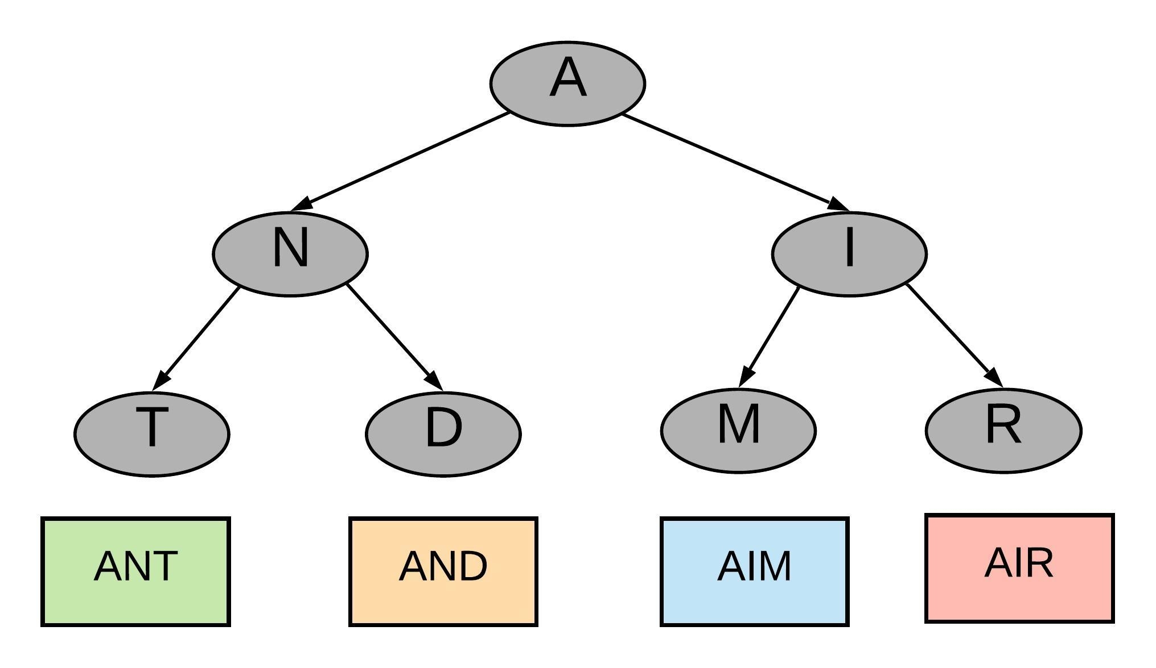

Our task is to find out if a given word is present in the tree. Let's say we have to search for the word **AIM**. A very brute way would be to go down all the paths, find out the word corresponding to a branch and compare it with what you are searching for. You will keep doing this unless you have found out the word you were looking for.

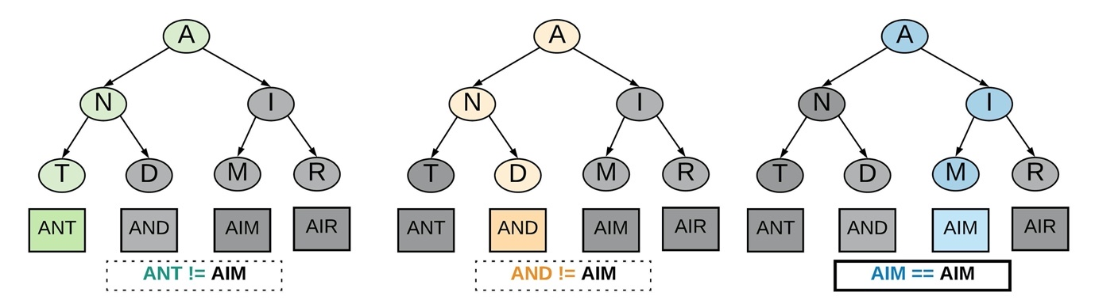

In the diagram above our brute approach made us go down the path for **ANT** and **AND** before it finally found the right branch for the word **AIM**.

The backtracking way of solving this problem would stop going down a path when the path doesn't seem right. When we say the path doesn't seem right we mean we come across a node which will never lead to the right result. As we come across such node we **back-track**. That is go back to the previous node and take the next step.

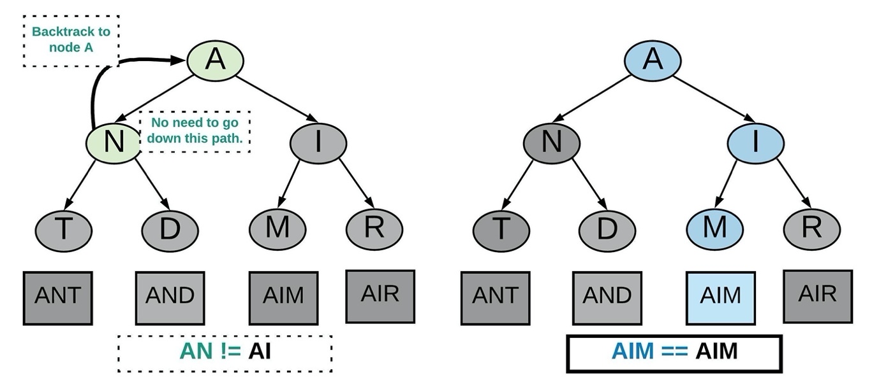

In the above diagram backtracking didn't make us go down the path from node **N**. This is because there is a mismatch we found early on and we decided to go back to the next step instead. Backtracking reduced the number of steps taken to reach the final result. This is known as **pruning** the recursion tree because we don't take unnecessary paths.

### ***Example 2***

One of the most classical problems that can be solved with the backtracking algorithm is the N-Queen puzzle.

The N-queens puzzle is the problem of placing *N* queens on an [*N*×*N*] chessboard such that no two queens can attack each other. One is asked to count the number of solutions to place the *N* queens on the board.

As a reminder, a queen can attack any piece that is situated at the same row, column or diagonal of the queue. As shown in the board below, if we place a queen at the row 1 and column 1 of the board, we then cross out all the cells that could be attached by this queen.

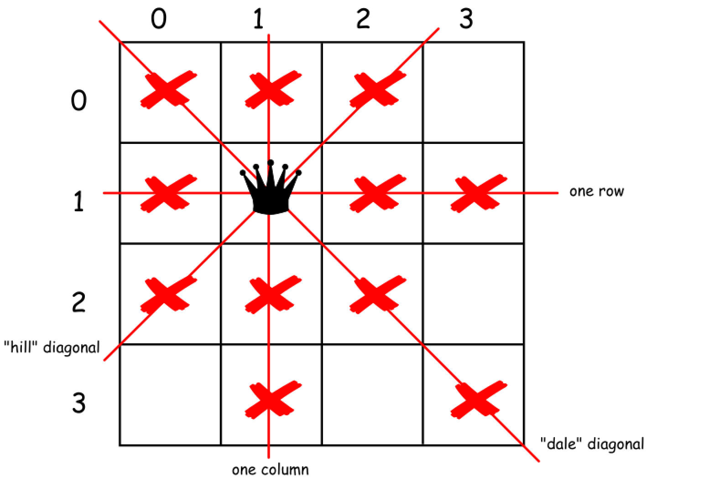

In order to count the number of possible solutions to place the N queens, we can break it down into the following steps:

        (1). Overall, we iterate over each row in the board, i.e. once we reach the last row of the board, we should have explored all the possible solutions.

        (2). At each iteration (we are located at certain row), we then further iterate over each column of the board, along the current row. At this second iteration, we then can **explore** the possibility of placing a queen on a particular cell.

        (3). Before, we place a queen on the cell with index of (row, col), we need to check if this cell is under the attacking zone of the queens that have been placed on the board before. Let us assume there is a function called is_not_under_attack(row, col) that can do the check.

        (4). Once the check passes, we then can proceed to place a queen. Along with the placement, one should also mark out the attacking zone of this newly-placed queen. Let us assume there is another function called place_queen(row, col) that can help us to do so.

        (5). As an important behaviour of backtracking, we should be able to abandon our previous decision at the moment we decide to move on to the next candidate. Let us assume there is a function called remove_queen(row, rol) that can help us to revert the decision along with the changes in step (4).

Now, with the above steps and functions, we can organize them in the form of recursion in order to implement the algorithm. In the following, we present the pseudocode of the backtracking algorithm.

|  |
| --- |
| def backtrack_nqueen(row = 0, count = 0):  for col in range(n):  # iterate through columns at the curent row.  if is_not_under_attack(row, col):  # explore this partial candidate solution, and mark the attacking zone  place_queen(row, col)  if row + 1 == n:  # we reach the bottom, i.e. we find a solution!  count += 1  else:  # we move on to the next row  count = backtrack(row + 1, count)  # backtrack, i.e. remove the queen and remove the attacking zone.  remove_queen(row, col)  return count |

By filling out those above-mentioned functions, one should be able to implement his/her own algorithm to solve the N-queen problem. **Note**: one can find the exercise of N-queen problem later in this chapter.

### ***References***

- [1]. [Backtracking](https://en.wikipedia.org/wiki/Backtracking). Wikipedia.

- [2]. [Brute-force search](https://en.wikipedia.org/wiki/Brute-force_search). Wikipedia.

**N-Queens II**

The **n-queens** puzzle is the problem of placing n queens on an n x n chessboard such that no two queens attack each other.

Given an integer n, return *the number of distinct solutions to the****n-queens puzzle***.

**Example 1:**

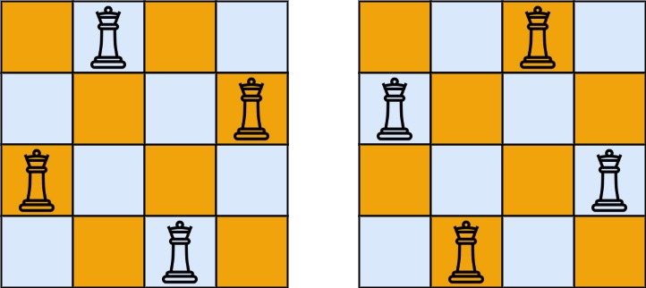

**Input:** n = 4

**Output:** 2

**Explanation:** There are two distinct solutions to the 4-queens puzzle as shown.

**Example 2:**

**Input:** n = 1

**Output:** 1

**Constraints:**

* 1 <= n <= 9

## Solution

#### **Intuition**

This problem is a classical one and it's important to know the solution to feel classy.

The first idea is to use brute-force that means to generate all possible ways to put N queens on the board, and then check them to keep only the combinations with no queen under attack. That means O(N^N) time complexity and hence we're forced to think further how to optimize.

There are two programming conceptions here which could help.

The first one is called constrained programming.

That basically means to put restrictions after each queen placement. One puts a queen on the board and that immediately excludes one column, one row and two diagonals for the further queens placement. That propagates constraints and helps to reduce the number of combinations to consider.

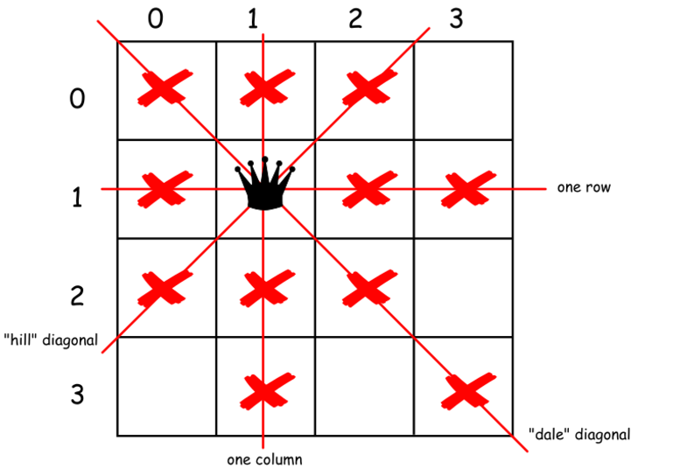

The second one called backtracking.

Let's imagine that one puts several queens on the board so that they don't attack each other. But the combination chosen is not the optimal one and there is no place for the next queen. What to do? To backtrack. That means to come back, to change the position of the previously placed queen and try to proceed again. If that would not work either, backtrack again.

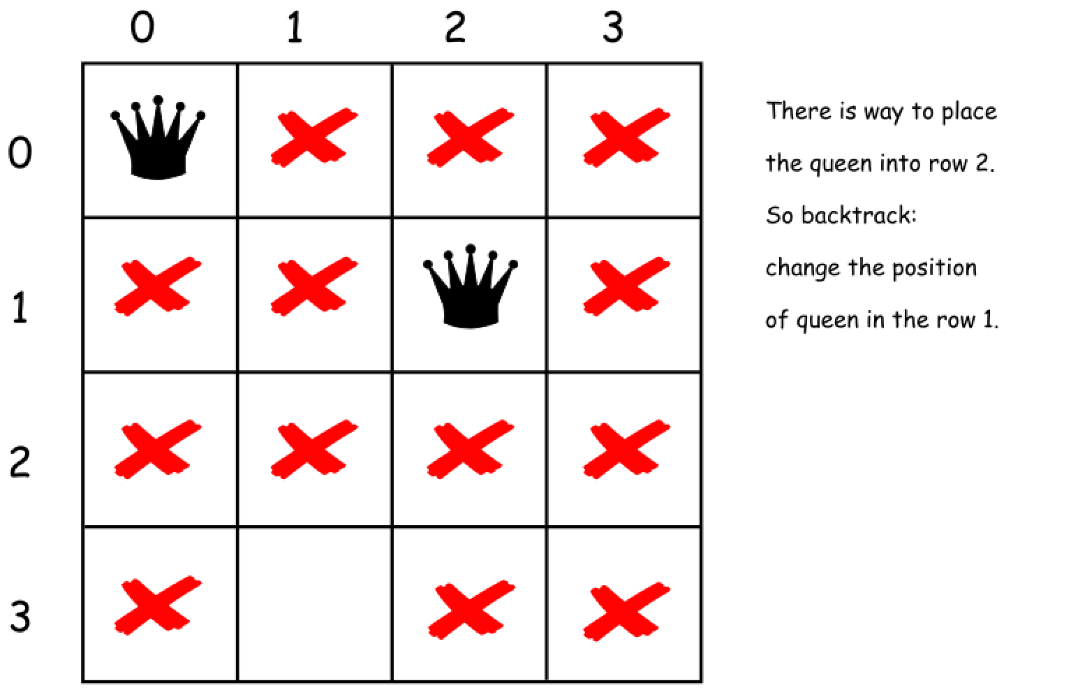

#### **Approach 1: Backtracking**

Before to construct the algorithm, let's figure out two tips that could help.

There could be the only one queen in a row and the only one queen in a column.

That means that there is no need to consider all squares on the board. One could just iterate over the columns.

For all "hill" diagonals row + column = const, and for all "dale" diagonals row - column = const.

That would allow us to mark the diagonals which are already under attack and to check if a given square (row, column) is under attack.

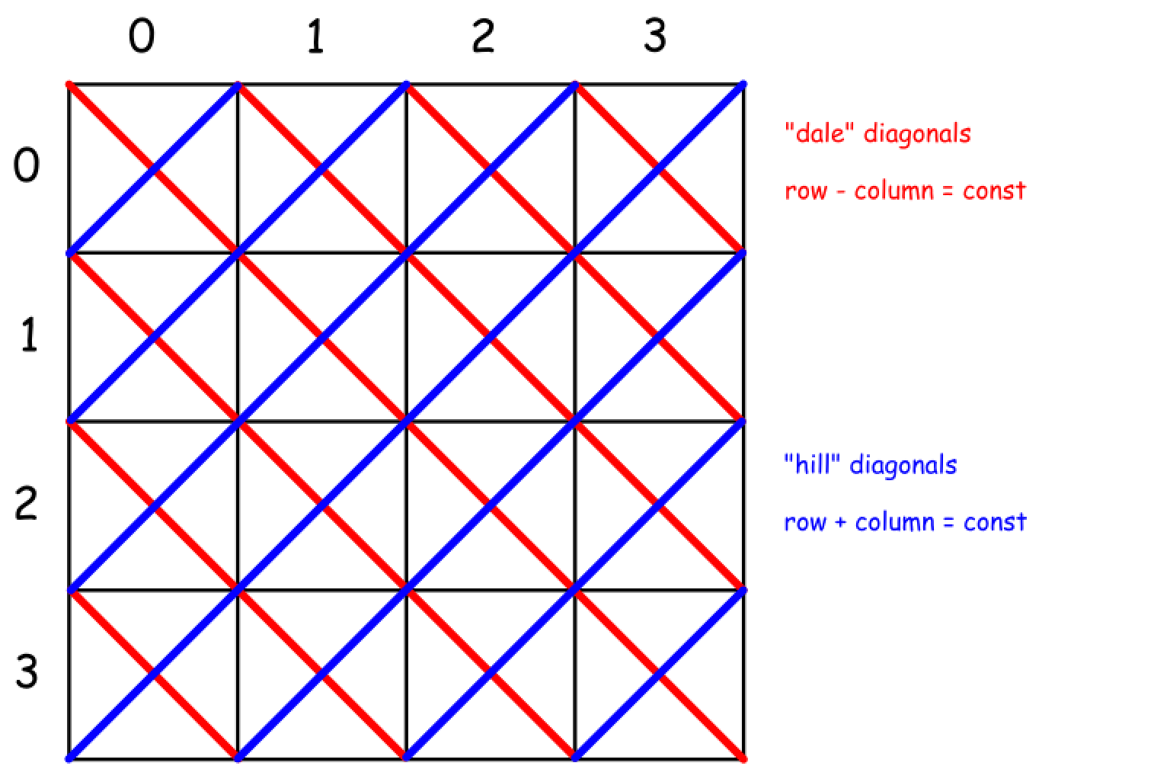

Now everything is ready to write down the backtrack function backtrack(row = 0, count = 0).

* Start from the first row = 0.
* Iterate over the columns and try to put a queen in each column.
  + If square (row, column) is not under attack
    - Place the queen in (row, column) square.
    - Exclude one row, one column and two diagonals from further consideration.
    - If all rows are filled up row == N
      * That means that we find out one more solution count++.
    - Else
      * Proceed to place further queens backtrack(row + 1, count).
    - Now backtrack : remove the queen from (row, column) square.

Here is a straightforward implementation of the above algorithm.

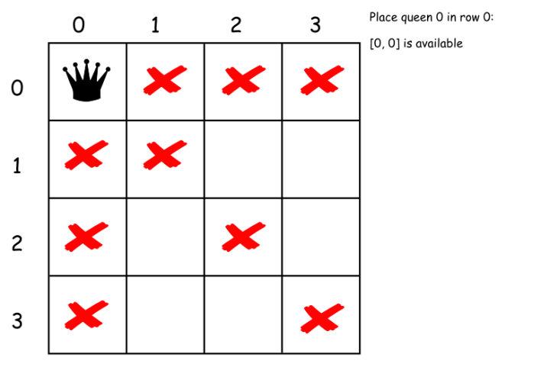

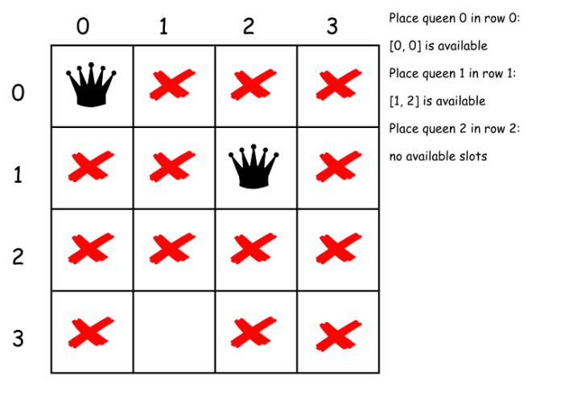

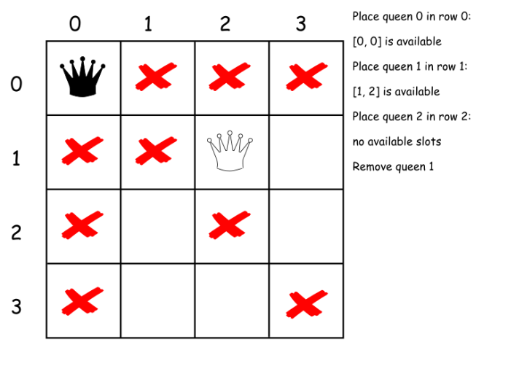

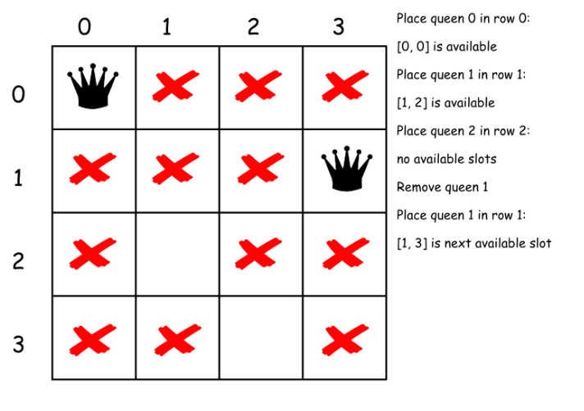

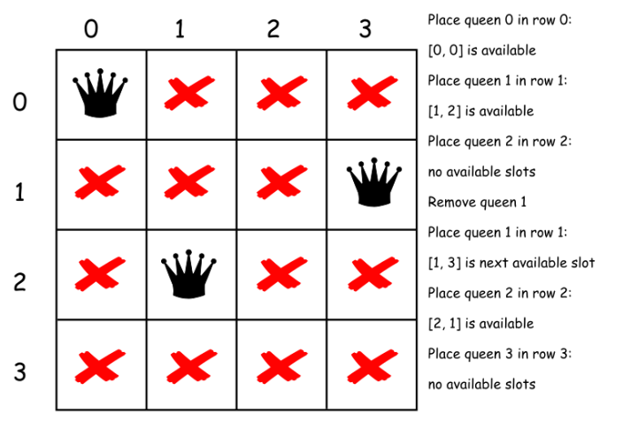

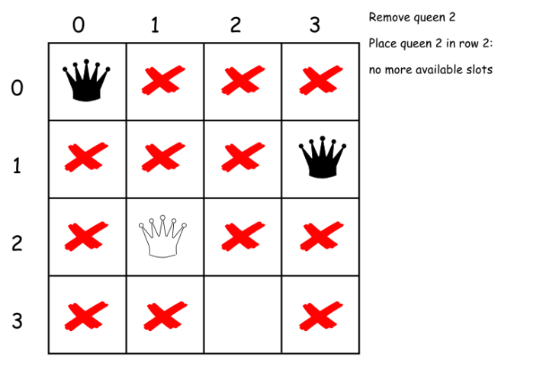

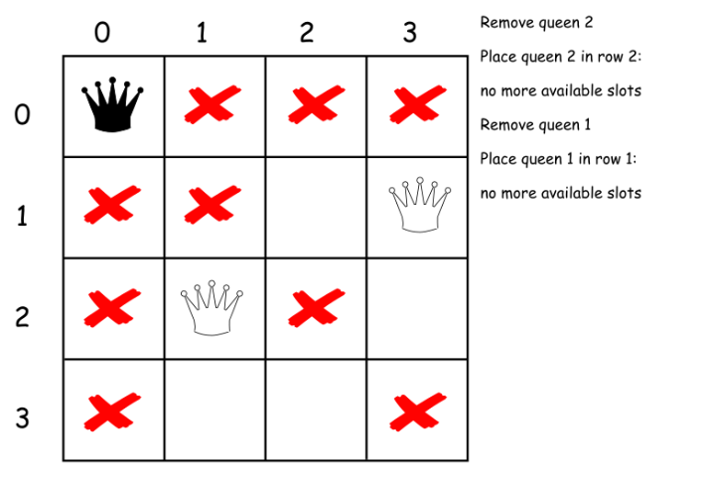

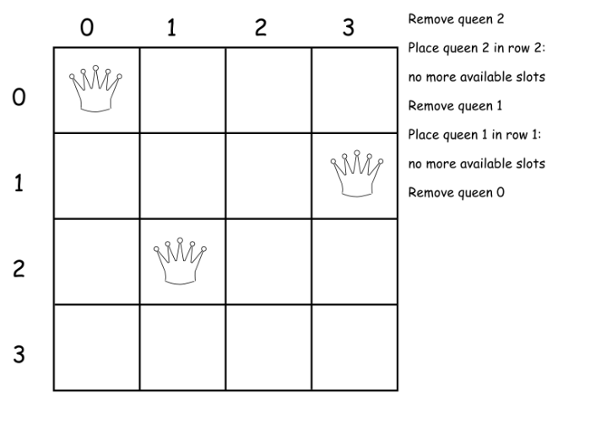

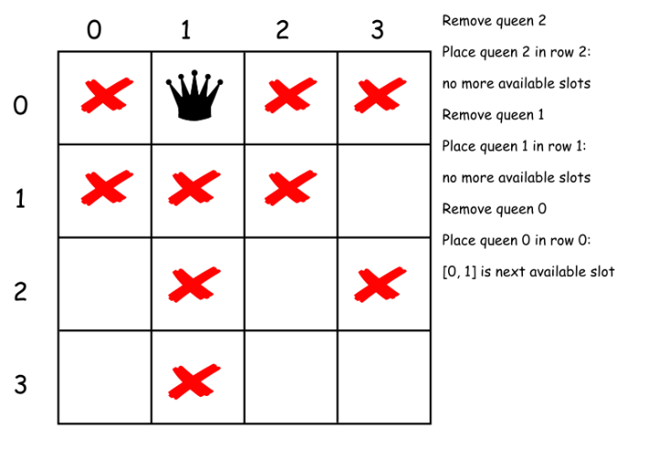

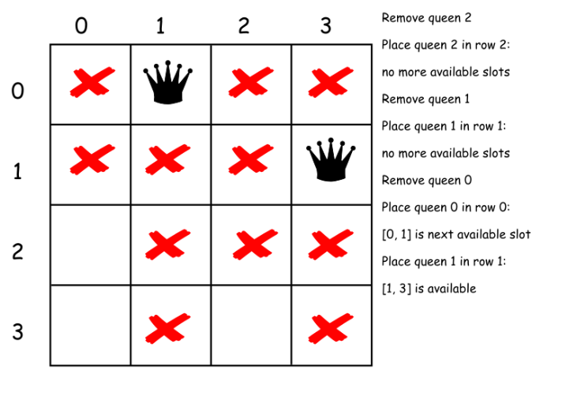

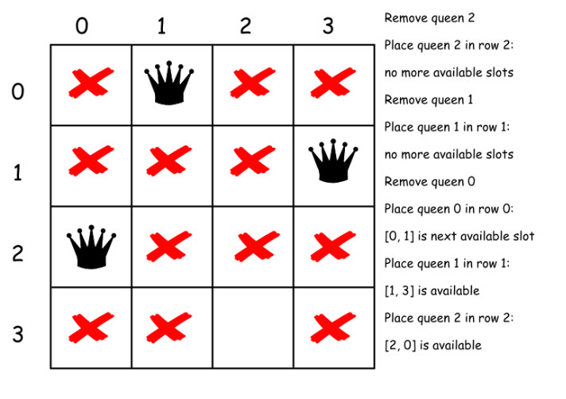

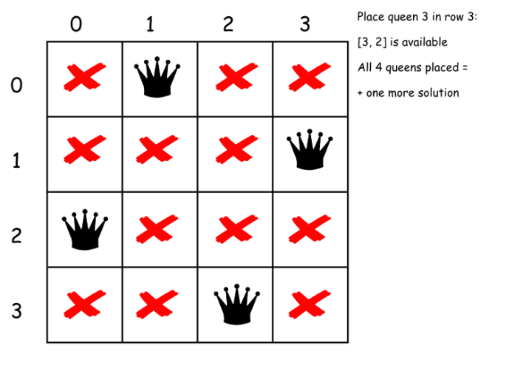

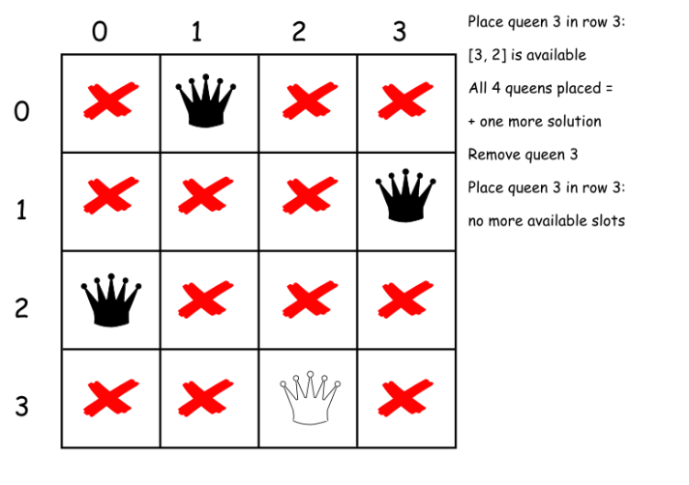

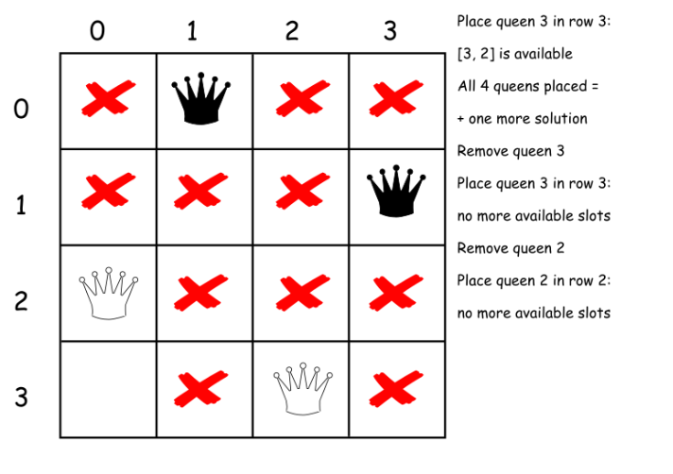

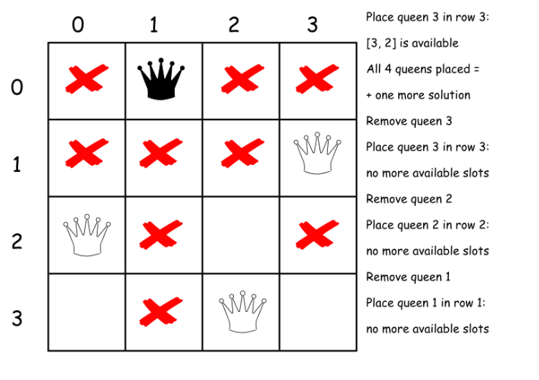

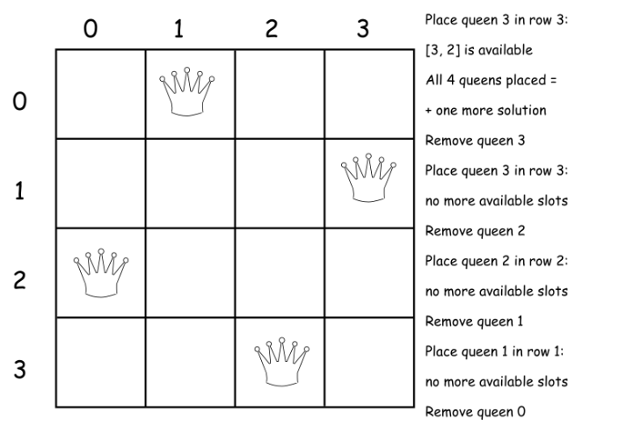

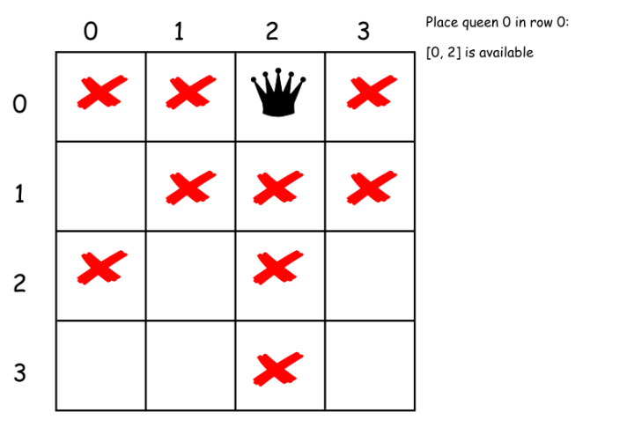

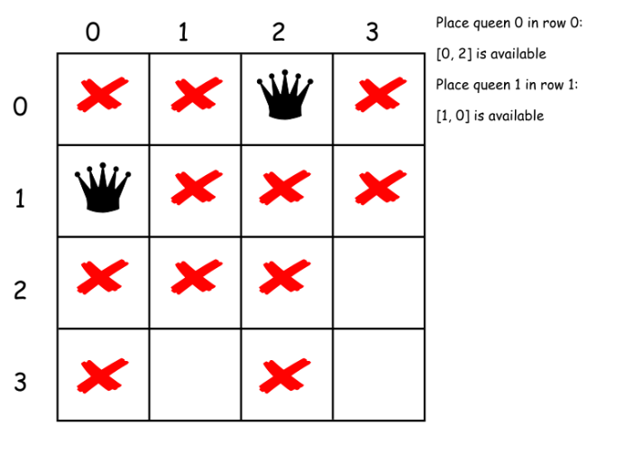

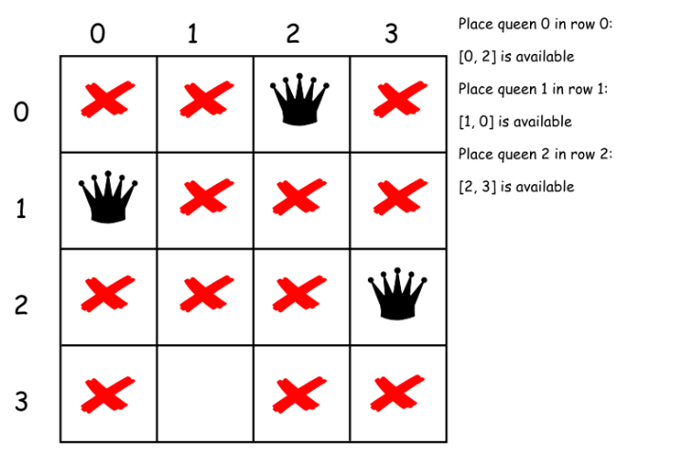

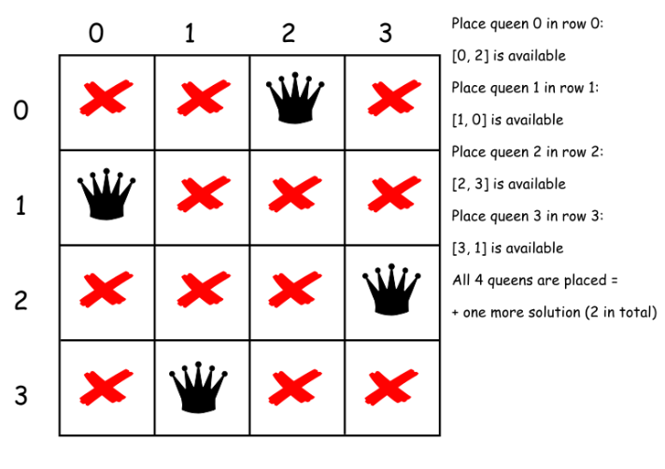

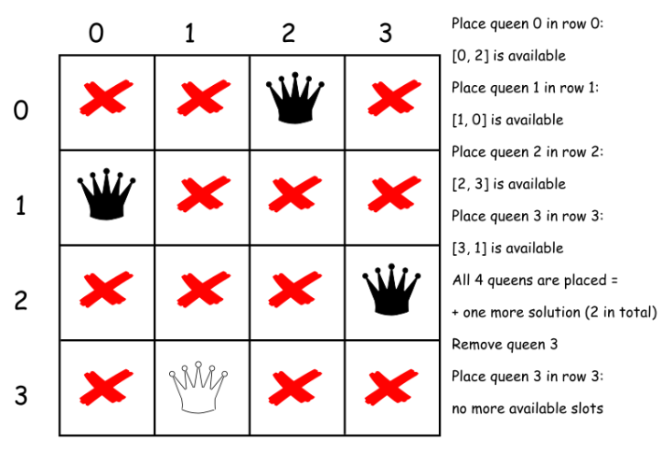

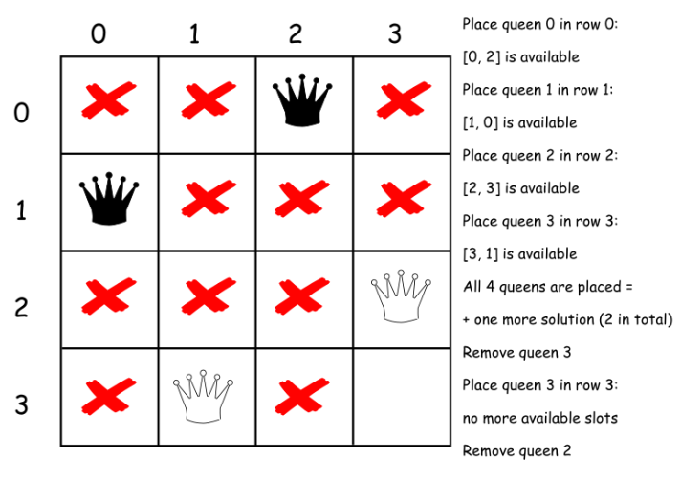

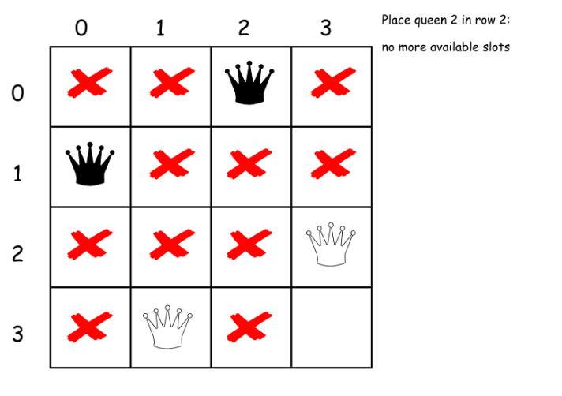

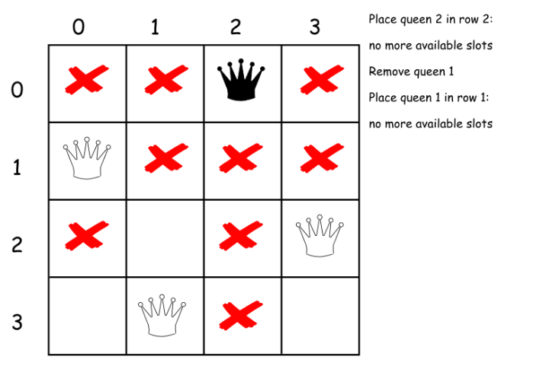

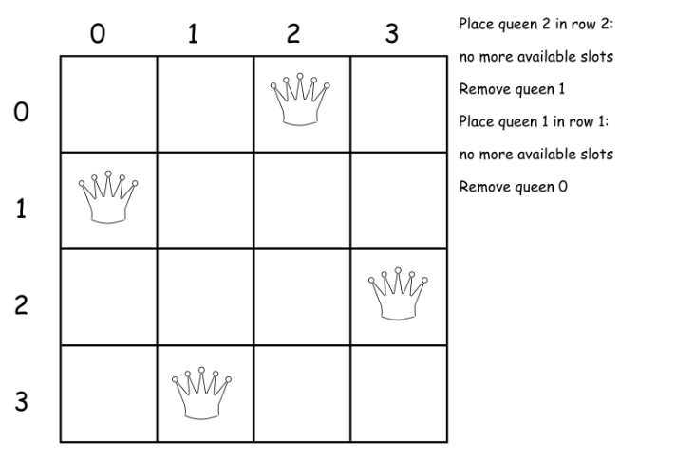

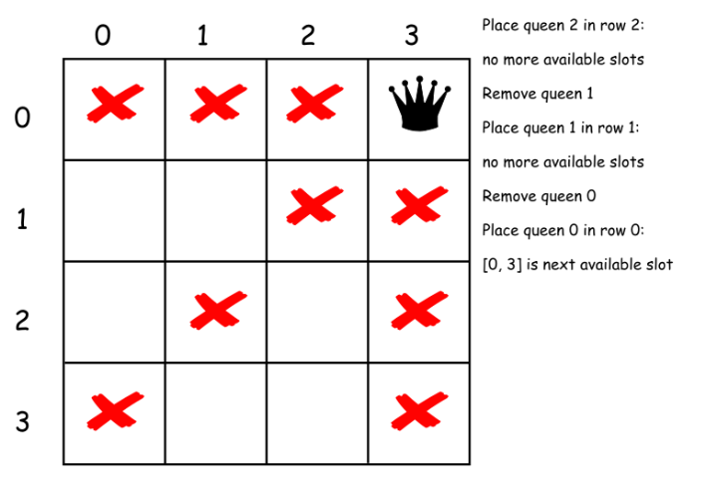

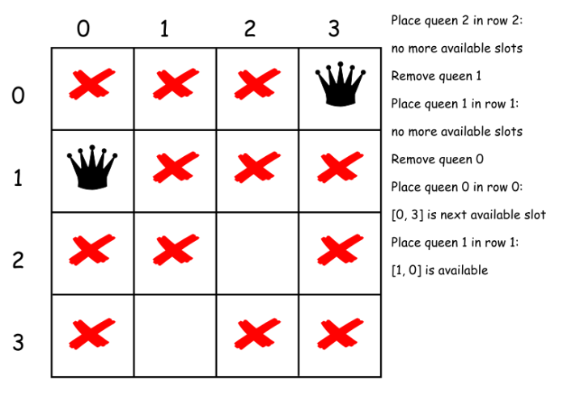

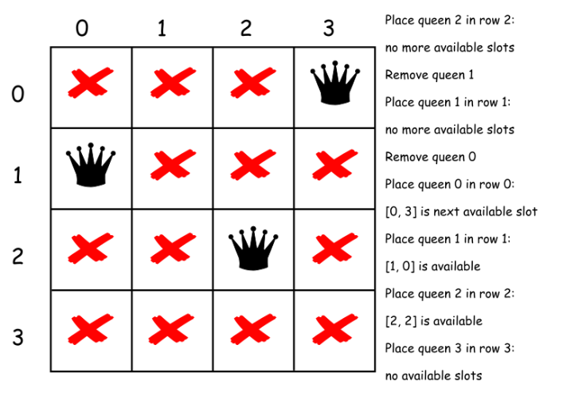

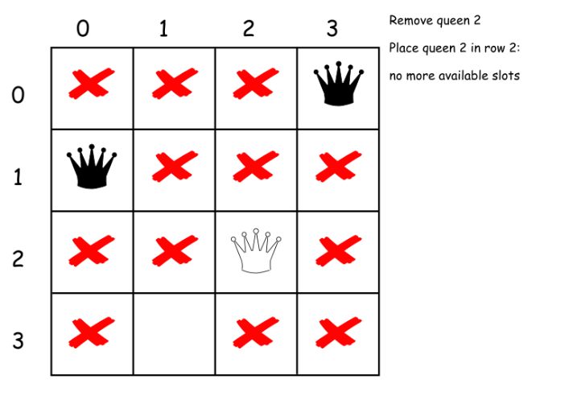

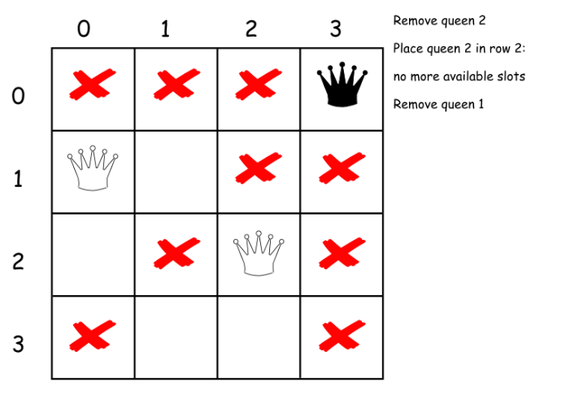

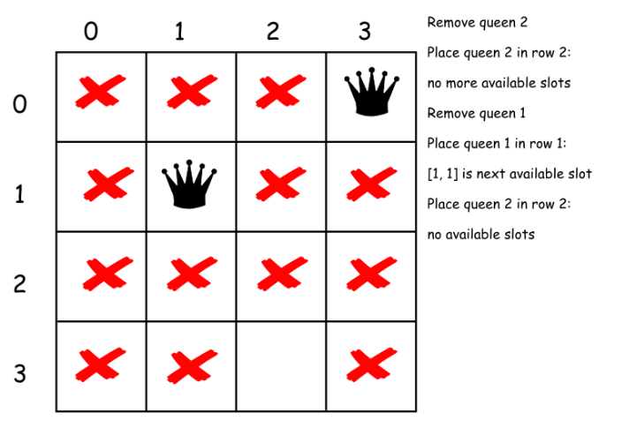

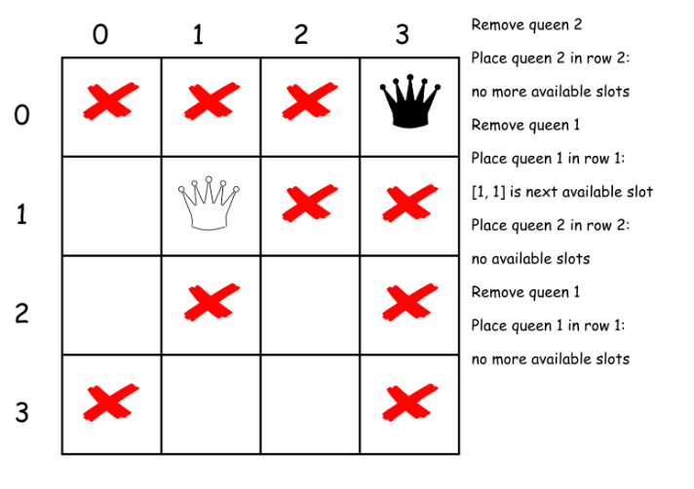

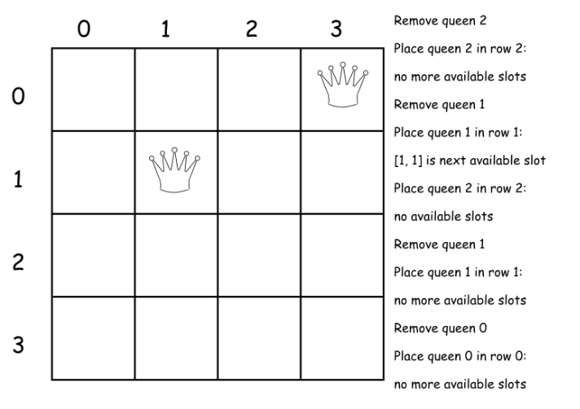

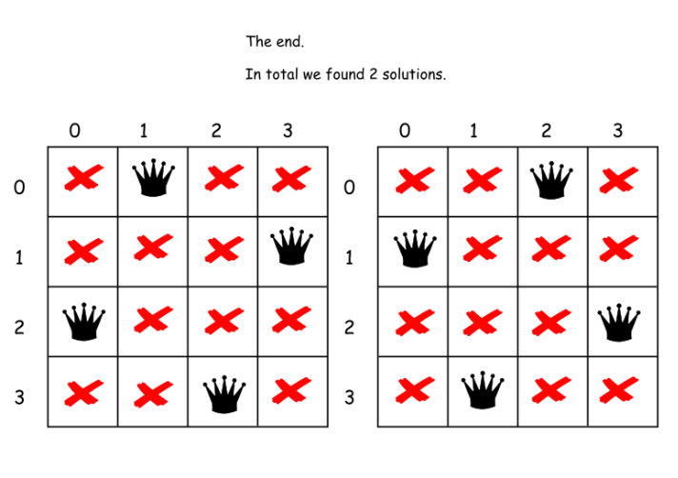

|  |
| --- |
| class Solution {  public boolean is_not_under_attack(int row, int col, int n,  int [] rows,  int [] hills,  int [] dales) {  int res = rows[col] + hills[row - col + 2 * n] + dales[row + col];  return (res == 0) ? true : false;  }  public int backtrack(int row, int count, int n,  int [] rows,  int [] hills,  int [] dales) {  for (int col = 0; col < n; col++) {  if (is_not_under_attack(row, col, n, rows, hills, dales)) {  // place_queen  rows[col] = 1;  hills[row - col + 2 * n] = 1; // "hill" diagonals  dales[row + col] = 1; //"dale" diagonals  // if n queens are already placed  if (row + 1 == n) count++;  // if not proceed to place the rest  else count = backtrack(row + 1, count, n,  rows, hills, dales);  // remove queen  rows[col] = 0;  hills[row - col + 2 * n] = 0;  dales[row + col] = 0;  }  }  return count;  }  public int totalNQueens(int n) {  int rows[] = new int[n];  // "hill" diagonals  int hills[] = new int[4 * n - 1];  // "dale" diagonals  int dales[] = new int[2 * n - 1];  return backtrack(0, 0, n, rows, hills, dales);  }  } |

**Complexity Analysis**

* Time complexity : O(*N*!). There is N possibilities to put the first queen, not more than N (N - 2) to put the second one, not more than N(N - 2)(N - 4) for the third one etc. In total that results in O(*N*!) time complexity.
* Space complexity : O(*N*) to keep an information about diagonals and rows.

#### **Approach 2: Backtracking via bitmap**

If you're on the interview - use the approach 1.

The next algorithm has the same time complexity O(*N*!) but works the way faster because of [bitwise operators usage](https://wiki.python.org/moin/BitwiseOperators). Kudos for this algorithm go to [takaken](http://www.ic-net.or.jp/home/takaken/e/queen/).

To facilitate the understanding of the algorithm, here is the code with step by step explanations.

|  |
| --- |
| class Solution {  public int backtrack(int row, int hills, int next_row, int dales, int count, int n) {  /**  row: current row to place the queen  hills: "hill" diagonals occupation [1 = taken, 0 = free]  next_row: free and taken slots for the next row [1 = taken, 0 = free]  dales: "dale" diagonals occupation [1 = taken, 0 = free]  count: number of all possible solutions  */  // all columns available for this board,  // i.e. n times '1' in binary representation  // bin(cols) = 0b1111 for n = 4, bin(cols) = 0b111 for n = 3  // [1 = available]  int columns = (1 << n) - 1;  if (row == n) // if all n queens are already placed  count++; // we found one more solution  else {  // free columns in the current row  // ! 0 and 1 are inversed with respect to hills, next_row and dales  // [0 = taken, 1 = free]  int free_columns = columns & ~(hills | next_row | dales);  // while there's still a column to place next queen  while (free_columns != 0) {  // the first bit '1' in a binary form of free_columns  // on this column we will place the current queen  int curr_column = - free_columns & free_columns;  // place the queen  // and exclude the column where the queen is placed  free_columns ^= curr_column;  count = backtrack(row + 1,  (hills | curr_column) << 1,  next_row | curr_column,  (dales | curr_column) >> 1,  count, n);  }  }  return count;  }  public int totalNQueens(int n) {  return backtrack(0, 0, 0, 0, 0, n);  }  } |

**Complexity Analysis**

* Time complexity : O(*N*!).
* Space complexity : O(*N*).

**Backtracking Template**

In this article, we will present you a pseudocode template that summarizes some common patterns for the backtracking algorithms. Furthermore, we will demonstrate with some concrete examples on how to apply the template.

### ***Template***

With the N-queen example as we presented in the previous article, one might have noticed some patterns about the backtracking algorithm. In the following, we present you a pseudocode template, which could help you to clarify the idea and structure the code when implementing the backtracking algorithms.

|  |
| --- |
| def backtrack(candidate):  if find_solution(candidate):  output(candidate)  return    # iterate all possible candidates.  for next_candidate in list_of_candidates:  if is_valid(next_candidate):  # try this partial candidate solution  place(next_candidate)  # given the candidate, explore further.  backtrack(next_candidate)  # backtrack  remove(next_candidate) |

Here are a few notes about the above pseudocode.

* Overall, the enumeration of candidates is done in two levels: 1). at the first level, the function is implemented as recursion. At each occurrence of recursion, the function is one step further to the final solution.  2). as the second level, within the recursion, we have an iteration that allows us to explore all the candidates that are of the same progress to the final solution.
* The backtracking should happen at the level of the iteration within the recursion.
* Unlike brute-force search, in backtracking algorithms we are often able to determine if a partial solution candidate is worth exploring further (i.e. is_valid(next_candidate)), which allows us to prune the search zones. This is also known as the constraint, e.g. the attacking zone of queen in N-queen game.
* There are two symmetric functions that allow us to mark the decision (place(candidate)) and revert the decision (remove(candidate)).

In the next sections, we show some concrete examples and explain how to apply the above pseudocode template.

### ***Robot Room Cleaner***

Given a room that is represented as a grid of cells, where each cell contains a value that indicates whether it is an obstacle or not, we are asked to clean the room with a robot cleaner which can turn in four directions and move one step at a time.

This is a typical problem that can be solved with the backtracking paradigm, as many of you might have figured out from the description of the problem.

Before diving into the algorithm, to facilitate the explanation, we plot a figure below with the grid of room and the movements of robot. As one can see, the robot is denoted as the red dot and each step that the robot takes is marked as a footprint.

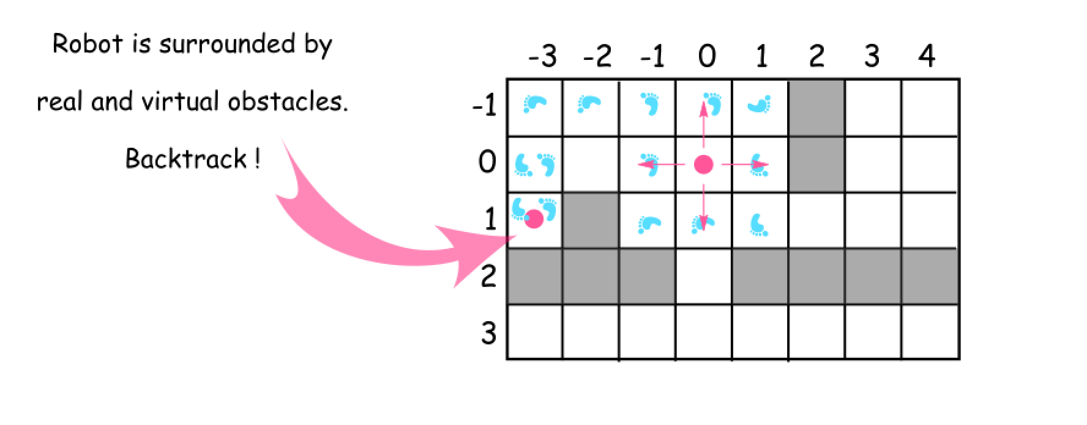

Fig 1. Robot Room Cleaner

We give the general idea below on how one can apply the above pseudocode template to implement a backtracking algorithm.

- [1]. One can model each step of the robot as a recursive function (i.e. backtrack()).

- [2]. At each step, technically the robot would have four candidates of direction to explore, e.g. the robot located at the coordinate of (0, 0). Since not each direction is available though, one should check if the cell in the given direction is an obstacle or it has been cleaned before, i.e. is_valid(candidate). Another benefit of the check is that it would greatly reduce the number of possible paths that one needs to explore.

- [3]. Once the robot decides to explore the cell in certain direction, the robot should mark its decision (i.e. place(candidate)). More importantly, later the robot should be able to revert the previous decision (i.e. remove(candidate)), by going back to the cell and restore its original direction.

- [4]. The robot conducts the cleaning step by step, in the form of recursion of the backtrack() function. The backtracking would be triggered whenever the robot reaches a point that it is surrounded either by the obstacles (e.g. cell at the row 1 and the column -3) or the cleaned cells. At the end of the backtracking, the robot would get back to the its starting point, and each cell in the grid would be traversed at least once. As a result, the room is cleaned at the end.

### ***Sudoku Solver***

Sudoku is a popular game that many of you are familiar with. The main idea of the game is to fill a grid with only the numbers from 1 to 9, while ensuring that each row and each column as well as each sub-grid of 9 elements does not contain duplicate numbers.

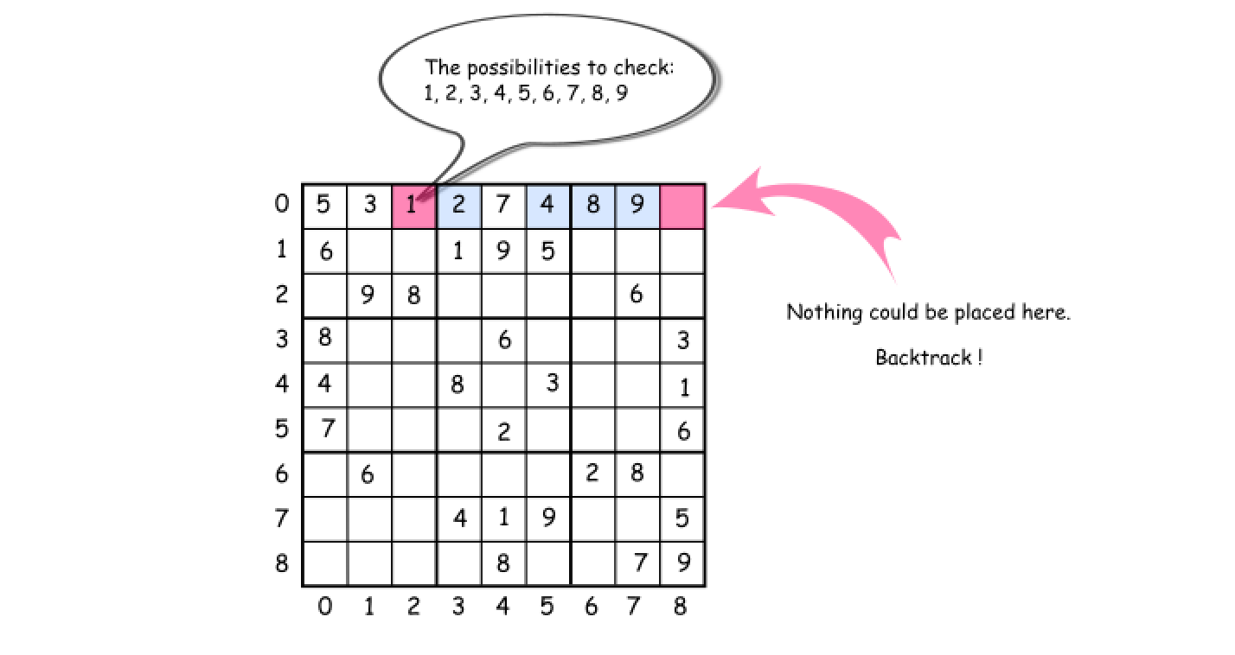

Fig 2. Sudoku Game

Once again, from the description of the Sudoku problem, one might have noticed the characteristics that hint on the solution of backtracking, such as the recursive nature of problem, a number of candidate solutions and some rules to filter out the candidates etc.

Indeed, we could solve the problem with the paradigm of backtracking. We break down on how to apply the backtracking template to implement a sudoku solver in the following.

- [1]. Given a grid with some pre-filled numbers, the task is to fill the empty cells with the numbers that meet the constraint of Sudoku game. We could model the each step to fill an empty cell as a recursion function (i.e. our famous backtrack() function).

- [2]. At each step, technically we have 9 candidates at hand to fill the empty cell. Yet, we could filter out the candidates by examining if they meet the rules of the Sudoku game, (i.e. is_valid(candidate)).

- [3]. Then, among all the suitable candidates, we can try out one by one by filling the cell (i.e. place(candidate)). Later we can revert our decision (i.e. remove(candidate)), so that we could try out the other candidates.

- [4]. The solver would carry on one step after another, in the form of recursion by the backtrack function. The backtracking would be triggered at the points where either the solver cannot find any suitable candidate (as shown in the above figure), or the solver finds a solution to the problem. At the end of the backtracking, we would enumerate all the possible solutions to the Sudoku game.

***Note:*** one can find the exercises to the above example within this chapter. One can try out the exercises with the above pseudocode template.

**Robot Room Cleaner**

Given a robot cleaner in a room modeled as a grid.

Each cell in the grid can be empty or blocked.

The robot cleaner with 4 given APIs can move forward, turn left or turn right. Each turn it made is 90 degrees.

When it tries to move into a blocked cell, its bumper sensor detects the obstacle and it stays on the current cell.

Design an algorithm to clean the entire room using only the 4 given APIs shown below.

interface Robot {

  // returns true if next cell is open and robot moves into the cell.

  // returns false if next cell is obstacle and robot stays on the current cell.

  boolean move();

// Robot will stay on the same cell after calling turnLeft/turnRight.

  // Each turn will be 90 degrees.

  void turnLeft();

  void turnRight();

// Clean the current cell.

void clean();

}

**Example:**

**Input:**

room = [

[1,1,1,1,1,0,1,1],

[1,1,1,1,1,0,1,1],

[1,0,1,1,1,1,1,1],

[0,0,0,1,0,0,0,0],

[1,1,1,1,1,1,1,1]

],

row = 1,

col = 3

**Explanation:**

All grids in the room are marked by either 0 or 1.

0 means the cell is blocked, while 1 means the cell is accessible.

The robot initially starts at the position of row=1, col=3.

From the top left corner, its position is one row below and three columns right.

**Notes:**

1. The input is only given to initialize the room and the robot's position internally. You must solve this problem "blindfolded". In other words, you must control the robot using only the mentioned 4 APIs, without knowing the room layout and the initial robot's position.
2. The robot's initial position will always be in an accessible cell.
3. The initial direction of the robot will be facing up.
4. All accessible cells are connected, which means the all cells marked as 1 will be accessible by the robot.
5. Assume all four edges of the grid are all surrounded by wall.

## Solution

#### **Approach 1: Spiral Backtracking**

**Concepts to use**

Let's use here two programming concepts.

The first one is called constrained programming.

That basically means to put restrictions after each robot move. Robot moves, and the cell is marked as visited. That propagates constraints and helps to reduce the number of combinations to consider.

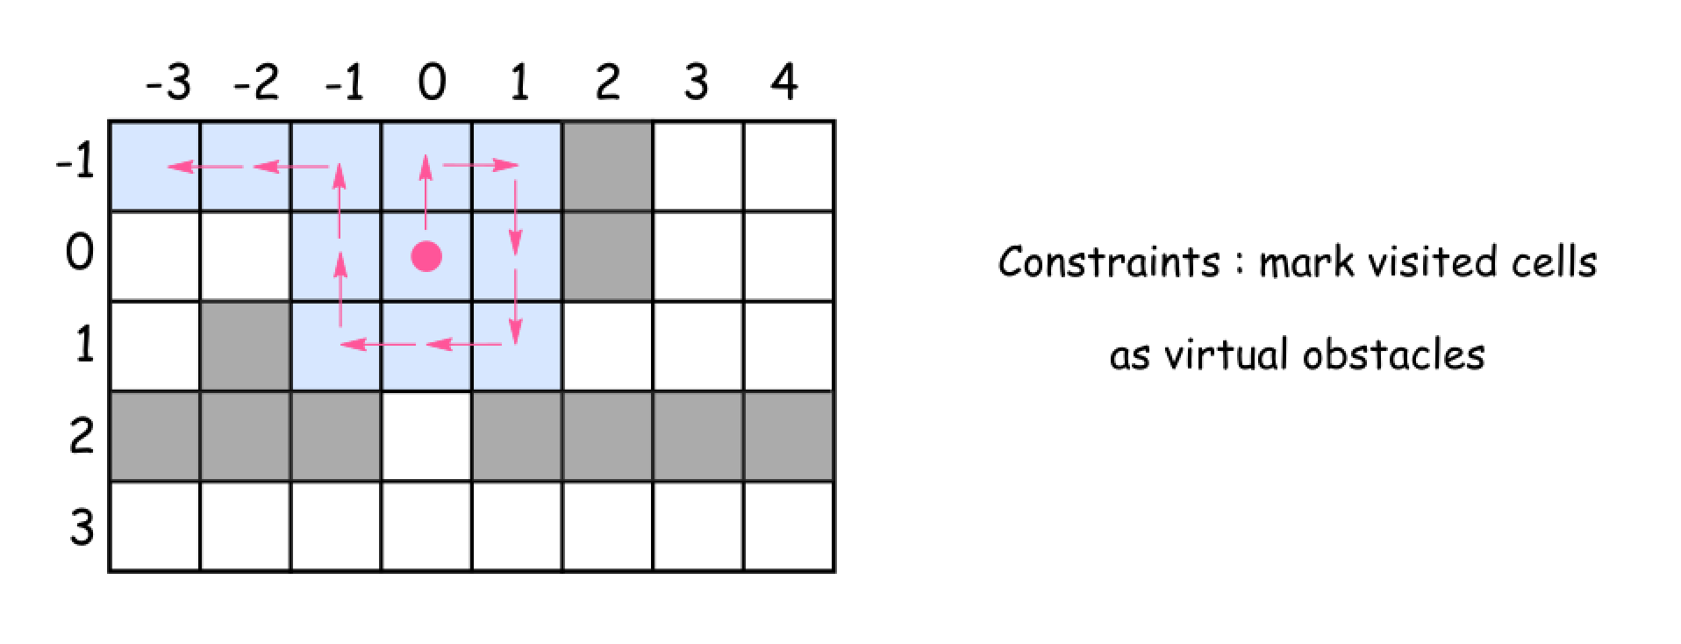

The second one called backtracking.

Let's imagine that after several moves the robot is surrounded by the visited cells. But several steps before there was a cell which proposed an alternative path to go. That path wasn't used and hence the room is not yet cleaned up. What to do? To backtrack. That means to come back to that cell, and to explore the alternative path.

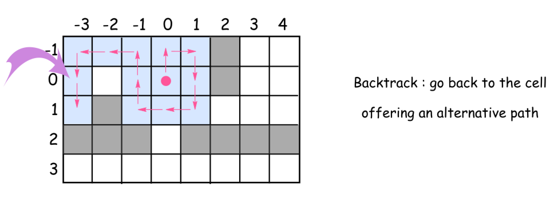

**Intuition**

This solution is based on the same idea as maze solving algorithm called [right-hand rule](https://en.wikipedia.org/wiki/Maze_solving_algorithm#Wall_follower). Go forward, cleaning and marking all the cells on the way as visited. At the obstacle turn right, again go forward, etc. Always turn right at the obstacles and then go forward. Consider already visited cells as virtual obstacles.

What do do if after the right turn there is an obstacle just in front ?

Turn right again.

How to explore the alternative paths from the cell ?

Go back to that cell and then turn right from your last explored direction.

When to stop ?

Stop when you explored all possible paths, i.e. all 4 directions (up, right, down, and left) for each visited cell.

**Algorithm**

Time to write down the algorithm for the backtrack function backtrack(cell = (0, 0), direction = 0).

* Mark the cell as visited and clean it up.
* Explore 4 directions : up, right, down, and left (the order is important since the idea is always to turn right) :
  + Check the next cell in the chosen direction :
    - If it's not visited yet and there is no obtacles :
      * Move forward.
      * Explore next cells backtrack(new_cell, new_direction).
      * Backtrack, i.e. go back to the previous cell.
    - Turn right because now there is an obstacle (or a virtual obstacle) just in front.

**Implementation**

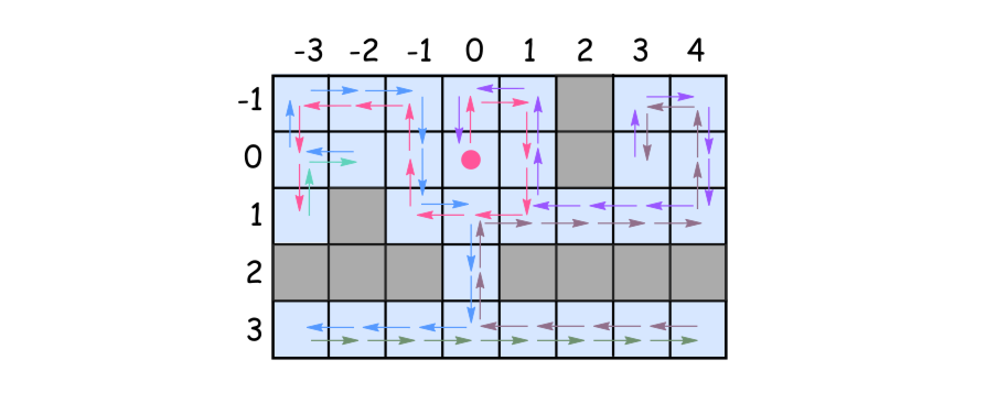

|  |
| --- |
| class Solution {  // going clockwise : 0: 'up', 1: 'right', 2: 'down', 3: 'left'  int[][] directions = {{-1, 0}, {0, 1}, {1, 0}, {0, -1}};  Set<Pair<Integer, Integer>> visited = new HashSet();  Robot robot;  public void goBack() {  robot.turnRight();  robot.turnRight();  robot.move();  robot.turnRight();  robot.turnRight();  }  public void backtrack(int row, int col, int d) {  visited.add(new Pair(row, col));  robot.clean();  // going clockwise : 0: 'up', 1: 'right', 2: 'down', 3: 'left'  for (int i = 0; i < 4; ++i) {  int newD = (d + i) % 4;  int newRow = row + directions[newD][0];  int newCol = col + directions[newD][1];  if (!visited.contains(new Pair(newRow, newCol)) && robot.move()) {  backtrack(newRow, newCol, newD);  goBack();  }  // turn the robot following chosen direction : clockwise  robot.turnRight();  }  }  public void cleanRoom(Robot robot) {  this.robot = robot;  backtrack(0, 0, 0);  }  } |

**Complexity Analysis**

* Time complexity : O(*N*−*M*), where *N* is a number of cells in the room and *M* is a number of obstacles.
  + We visit each non-obstacle cell once and only once.
  + At each visit, we will check 4 directions around the cell. Therefore, the total number of operations would be 4⋅(*N*−*M*).
* Space complexity : O(*N*−*M*), where N*N* is a number of cells in the room and *M* is a number of obstacles.
  + We employed a hashtable to keep track of whether a non-obstacle cell is visited or not.

**Sudoku Solver**

Write a program to solve a Sudoku puzzle by filling the empty cells.

A sudoku solution must satisfy **all of the following rules**:

1. Each of the digits 1-9 must occur exactly once in each row.
2. Each of the digits 1-9 must occur exactly once in each column.
3. Each of the digits 1-9 must occur exactly once in each of the 9 3x3 sub-boxes of the grid.

The '.' character indicates empty cells.

**Example 1:**

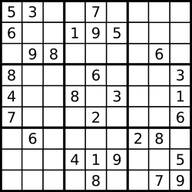

**Input:** board = [["5","3",".",".","7",".",".",".","."],["6",".",".","1","9","5",".",".","."],[".","9","8",".",".",".",".","6","."],["8",".",".",".","6",".",".",".","3"],["4",".",".","8",".","3",".",".","1"],["7",".",".",".","2",".",".",".","6"],[".","6",".",".",".",".","2","8","."],[".",".",".","4","1","9",".",".","5"],[".",".",".",".","8",".",".","7","9"]]

**Output:** [["5","3","4","6","7","8","9","1","2"],["6","7","2","1","9","5","3","4","8"],["1","9","8","3","4","2","5","6","7"],["8","5","9","7","6","1","4","2","3"],["4","2","6","8","5","3","7","9","1"],["7","1","3","9","2","4","8","5","6"],["9","6","1","5","3","7","2","8","4"],["2","8","7","4","1","9","6","3","5"],["3","4","5","2","8","6","1","7","9"]]

**Explanation:** The input board is shown above and the only valid solution is shown below:

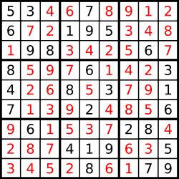

**Constraints:**

* board.length == 9
* board[i].length == 9
* board[i][j] is a digit or '.'.
* It is **guaranteed** that the input board has only one solution.

## Solution

#### **Approach 0: Brute Force**

The first idea is to use brut-force to generate all possible ways to fill the cells with numbers from 1 to 9, and then check them to keep the solution only. That means 9^{81} operations to do, where 9 is a number of available digits and 81 is a number of cells to fill. Hence we're forced to think further how to optimize.

#### **Approach 1: Backtracking**

**Conceptions to use**

There are two programming conceptions here which could help.

The first one is called constrained programming.

That basically means to put restrictions after each number placement. One puts a number on the board and that immediately excludes this number from further usage in the current row, column and sub-box. That propagates constraints and helps to reduce the number of combinations to consider.

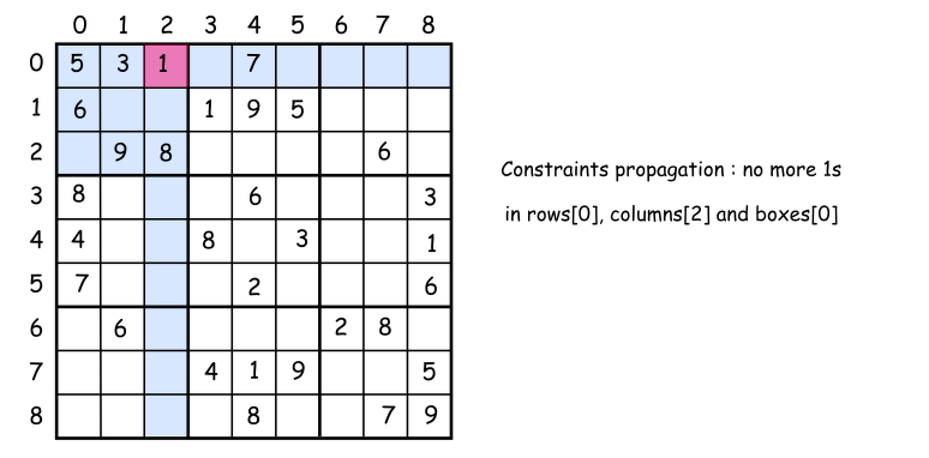

The second one called backtracking.

Let's imagine that one has already managed to put several numbers on the board. But the combination chosen is not the optimal one and there is no way to place the further numbers. What to do? To backtrack. That means to come back, to change the previously placed number and try to proceed again. If that would not work either, backtrack again.

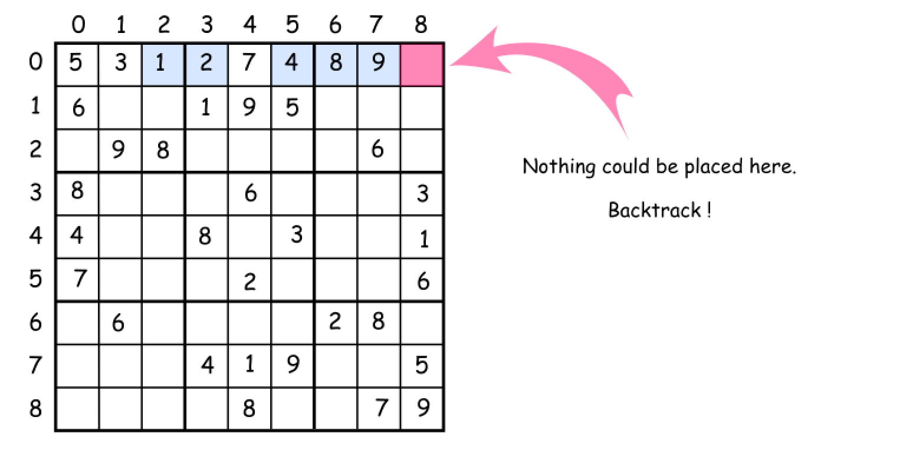

**How to enumerate sub-boxes**

One tip to enumerate sub-boxes: let's use box_index = (row / 3) * 3 + column / 3 where / is an integer division.

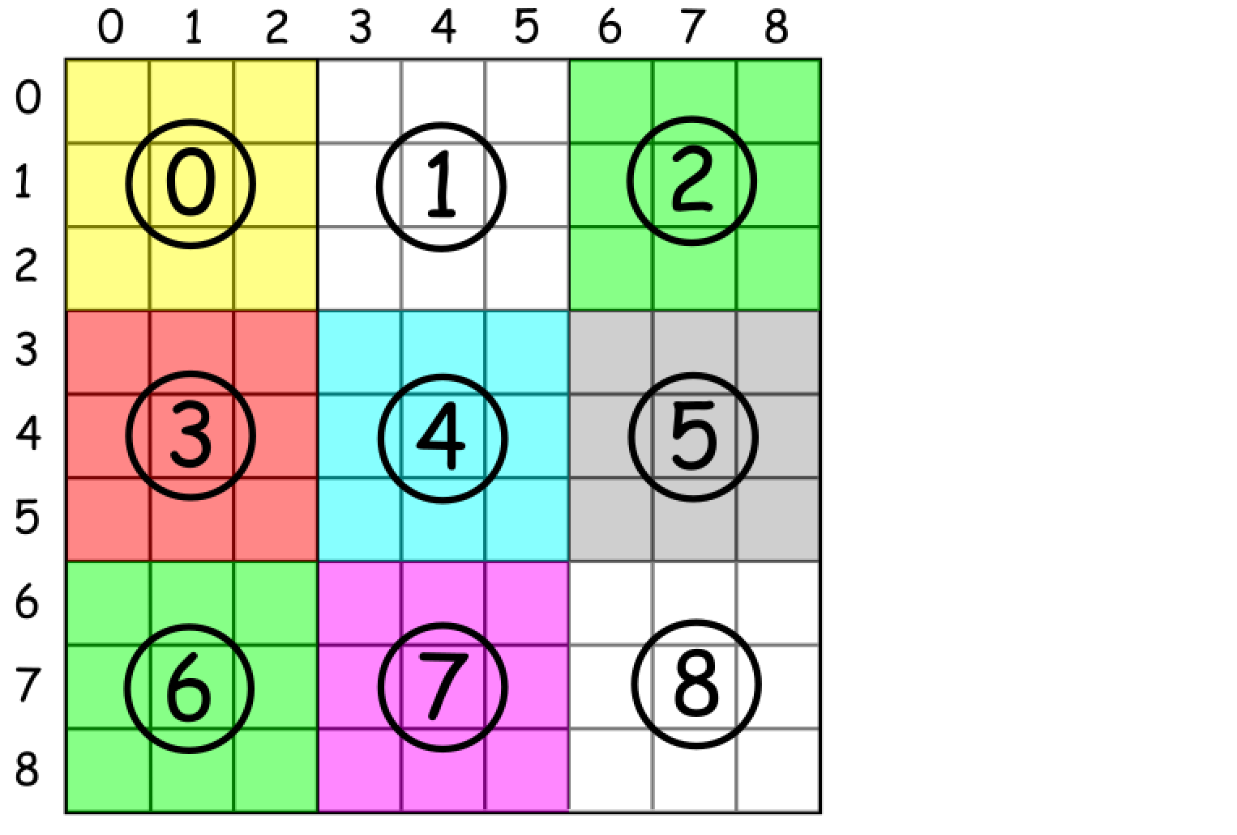

**Algorithm**

Now everything is ready to write down the backtrack function backtrack(row = 0, col = 0).

* Start from the upper left cell row = 0, col = 0. Proceed till the first free cell.
* Iterate over the numbers from 1 to 9 and try to put each number d in the (row, col) cell.
  + If number d is not yet in the current row, column and box :
    - Place the d in a (row, col) cell.
    - Write down that d is now present in the current row, column and box.
    - If we're on the last cell row == 8, col == 8 :
      * That means that we've solved the sudoku.
    - Else
      * Proceed to place further numbers.
    - Backtrack if the solution is not yet here : remove the last number from the (row, col) cell.

**Implementation**

|  |
| --- |
| class Solution {  // box size  int n = 3;  // row size  int N = n * n;  int [][] rows = new int[N][N + 1];  int [][] columns = new int[N][N + 1];  int [][] boxes = new int[N][N + 1];  char[][] board;  boolean sudokuSolved = false;  public boolean couldPlace(int d, int row, int col) {  /*  Check if one could place a number d in (row, col) cell  */  int idx = (row / n ) * n + col / n;  return rows[row][d] + columns[col][d] + boxes[idx][d] == 0;  }  public void placeNumber(int d, int row, int col) {  /*  Place a number d in (row, col) cell  */  int idx = (row / n ) * n + col / n;  rows[row][d]++;  columns[col][d]++;  boxes[idx][d]++;  board[row][col] = (char)(d + '0');  }  public void removeNumber(int d, int row, int col) {  /*  Remove a number which didn't lead to a solution  */  int idx = (row / n ) * n + col / n;  rows[row][d]--;  columns[col][d]--;  boxes[idx][d]--;  board[row][col] = '.';  }  public void placeNextNumbers(int row, int col) {  /*  Call backtrack function in recursion  to continue to place numbers  till the moment we have a solution  */  // if we're in the last cell  // that means we have the solution  if ((col == N - 1) && (row == N - 1)) {  sudokuSolved = true;  }  // if not yet  else {  // if we're in the end of the row  // go to the next row  if (col == N - 1) backtrack(row + 1, 0);  // go to the next column  else backtrack(row, col + 1);  }  }  public void backtrack(int row, int col) {  /*  Backtracking  */  // if the cell is empty  if (board[row][col] == '.') {  // iterate over all numbers from 1 to 9  for (int d = 1; d < 10; d++) {  if (couldPlace(d, row, col)) {  placeNumber(d, row, col);  placeNextNumbers(row, col);  // if sudoku is solved, there is no need to backtrack  // since the single unique solution is promised  if (!sudokuSolved) removeNumber(d, row, col);  }  }  }  else placeNextNumbers(row, col);  }  public void solveSudoku(char[][] board) {  this.board = board;  // init rows, columns and boxes  for (int i = 0; i < N; i++) {  for (int j = 0; j < N; j++) {  char num = board[i][j];  if (num != '.') {  int d = Character.getNumericValue(num);  placeNumber(d, i, j);  }  }  }  backtrack(0, 0);  }  } |

**Complexity Analysis**

* Time complexity is constant here since the board size is fixed and there is no N-parameter to measure. Though let's discuss the number of operations needed : (9!)^9. Let's consider one row, i.e. not more than 9 cells to fill. There are not more than 9 possibilities for the first number to put, not more than 9×8 for the second one, not more than 9×8×7 for the third one etc. In total that results in not more than 9! possibilities for a just one row, that means not more than (9!)^9 operations in total. Let's compare:
  + 9^{81} = 196627050475552913618075908526912116283103450944214766927315415537966391196809 for the brute force,
  + and (9!)^9 = 109110688415571316480344899355894085582848000000000 for the standard backtracking, i.e. the number of operations is reduced in 10^{27} times !
* Space complexity : the board size is fixed, and the space is used to store board, rows, columns and boxes structures, each contains 81 elements.

**Combinations**

Given two integers *n* and *k*, return all possible combinations of *k* numbers out of 1 ... *n*.

You may return the answer in **any order**.

**Example 1:**

**Input:** n = 4, k = 2

**Output:**

[

[2,4],

[3,4],

[2,3],

[1,2],

[1,3],

[1,4],

]

**Example 2:**

**Input:** n = 1, k = 1

**Output:** [[1]]

**Constraints:**

* 1 <= n <= 20
* 1 <= k <= n

## Solution

#### **Approach 1: Backtracking**

**Algorithm**

[Backtracking](https://en.wikipedia.org/wiki/Backtracking) is an algorithm for finding all solutions by exploring all potential candidates. If the solution candidate turns to be not a solution (or at least not the last one), backtracking algorithm discards it by making some changes on the previous step, i.e. backtracks and then try again.

Here is a backtrack function which takes a first integer to add and a current combination as arguments backtrack(first, curr).

* If the current combination is done - add it to output.
* Iterate over the integers from first to n.
  + Add integer i into the current combination curr.
  + Proceed to add more integers into the combination : backtrack(i + 1, curr).
  + Backtrack by removing i from curr.

**Implementation**





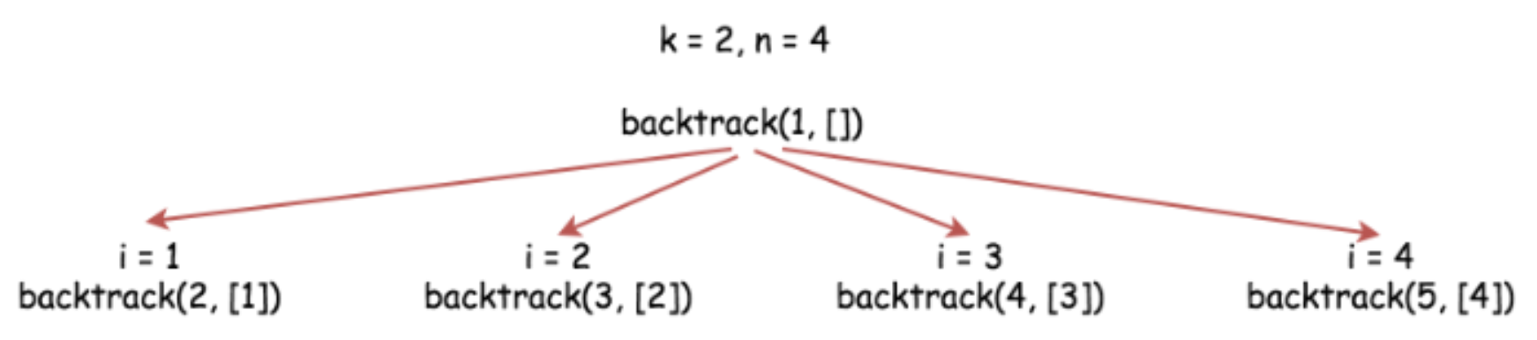

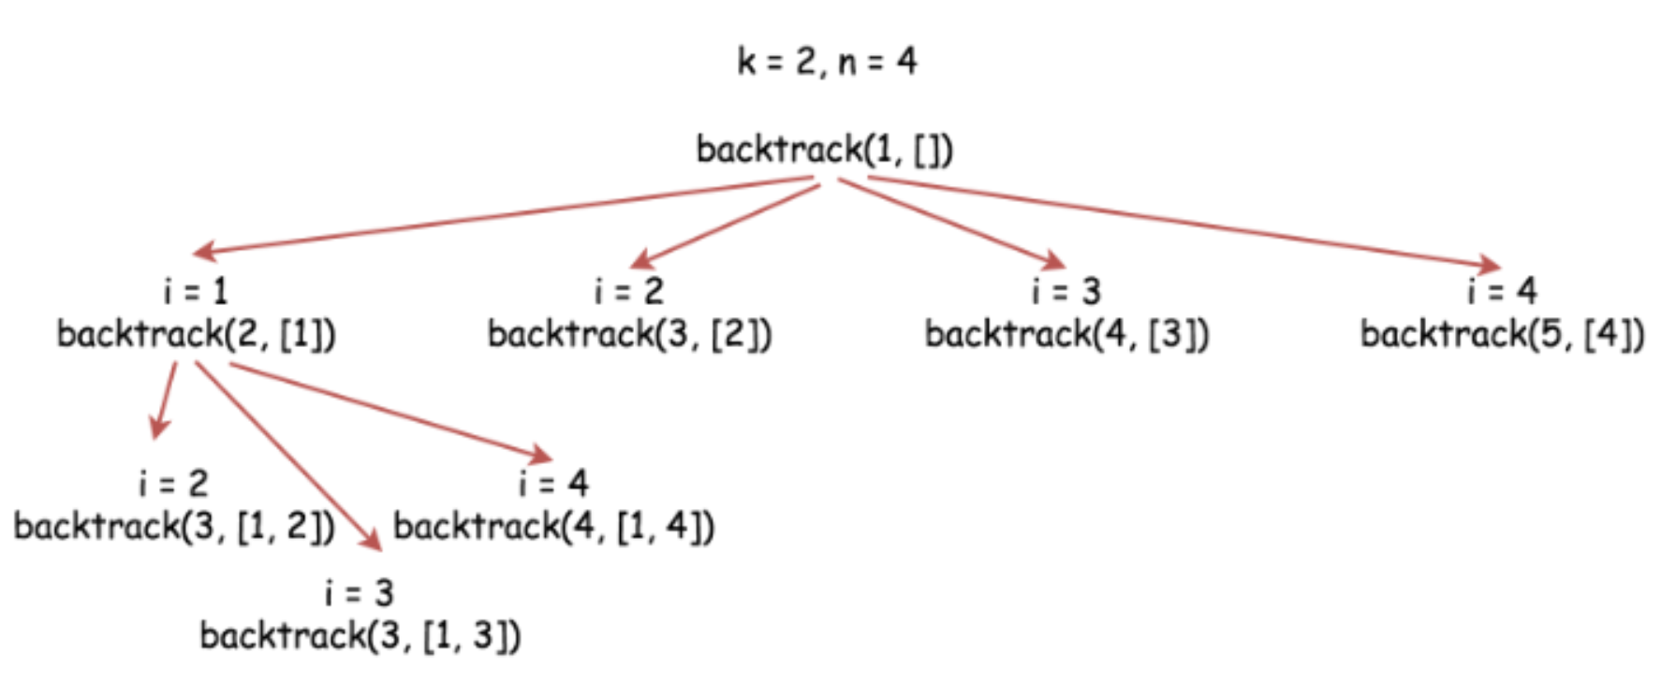

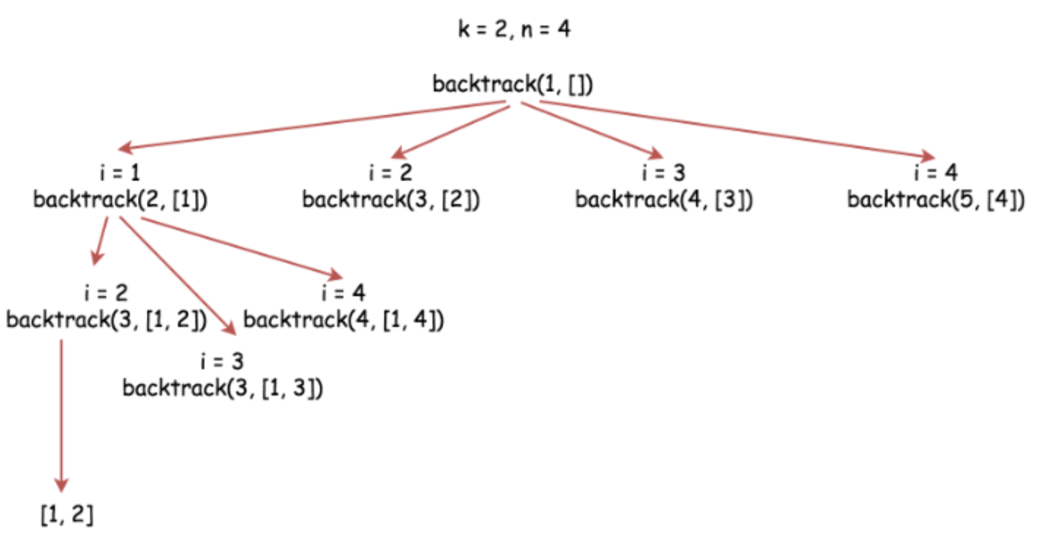

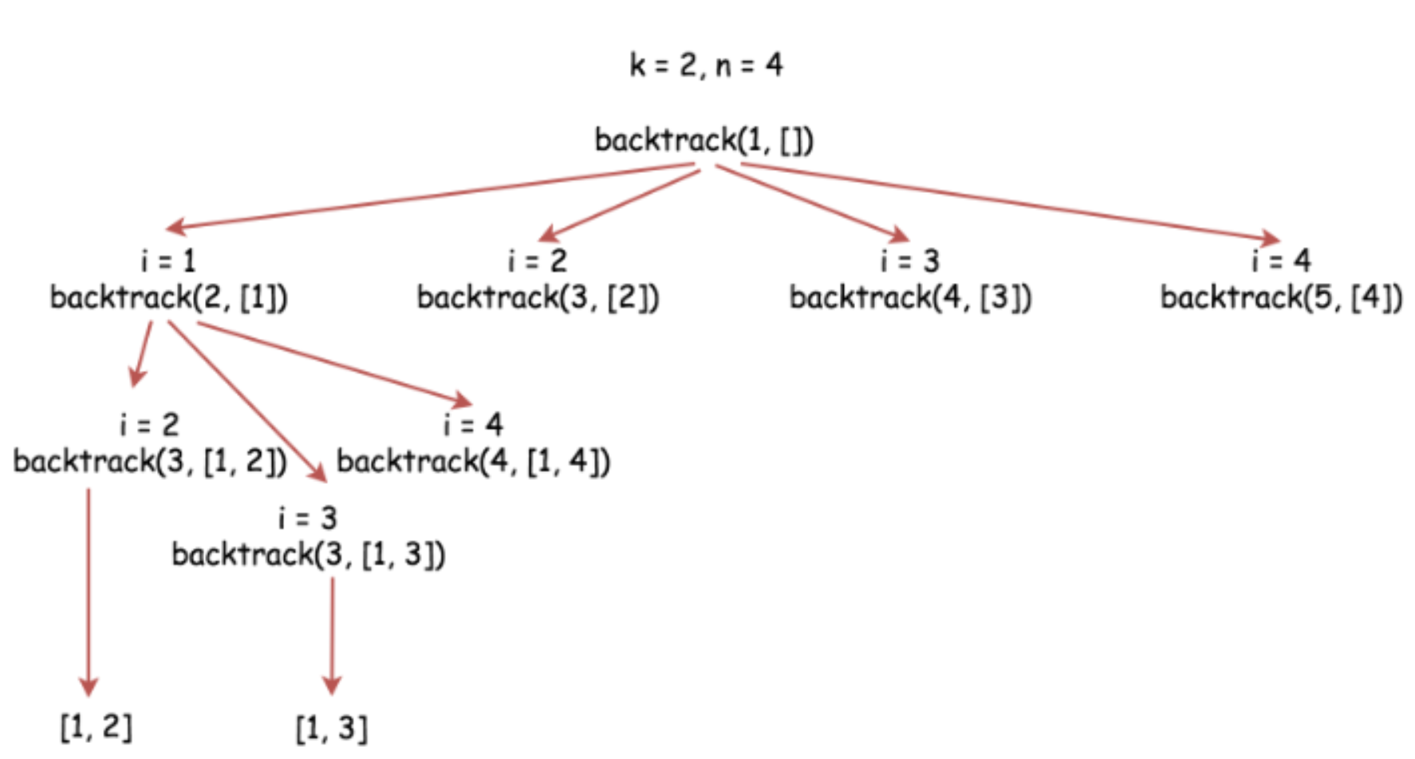

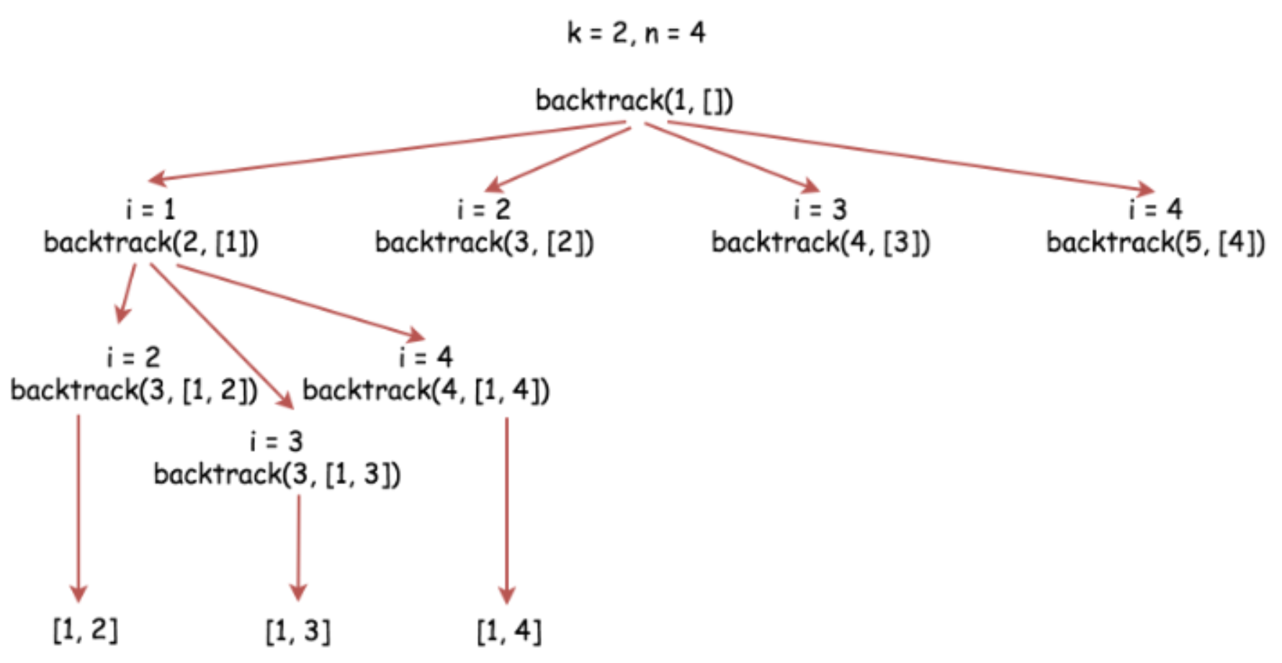

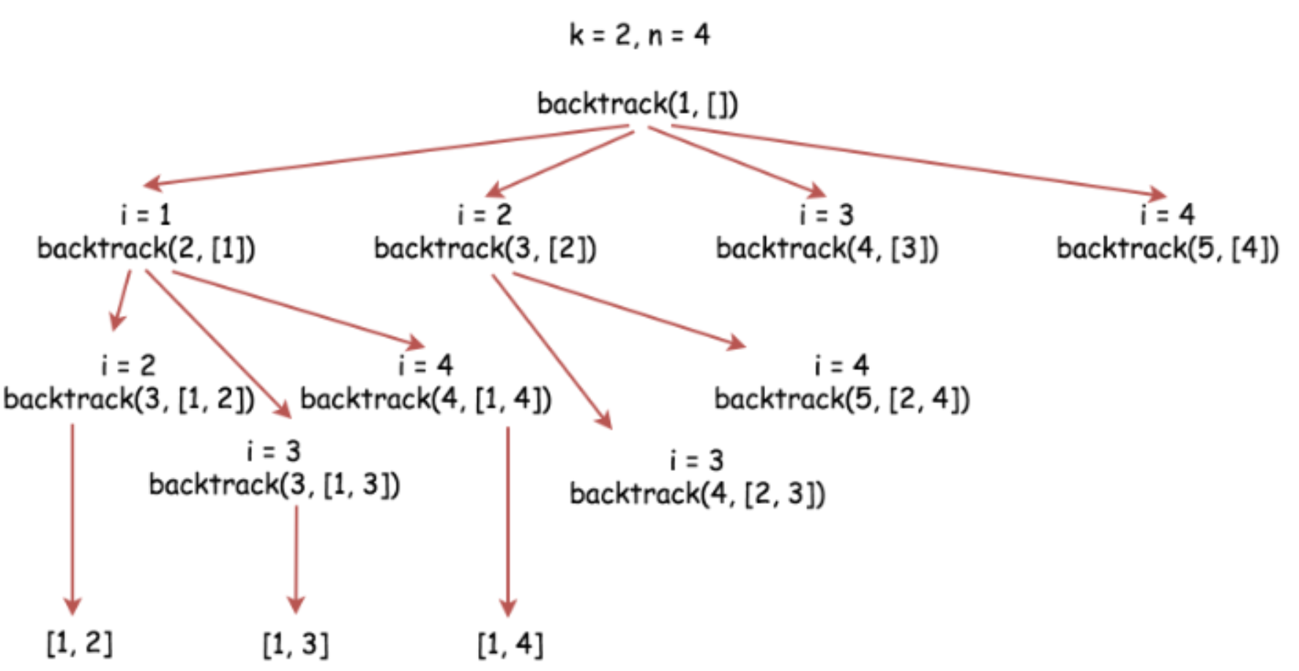

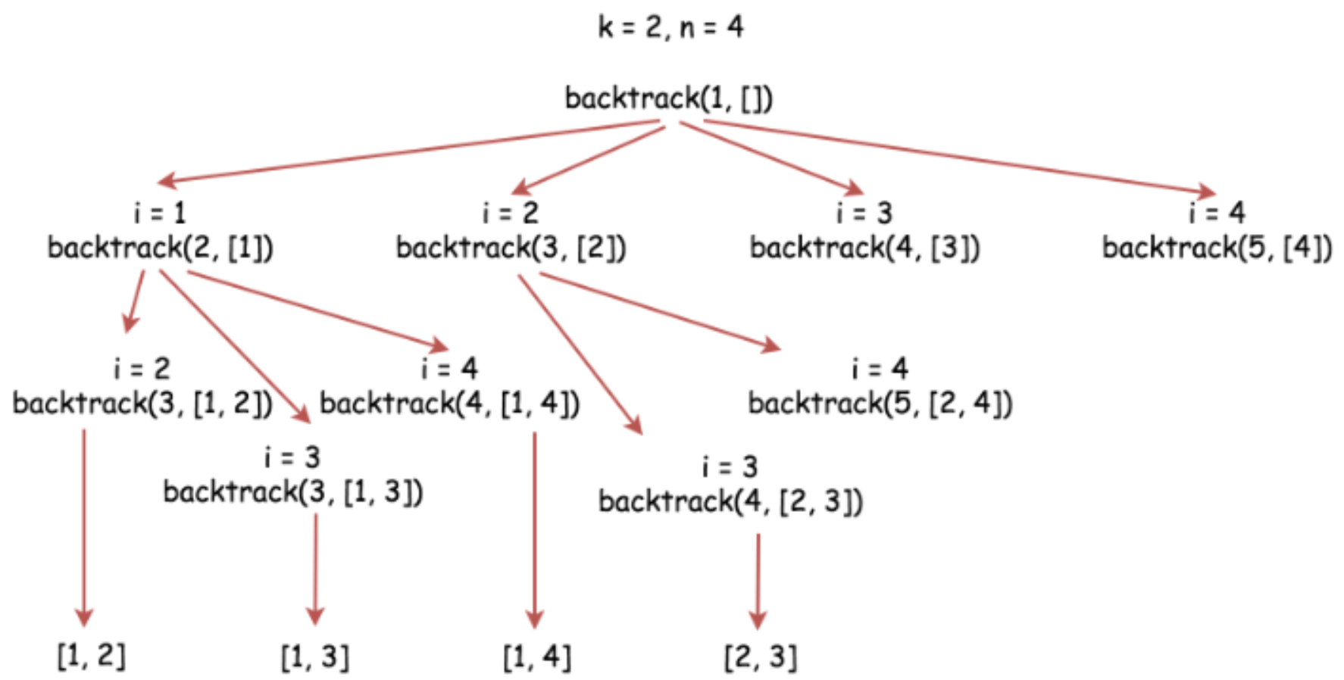

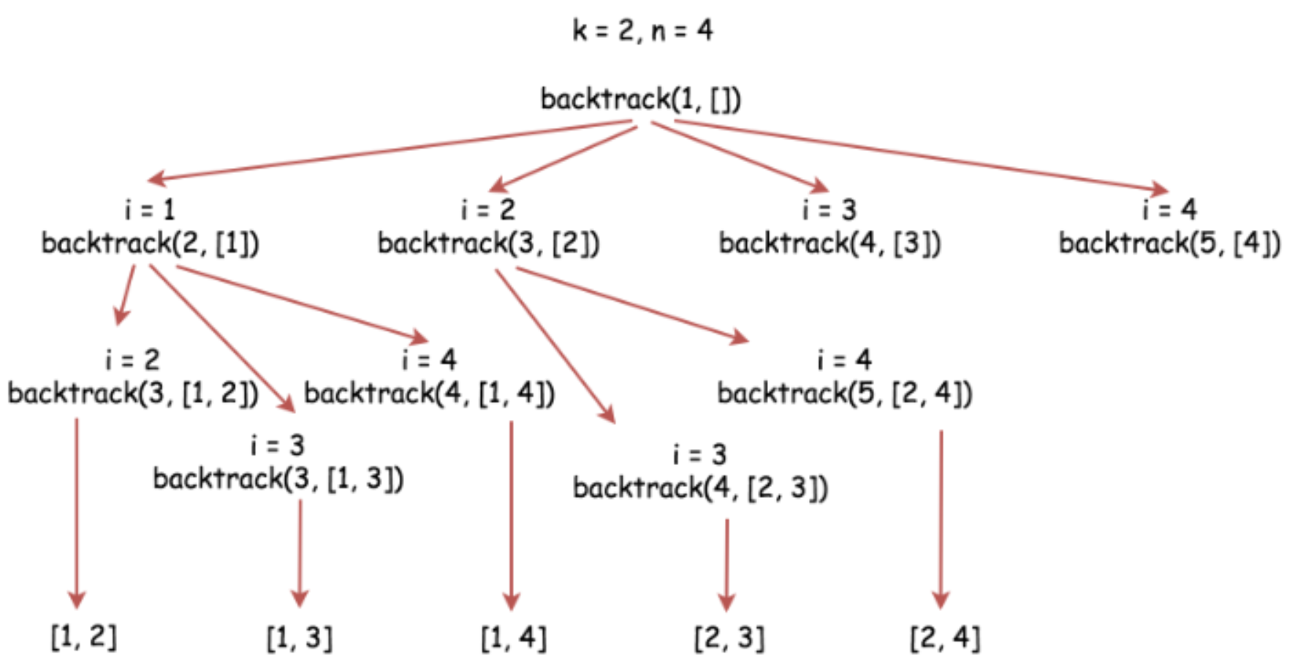

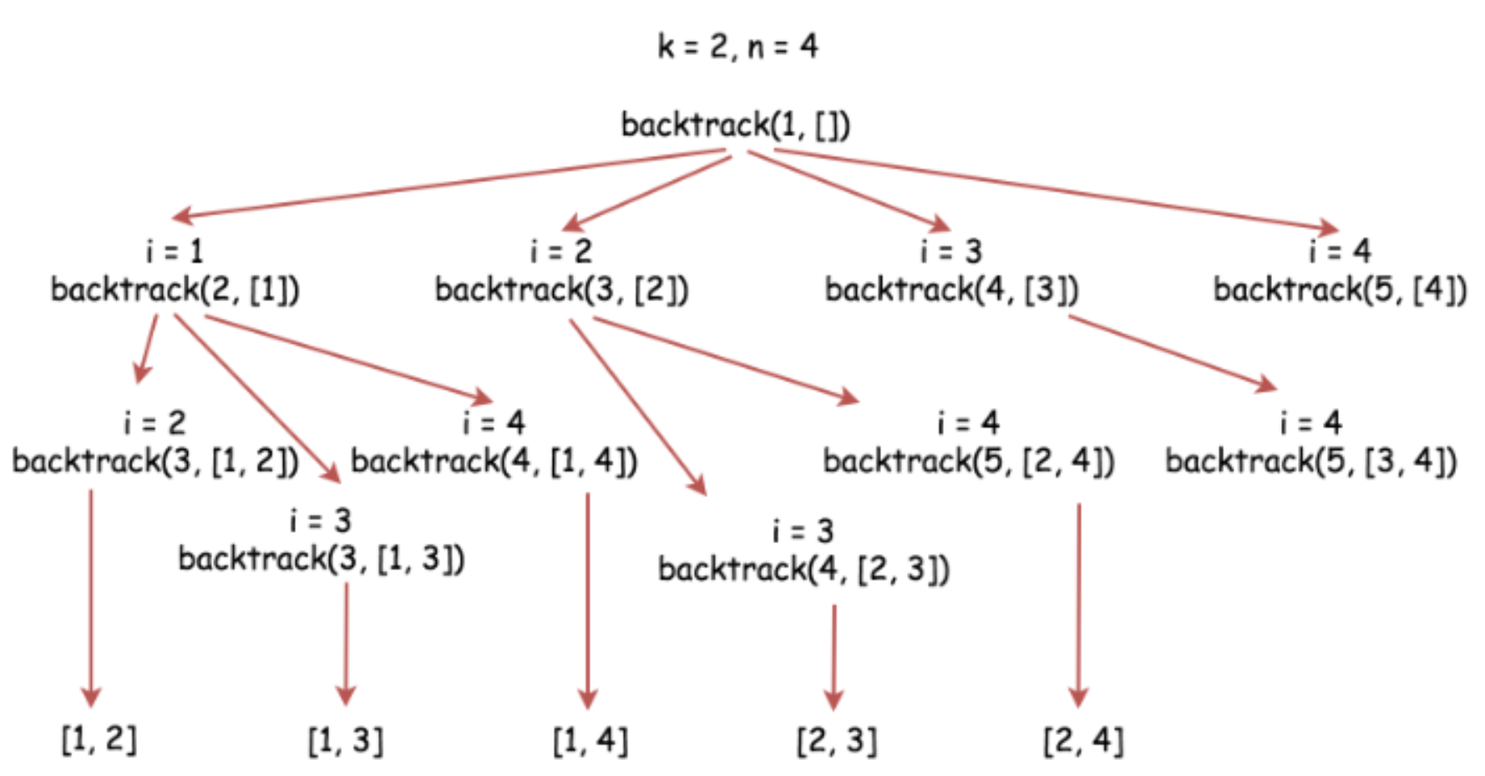

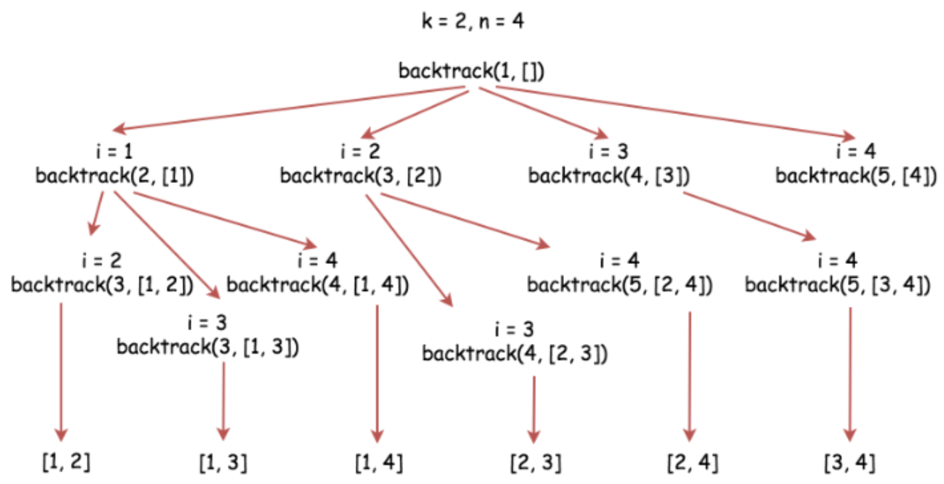

|  |
| --- |
| class Solution {  List<List<Integer>> output = new LinkedList();  int n;  int k;  public void backtrack(int first, LinkedList<Integer> curr) {  // if the combination is done  if (curr.size() == k)  output.add(new LinkedList(curr));  for (int i = first; i < n + 1; ++i) {  // add i into the current combination  curr.add(i);  // use next integers to complete the combination  backtrack(i + 1, curr);  // backtrack  curr.removeLast();  }  }  public List<List<Integer>> combine(int n, int k) {  this.n = n;  this.k = k;  backtrack(1, new LinkedList<Integer>());  return output;  }  } |

**Complexity Analysis**

* Time complexity : 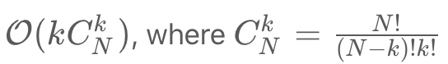 ​ is a number of combinations to build. append / pop (add / removeLast) operations are constant-time ones and the only consuming part here is to append the built combination of length k to the output.
* Space complexity : 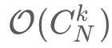 to keep all the combinations for an output.

#### **Approach 2: Lexicographic (binary sorted) combinations**

**Intuition**

The idea here is not just to get the combinations but to generate them in a lexicographic sorted order.

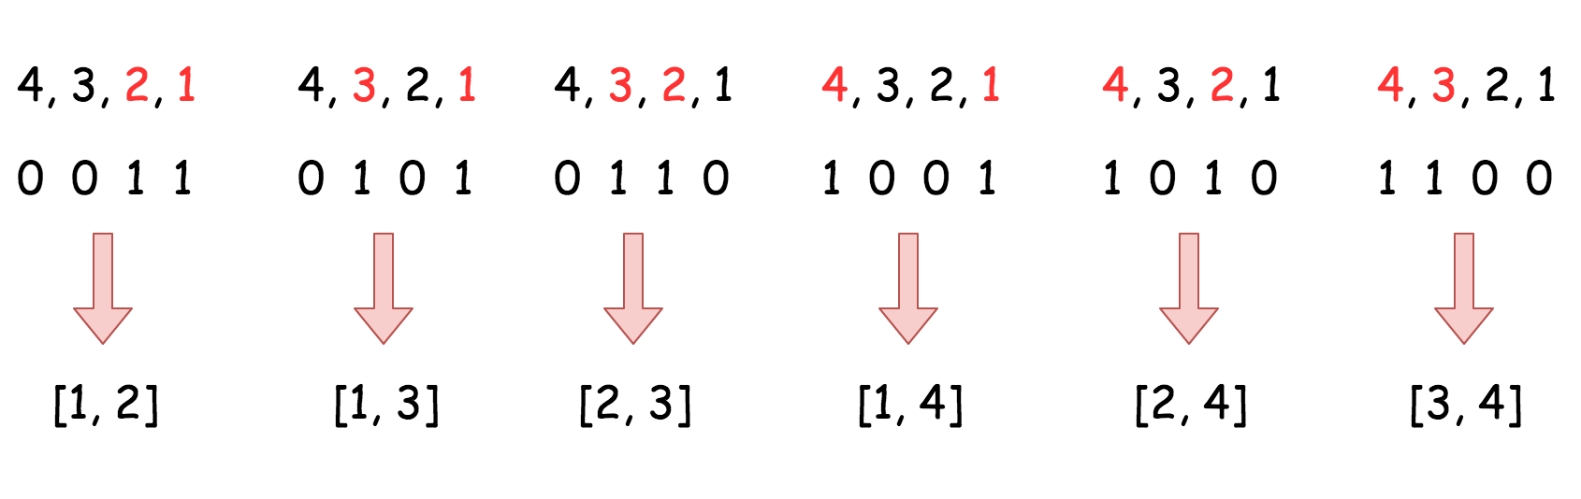

**Algorithm**

The algorithm is quite straightforward :

* Initiate nums as a list of integers from 1 to k. Add n + 1 as a last element, it will serve as a sentinel. Set the pointer in the beginning of the list j = 0.
* While j < k :
  + Add the first k elements from nums into the output, i.e. all elements but the sentinel.
  + Find the first number in nums such that nums[j] + 1 != nums[j + 1] and increase it by one nums[j]++ to move to the next combination.

**Implementation**

|  |
| --- |
| class Solution {  public List<List<Integer>> combine(int n, int k) {  // init first combination  LinkedList<Integer> nums = new LinkedList<Integer>();  for(int i = 1; i < k + 1; ++i)  nums.add(i);  nums.add(n + 1);  List<List<Integer>> output = new ArrayList<List<Integer>>();  int j = 0;  while (j < k) {  // add current combination  output.add(new LinkedList(nums.subList(0, k)));  // increase first nums[j] by one  // if nums[j] + 1 != nums[j + 1]  j = 0;  while ((j < k) && (nums.get(j + 1) == nums.get(j) + 1))  nums.set(j, j++ + 1);  nums.set(j, nums.get(j) + 1);  }  return output;  }  } |

**Complexity Analysis**

* Time complexity : 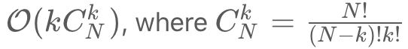 is a number of combinations to build.

The external while loop is executed  ​ times since the number of combinations is . The inner while loop is performed 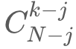​ times for a given j. In average over  visits from the external loop that results in less than one execution per visit.  
Hence the most consuming part here is to append each combination of length *k* ( combinations in total) to the output, that takes O(K) time.

You could notice that the second algorithm is much faster than the first one despite they both have the same time complexity. It's a consequence of dealing with the recursive call stack frame for the first algorithm, and the effect is much more pronounced in Python than in Java.

* Space complexity : O() to keep all the combinations for an output.

## Recursion to Iteration

Sometimes it is desirable to implement the algorithm with iteration instead of recursion, due to the constraint of memory consumption or efficiency.

In this chapter, we will discuss how to convert a recursion algorithm to an iteration one.

**Unfold Recursion**

In this article, we illustrate how to convert a recursion algorithm to non-recursion one, i.e. ***unfold*** the recursion.

Recursion could be an elegant and intuitive solution, when applied properly. Nevertheless, sometimes, one might have to convert a recursive algorithm to iterative one for various reasons.

***Risk of Stackoverflow***

    The recursion often incurs additional memory consumption on the system stack, which is a limited resource for each program. If not used properly, the recursion algorithm could lead to stackoverflow. One might argue that a specific type of recursion called [tail recursion](https://leetcode.com/explore/featured/card/recursion-i/256/complexity-analysis/2374/) could solve this problem. Unfortunately, not every recursion can be converted to tail recursion, and not every compiler supports the optimization of the tail recursion.

***Efficiency***

    Along with the additional memory consumption, the recursion could impose at least the additional cost of function calls, and in a worse case [duplicate calculation](https://leetcode.com/explore/featured/card/recursion-i/255/recursion-memoization/1495/), i.e. one of the caveats of recursion that we discussed previously in the Explore card of [Recursion I](https://leetcode.com/explore/featured/card/recursion-i/).

***Complexity***

    The nature of recursion is quite close to the mathematics, which is why the recursion appears to be more intuitive and comprehensive for many people. However, when we abuse the recursion, the recursive program could become more difficult to read and understand than the non-recursive one, e.g. nested recursion etc.

The good news is that we can always convert a recursion to iteration. In order to do so, in general, we use a data structure of stack or queue, which replaces the role of the system call stack during the process of recursion.

In the next section, we will show you some examples on how to convert the recursion to iteration.

### ***Example***

The problem that we would like to solve here is to determine if two binary trees are the same or not. Here is the description of the problem.

Given two binary trees, write a function to check if they are the same or not.

Two binary trees are considered the same if they are structurally identical and the nodes have the same value.

First, let us start with a recursive solution.

|  |
| --- |
| /**  * Definition for a binary tree node.  * public class TreeNode {  * int val;  * TreeNode left;  * TreeNode right;  * TreeNode(int x) { val = x; }  * }  */  class Solution {  public boolean isSameTree(TreeNode p, TreeNode q) {  // p and q are both null  if (p == null && q == null) return true;  // one of p and q is null  if (q == null || p == null) return false;  if (p.val != q.val) return false;  return isSameTree(p.right, q.right) &&  isSameTree(p.left, q.left);  }  } |

As one can see, the above recursion approach is rather intuitive, which follows directly the definition of the problem. Given two nodes, first, we check if the values of the nodes are equal. If this is the case, we then recursively check the left and right child nodes of the given input nodes.

For comparison, here are some sample solutions that convert the above recursion approach to iteration.

|  |
| --- |
| class Solution {  public boolean check(TreeNode p, TreeNode q) {  // p and q are null  if (p == null && q == null) return true;  // one of p and q is null  if (q == null || p == null) return false;  if (p.val != q.val) return false;  return true;  }  public boolean isSameTree(TreeNode p, TreeNode q) {  if (p == null && q == null) return true;  if (!check(p, q)) return false;  // init deques  ArrayDeque<TreeNode> deqP = new ArrayDeque<TreeNode>();  ArrayDeque<TreeNode> deqQ = new ArrayDeque<TreeNode>();  deqP.addLast(p);  deqQ.addLast(q);  while (!deqP.isEmpty()) {  p = deqP.removeFirst();  q = deqQ.removeFirst();  if (!check(p, q)) return false;  if (p != null) {  // in Java nulls are not allowed in Deque  if (!check(p.left, q.left)) return false;  if (p.left != null) {  deqP.addLast(p.left);  deqQ.addLast(q.left);  }  if (!check(p.right, q.right)) return false;  if (p.right != null) {  deqP.addLast(p.right);  deqQ.addLast(q.right);  }  }  }  return true;  }  } |

To convert a recursion approach to an iteration one, we could perform the following two steps:

1. We use a stack or queue data structure within the function, to replace the role of the system call stack. At each occurrence of recursion, we simply push the parameters as a new element into the data structure that we created, instead of invoking a recursion.
2. In addition, we create a loop over the data structure that we created before. The chain invocation of recursion would then be replaced with the iteration within the loop.

### ***Next***

In the rest of the chapters, one can find some more problems to practice on. One can try to implement both recursion and iteration approaches for each problem.

**Same Tree**

Given the roots of two binary trees p and q, write a function to check if they are the same or not.

Two binary trees are considered the same if they are structurally identical, and the nodes have the same value.

**Example 1:**

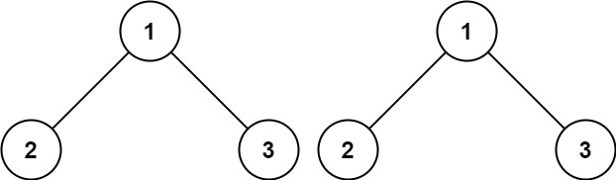

**Input:** p = [1,2,3], q = [1,2,3]

**Output:** true

**Example 2:**

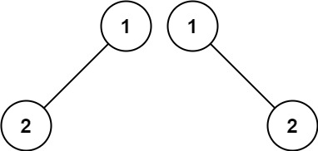

**Input:** p = [1,2], q = [1,null,2]

**Output:** false

**Example 3:**

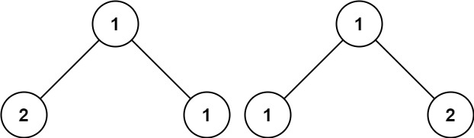

**Input:** p = [1,2,1], q = [1,1,2]

**Output:** false

**Constraints:**

* The number of nodes in both trees is in the range [0, 100].
* -104 <= Node.val <= 104

## Solution

#### **Approach 1: Recursion**

**Intuition**

The simplest strategy here is to use recursion. Check if p and q nodes are not None, and their values are equal. If all checks are OK, do the same for the child nodes recursively.

**Implementation**

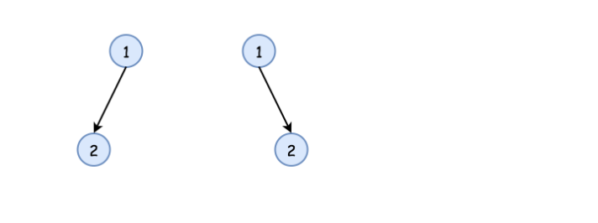

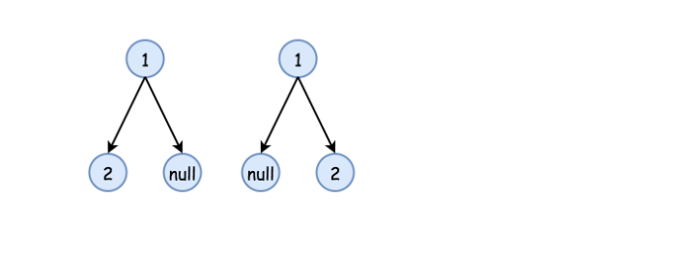

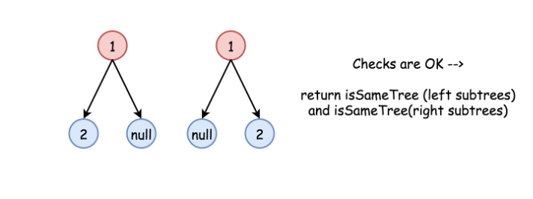

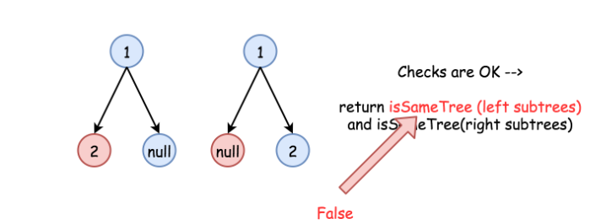

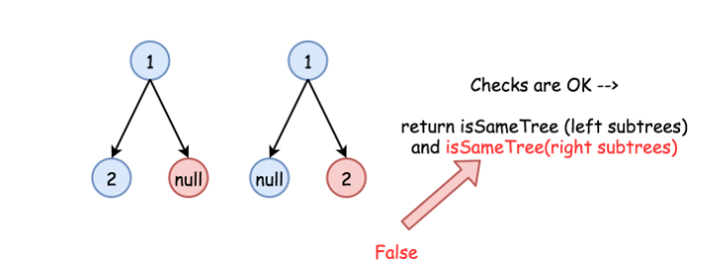

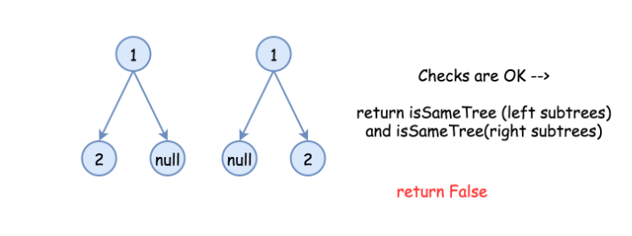

|  |
| --- |
| /**  * Definition for a binary tree node.  * public class TreeNode {  * int val;  * TreeNode left;  * TreeNode right;  * TreeNode(int x) { val = x; }  * }  */  class Solution {  public boolean isSameTree(TreeNode p, TreeNode q) {  // p and q are both null  if (p == null && q == null) return true;  // one of p and q is null  if (q == null || p == null) return false;  if (p.val != q.val) return false;  return isSameTree(p.right, q.right) &&  isSameTree(p.left, q.left);  }  } |

**Complexity Analysis**

* Time complexity : O(*N*), where N is a number of nodes in the tree, since one visits each node exactly once.
* Space complexity : O(log(*N*)) in the best case of completely balanced tree and O(*N*) in the worst case of completely unbalanced tree, to keep a recursion stack.

#### **Approach 2: Iteration**

**Intuition**

Start from the root and then at each iteration pop the current node out of the deque. Then do the same checks as in the approach 1 :

* p and p are not None,
* p.val is equal to q.val,

and if checks are OK, push the child nodes.

**Implementation**

|  |
| --- |
| class Solution {  public boolean check(TreeNode p, TreeNode q) {  // p and q are null  if (p == null && q == null) return true;  // one of p and q is null  if (q == null || p == null) return false;  if (p.val != q.val) return false;  return true;  }  public boolean isSameTree(TreeNode p, TreeNode q) {  if (p == null && q == null) return true;  if (!check(p, q)) return false;  // init deques  ArrayDeque<TreeNode> deqP = new ArrayDeque<TreeNode>();  ArrayDeque<TreeNode> deqQ = new ArrayDeque<TreeNode>();  deqP.addLast(p);  deqQ.addLast(q);  while (!deqP.isEmpty()) {  p = deqP.removeFirst();  q = deqQ.removeFirst();  if (!check(p, q)) return false;  if (p != null) {  // in Java nulls are not allowed in Deque  if (!check(p.left, q.left)) return false;  if (p.left != null) {  deqP.addLast(p.left);  deqQ.addLast(q.left);  }  if (!check(p.right, q.right)) return false;  if (p.right != null) {  deqP.addLast(p.right);  deqQ.addLast(q.right);  }  }  }  return true;  }  } |

**Complexity Analysis**

* Time complexity : O(*N*) since each node is visited exactly once.
* Space complexity : O(log(*N*)) in the best case of completely balanced tree and O(*N*) in the worst case of completely unbalanced tree, to keep a deque.

**Generate Parentheses**

Given n pairs of parentheses, write a function to *generate all combinations of well-formed parentheses*.

**Example 1:**

**Input:** n = 3

**Output:** ["((()))","(()())","(())()","()(())","()()()"]

**Example 2:**

**Input:** n = 1

**Output:** ["()"]

**Constraints:**

* 1 <= n <= 8

#### **Approach 1: Brute Force**

**Intuition**

We can generate all 2^{2n} sequences of '(' and ')' characters. Then, we will check if each one is valid.

**Algorithm**

To generate all sequences, we use a recursion. All sequences of length n is just '(' plus all sequences of length n-1, and then ')' plus all sequences of length n-1.

To check whether a sequence is valid, we keep track of balance, the net number of opening brackets minus closing brackets. If it falls below zero at any time, or doesn't end in zero, the sequence is invalid - otherwise it is valid.

|  |
| --- |
| class Solution {  public List<String> generateParenthesis(int n) {  List<String> combinations = new ArrayList();  generateAll(new char[2 * n], 0, combinations);  return combinations;  }  public void generateAll(char[] current, int pos, List<String> result) {  if (pos == current.length) {  if (valid(current))  result.add(new String(current));  } else {  current[pos] = '(';  generateAll(current, pos+1, result);  current[pos] = ')';  generateAll(current, pos+1, result);  }  }  public boolean valid(char[] current) {  int balance = 0;  for (char c: current) {  if (c == '(') balance++;  else balance--;  if (balance < 0) return false;  }  return (balance == 0);  }  } |

**Complexity Analysis**

* Time Complexity : O(22nn). For each of 22n sequences, we need to create and validate the sequence, which takes *O*(*n*) work.
* Space Complexity : O(22nn). Naively, every sequence could be valid. See [Approach 3](https://leetcode.com/problems/generate-parentheses/solution/#approach-3-closure-number) for development of a tighter asymptotic bound.

#### **Approach 2: Backtracking**

**Intuition and Algorithm**

Instead of adding '(' or ')' every time as in [Approach 1](https://leetcode.com/problems/generate-parentheses/solution/#approach-1-brute-force), let's only add them when we know it will remain a valid sequence. We can do this by keeping track of the number of opening and closing brackets we have placed so far.

We can start an opening bracket if we still have one (of n) left to place. And we can start a closing bracket if it would not exceed the number of opening brackets.

|  |
| --- |
| class Solution {  public List<String> generateParenthesis(int n) {  List<String> ans = new ArrayList();  backtrack(ans, "", 0, 0, n);  return ans;  }  public void backtrack(List<String> ans, String cur, int open, int close, int max){  if (cur.length() == max * 2) {  ans.add(cur);  return;  }  if (open < max)  backtrack(ans, cur+"(", open+1, close, max);  if (close < open)  backtrack(ans, cur+")", open, close+1, max);  }  } |

**Complexity Analysis**

Our complexity analysis rests on understanding how many elements there are in generateParenthesis(n). This analysis is outside the scope of this article, but it turns out this is the n-th Catalan number ​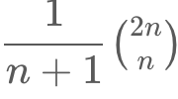, which is bounded asymptotically by 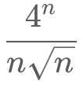​.

* Time Complexity : O(****​). Each valid sequence has at most n steps during the backtracking procedure.
* Space Complexity : O(****​), as described above, and using *O*(*n*) space to store the sequence.

#### **Approach 3: Closure Number**

**Intuition**

To enumerate something, generally we would like to express it as a sum of disjoint subsets that are easier to count.

Consider the closure number of a valid parentheses sequence S: the least index >= 0 so that S[0], S[1], ..., S[2*index+1] is valid. Clearly, every parentheses sequence has a unique closure number. We can try to enumerate them individually.

**Algorithm**

For each closure number c, we know the starting and ending brackets must be at index 0 and 2*c + 1. Then, the 2*c elements between must be a valid sequence, plus the rest of the elements must be a valid sequence.

|  |
| --- |
| class Solution {  public List<String> generateParenthesis(int n) {  List<String> ans = new ArrayList();  if (n == 0) {  ans.add("");  } else {  for (int c = 0; c < n; ++c)  for (String left: generateParenthesis(c))  for (String right: generateParenthesis(n-1-c))  ans.add("(" + left + ")" + right);  }  return ans;  }  } |

**Complexity Analysis**

* Time and Space Complexity : O(​). The analysis is similar to [Approach 2](https://leetcode.com/problems/generate-parentheses/solution/#approach-2-backtracking).

**Binary Tree Inorder Traversal**

Given the root of a binary tree, return *the inorder traversal of its nodes' values*.

**Example 1:**

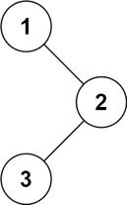

**Input:** root = [1,null,2,3]

**Output:** [1,3,2]

**Example 2:**

**Input:** root = []

**Output:** []

**Example 3:**

**Input:** root = [1]

**Output:** [1]

**Example 4:**

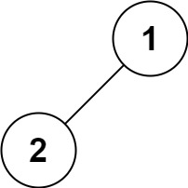

**Input:** root = [1,2]

**Output:** [2,1]

**Example 5:**

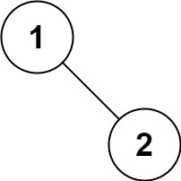

**Input:** root = [1,null,2]

**Output:** [1,2]

**Constraints:**

* The number of nodes in the tree is in the range [0, 100].
* -100 <= Node.val <= 100

**Follow up:**

Recursive solution is trivial, could you do it iteratively?

|  |
| --- |
| class Solution {  public List<Integer> inorderTraversal(TreeNode root) {  List<Integer> nodes = new ArrayList<>();  TreeNode cur = root;  while (cur != null) {  if (cur.left != null) {  TreeNode pre = cur.left;  while ((pre.right != null) && (pre.right != cur)) {  pre = pre.right;  }  if (pre.right == null) {  pre.right = cur;  cur = cur.left;  } else {  pre.right = null;  nodes.add(cur.val);  cur = cur.right;  }  } else {  nodes.add(cur.val);  cur = cur.right;  }  }  return nodes;  }  } |

See Binary Tree

**Binary Tree Level Order Traversal**

Given a binary tree, return the *level order* traversal of its nodes' values. (ie, from left to right, level by level).

For example:  
Given binary tree [3,9,20,null,null,15,7],

3

/ \

9 20

/ \

15 7

return its level order traversal as:

[

[3],

[9,20],

[15,7]

]

## Solution

#### **How to traverse the tree**

There are two general strategies to traverse a tree:

* Depth First Search (DFS)

In this strategy, we adopt the depth as the priority, so that one would start from a root and reach all the way down to certain leaf, and then back to root to reach another branch.

The DFS strategy can further be distinguished as preorder, inorder, and postorder depending on the relative order among the root node, left node and right node.

* Breadth First Search (BFS)

We scan through the tree level by level, following the order of height, from top to bottom. The nodes on higher level would be visited before the ones with lower levels.

On the following figure the nodes are numerated in the order you visit them, please follow 1-2-3-4-5 to compare different strategies.



Here the problem is to implement split-level BFS traversal : [[1], [2, 3], [4, 5]].

#### **Approach 1: Recursion**

**Algorithm**

The simplest way to solve the problem is to use a recursion. Let's first ensure that the tree is not empty, and then call recursively the function helper(node, level), which takes the current node and its level as the arguments.

This function does the following :

* The output list here is called levels, and hence the current level is just a length of this list len(levels). Compare the number of a current level len(levels) with a node level level. If you're still on the previous level - add the new one by adding a new list into levels.
* Append the node value to the last list in levels.
* Process recursively child nodes if they are not None : helper(node.left / node.right, level + 1).

**Implementation**

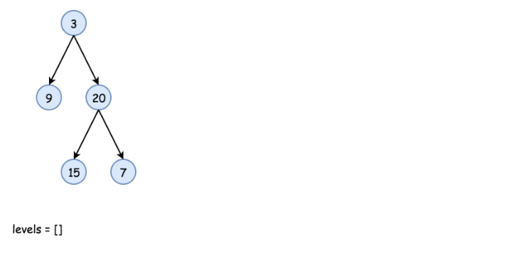

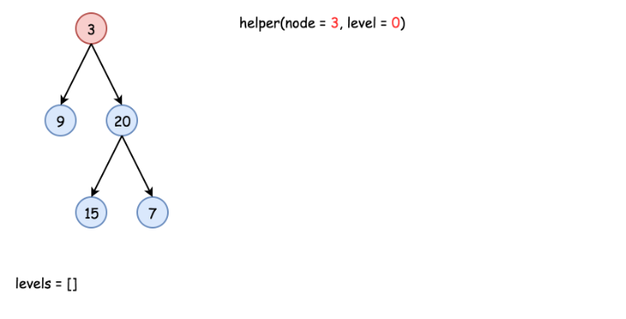

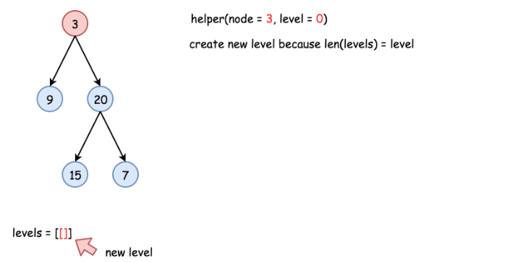

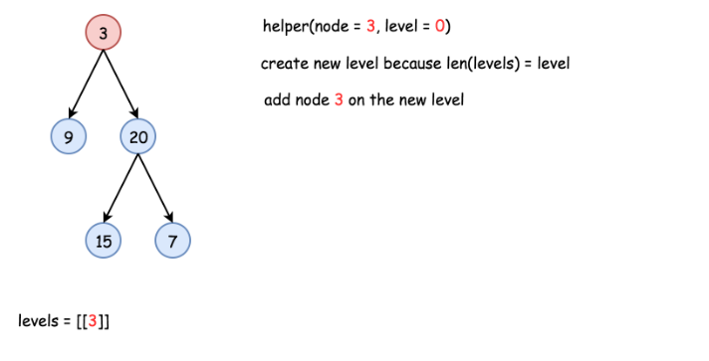

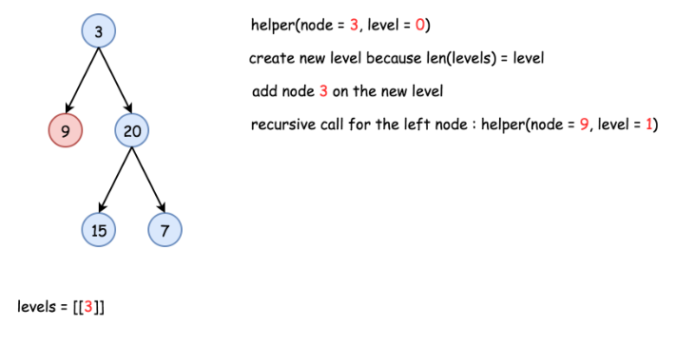

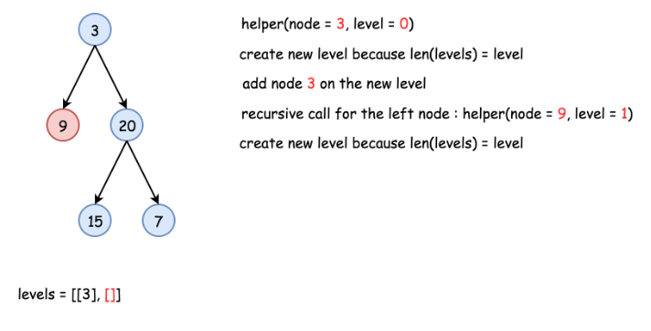

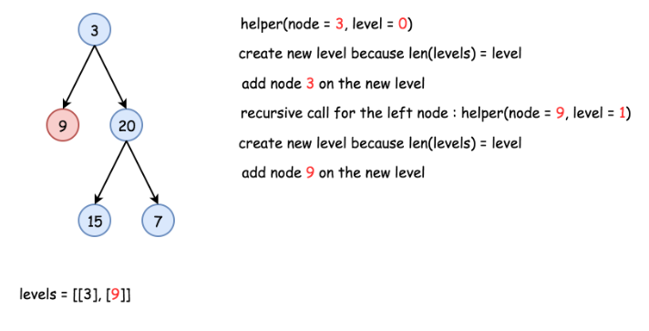

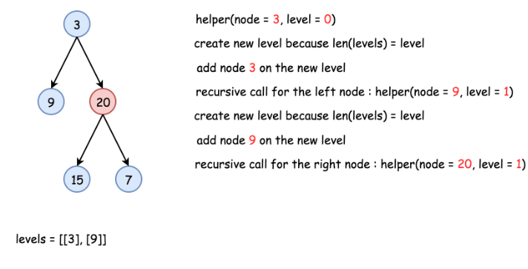

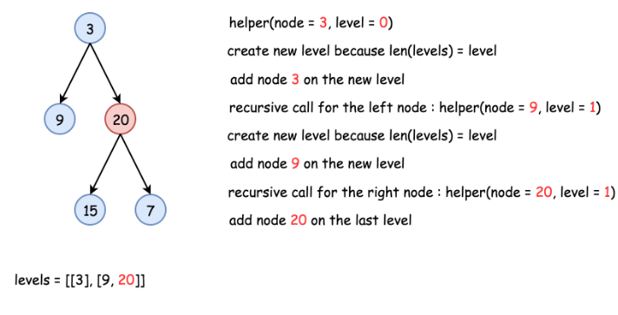

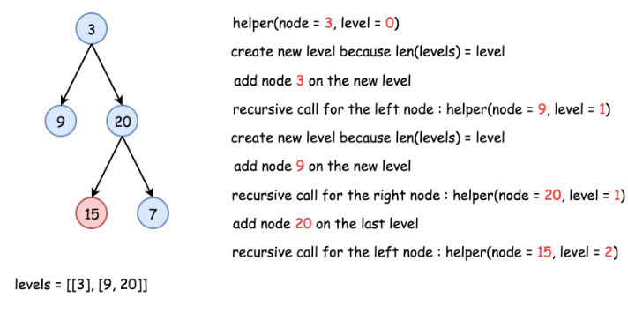

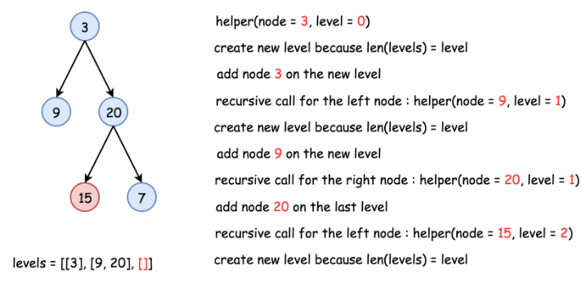

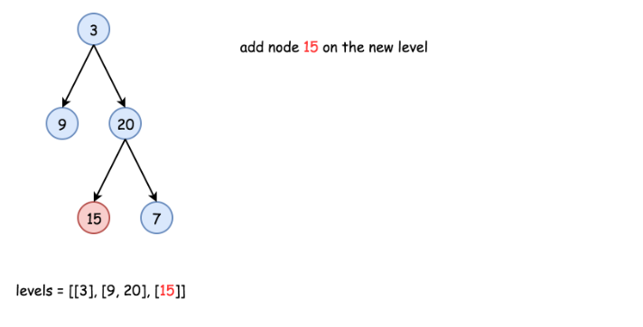

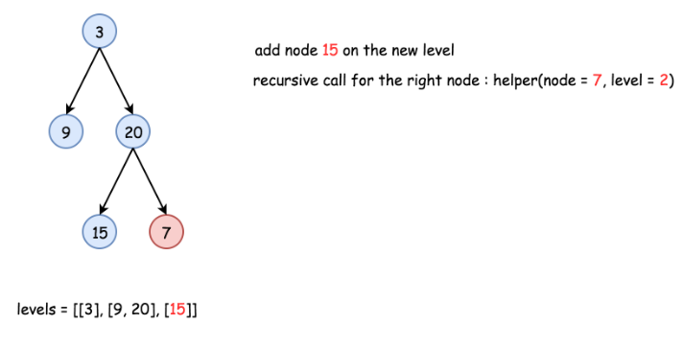

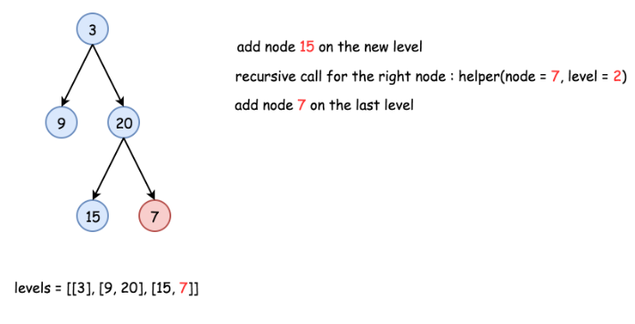

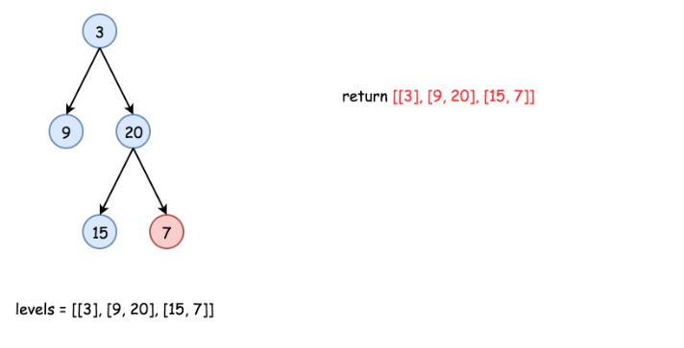

|  |
| --- |
| class Solution {  List<List<Integer>> levels = new ArrayList<List<Integer>>();  public void helper(TreeNode node, int level) {  // start the current level  if (levels.size() == level)  levels.add(new ArrayList<Integer>());  // fulfil the current level  levels.get(level).add(node.val);  // process child nodes for the next level  if (node.left != null)  helper(node.left, level + 1);  if (node.right != null)  helper(node.right, level + 1);  }    public List<List<Integer>> levelOrder(TreeNode root) {  if (root == null) return levels;  helper(root, 0);  return levels;  }  } |

**Complexity Analysis**

* Time complexity : O(*N*) since each node is processed exactly once.
* Space complexity : O(*N*) to keep the output structure which contains N node values.

#### **Approach 2: Iteration**

**Algorithm**

The recursion above could be rewritten in the iteration form.

Let's keep nodes of each tree level in the queue structure, which typically orders elements in a FIFO (first-in-first-out) manner. In Java one could use [LinkedList implementation of the Queue interface](https://docs.oracle.com/javase/7/docs/api/java/util/Queue.html). In Python using [Queue structure](https://docs.python.org/3/library/queue.html) would be an overkill since it's designed for a safe exchange between multiple threads and hence requires locking which leads to a performance loose. In Python the queue implementation with a fast atomic append() and popleft() is [deque](https://docs.python.org/3/library/collections.html#collections.deque).

The zero level contains only one node root. The algorithm is simple :

* Initiate queue with a root and start from the level number 0 : level = 0.
* While queue is not empty :
  + Start the current level by adding an empty list into output structure levels.
  + Compute how many elements should be on the current level : it's a queue length.
  + Pop out all these elements from the queue and add them into the current level.
  + Push their child nodes into the queue for the next level.
  + Go to the next level level++.

**Implementation**

|  |
| --- |
| class Solution {  public List<List<Integer>> levelOrder(TreeNode root) {  List<List<Integer>> levels = new ArrayList<List<Integer>>();  if (root == null) return levels;  Queue<TreeNode> queue = new LinkedList<TreeNode>();  queue.add(root);  int level = 0;  while ( !queue.isEmpty() ) {  // start the current level  levels.add(new ArrayList<Integer>());  // number of elements in the current level  int level_length = queue.size();  for(int i = 0; i < level_length; ++i) {  TreeNode node = queue.remove();  // fulfill the current level  levels.get(level).add(node.val);  // add child nodes of the current level  // in the queue for the next level  if (node.left != null) queue.add(node.left);  if (node.right != null) queue.add(node.right);  }  // go to next level  level++;  }  return levels;  }  } |

**Complexity Analysis**

* Time complexity : O(*N*) since each node is processed exactly once.
* Space complexity : O(*N*) to keep the output structure which contains N node values.

## Conclusion

In this chapter, we add more exercises for one to practice the paradigms that one has learned in this Explore Card.

**Beyond Recursion**

In this card, we introduced the paradigms of divide-and-conquer and backtracking, which often implemented in the form of recursion. Each of the paradigms is well suited for certain types of problems. In this article, we give a brief summary of these paradigms and highlight their differences.

In the rest of the chapter, we list a few more exercises for one to practice these paradigms. If you have any doubt or question, you can always make a post in the [Forum](https://leetcode.com/discuss/explore/recursion-ii) that is located at the end of the card. We will try our best to get back to you as soon as possible.

### ***Divide and Conquer***

A divide-and-conquer algorithm works by ***recursively*** breaking the problem down into **two** or more subproblems of the same or related type, until these subproblems become simple enough to be solved directly [**[1]**](http://en.wikipedia.org/wiki/Divide-and-conquer_algorithm). Then one combines the results of subproblems to form the final solution.

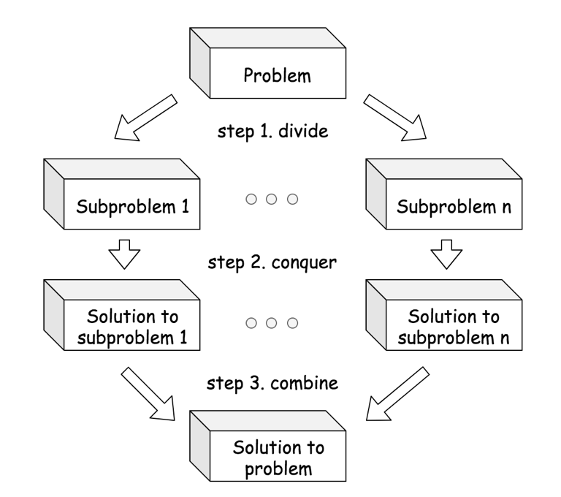

### ***Backtracking***

Backtracking is a general algorithm for finding all (or some) solutions to some computational problems (notably constraint satisfaction problems), which incrementally builds candidates to the solution and abandons a candidate ("backtracks") as soon as it determines that the candidate cannot leads to a valid solution.**[2]**

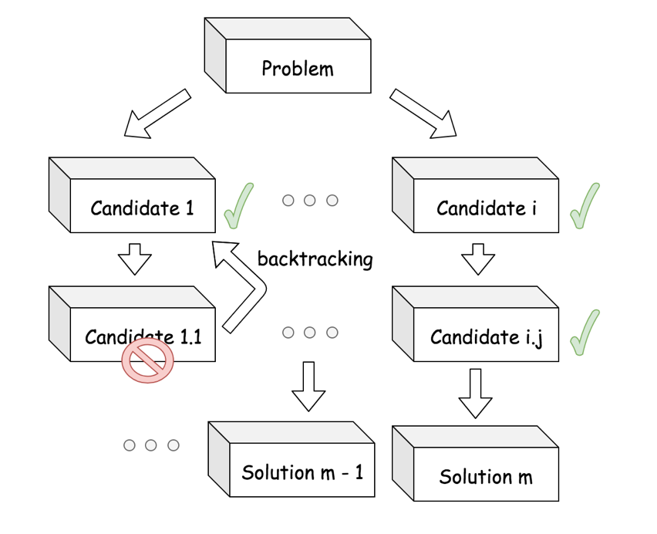

### ***Divde and Conquer VS. Backtracking***

1. Often the case, the divide-and-conquer problem has a **sole** solution, while the backtracking problem has unknown number of solutions. For example, when we apply the merge sort algorithm to sort a list, we obtain a single sorted list, while there are many solutions to place the queens for the N-queen problem.
2. Each step in the divide-and-conquer problem is ***indispensable*** to build the final solution, while many steps in backtracking problem might not be useful to build the solution, but serve as **atttempts** to search for the potential solutions. For example, each step in the merge sort algorithm, i.e. divide, conquer and combine, are all indispensable to build the final solution, while there are many trials and errors during the process of building solutions for the N-queen problem.
3. When building the solution in the divide-and-conquer algorithm, we have a **clear and predefined** path, though there might be several different manners to build the path. While in the backtracking problems, one does not know in advance the ***exact path*** to the solution. For example, in the top-down merge sort algorithm, we first recursively divide the problems into two subproblems and then combine the solutions of these subproblems. The steps are clearly defined and the number of steps is fixed as well. While in the N-queen problem, if we know exactly where to place the queens, it would only take N steps to do so. When applying the backtracking algorithm to the N-queen problem, we try many candidates and many of them do not eventually lead to a solution but abandoned at the end. As a result, we do not know beforehand how many steps exactly it would take to build a valid solution.

### ***References***

- [1]. [Divide and Conquer](https://en.wikipedia.org/wiki/Divide-and-conquer_algorithm). Wikipedia.

- [2]. [Backtracking](https://en.wikipedia.org/wiki/Backtracking). Wikipedia.

**Convert Binary Search Tree to Sorted Doubly Linked List**

Convert a **Binary Search Tree** to a sorted **Circular Doubly-Linked List** in place.

You can think of the left and right pointers as synonymous to the predecessor and successor pointers in a doubly-linked list. For a circular doubly linked list, the predecessor of the first element is the last element, and the successor of the last element is the first element.

We want to do the transformation **in place**. After the transformation, the left pointer of the tree node should point to its predecessor, and the right pointer should point to its successor. You should return the pointer to the smallest element of the linked list.

**Example 1:**

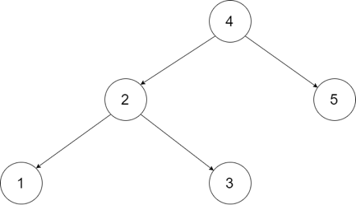

**Input:** root = [4,2,5,1,3]

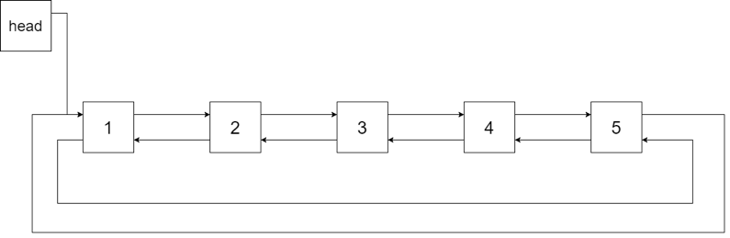

**Output:** [1,2,3,4,5]

**Explanation:** The figure below shows the transformed BST. The solid line indicates the successor relationship, while the dashed line means the predecessor relationship.

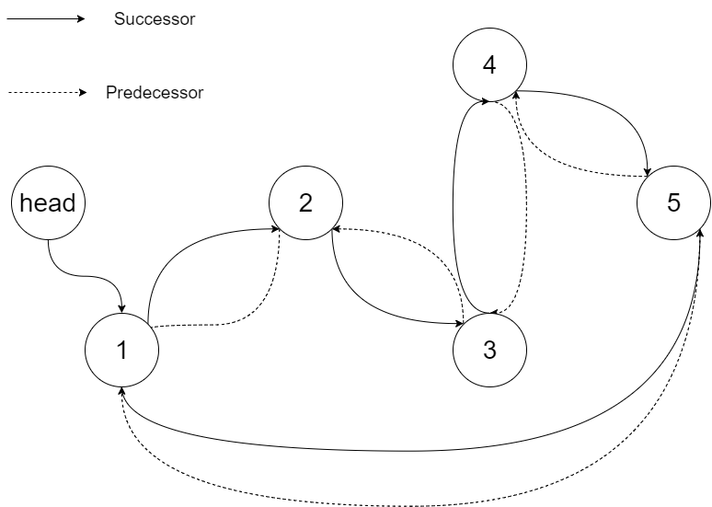

**Example 2:**

**Input:** root = [2,1,3]

**Output:** [1,2,3]

**Example 3:**

**Input:** root = []

**Output:** []

**Explanation:** Input is an empty tree. Output is also an empty Linked List.

**Example 4:**

**Input:** root = [1]

**Output:** [1]

**Constraints:**

* -1000 <= Node.val <= 1000
* Node.left.val < Node.val < Node.right.val
* All values of Node.val are unique.
* 0 <= Number of Nodes <= 2000

## Solution

#### **How to traverse the tree**

There are two general strategies to traverse a tree:

* Depth First Search (DFS)

In this strategy, we adopt the depth as the priority, so that one would start from a root and reach all the way down to certain leaf, and then back to root to reach another branch.

The DFS strategy can further be distinguished as preorder, inorder, and postorder depending on the relative order among the root node, left node and right node.

* Breadth First Search (BFS)

We scan through the tree level by level, following the order of height, from top to bottom. The nodes on higher level would be visited before the ones with lower levels.

On the following figure the nodes are numerated in the order you visit them, please follow 1-2-3-4-5 to compare different strategies.

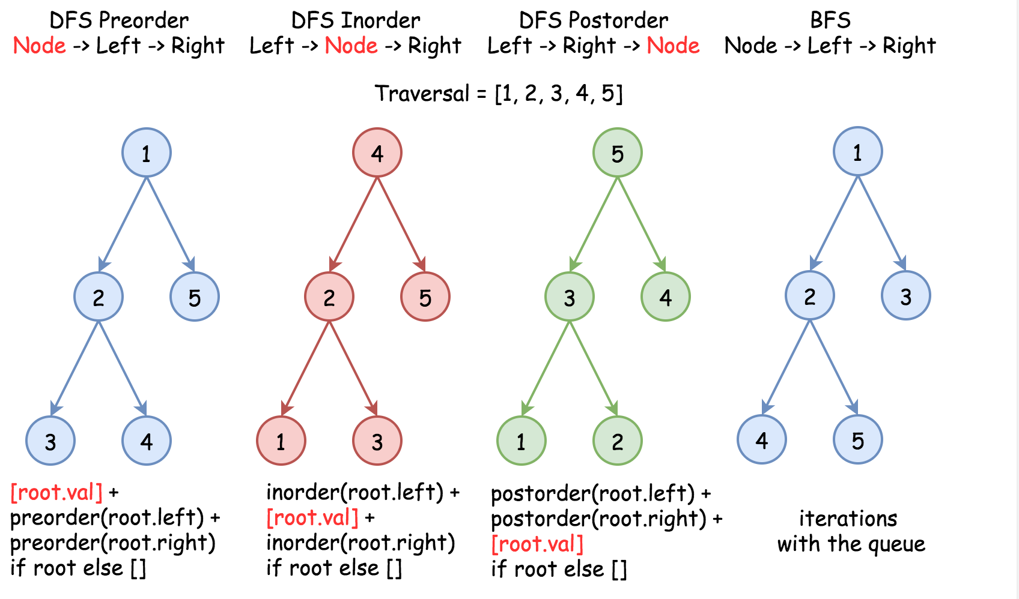

Here the problem is to implement DFS inorder traversal in a textbook recursion way because of in-place requirement.

#### **Approach 1: Recursion**

**Algorithm**

Standard inorder recursion follows left -> node -> right order, where left and right parts are the recursion calls and node part is where all processing is done.

Processing here is basically to link the previous node with the current one, and because of that one has to track the last node which is the largest node in a new doubly linked list so far.

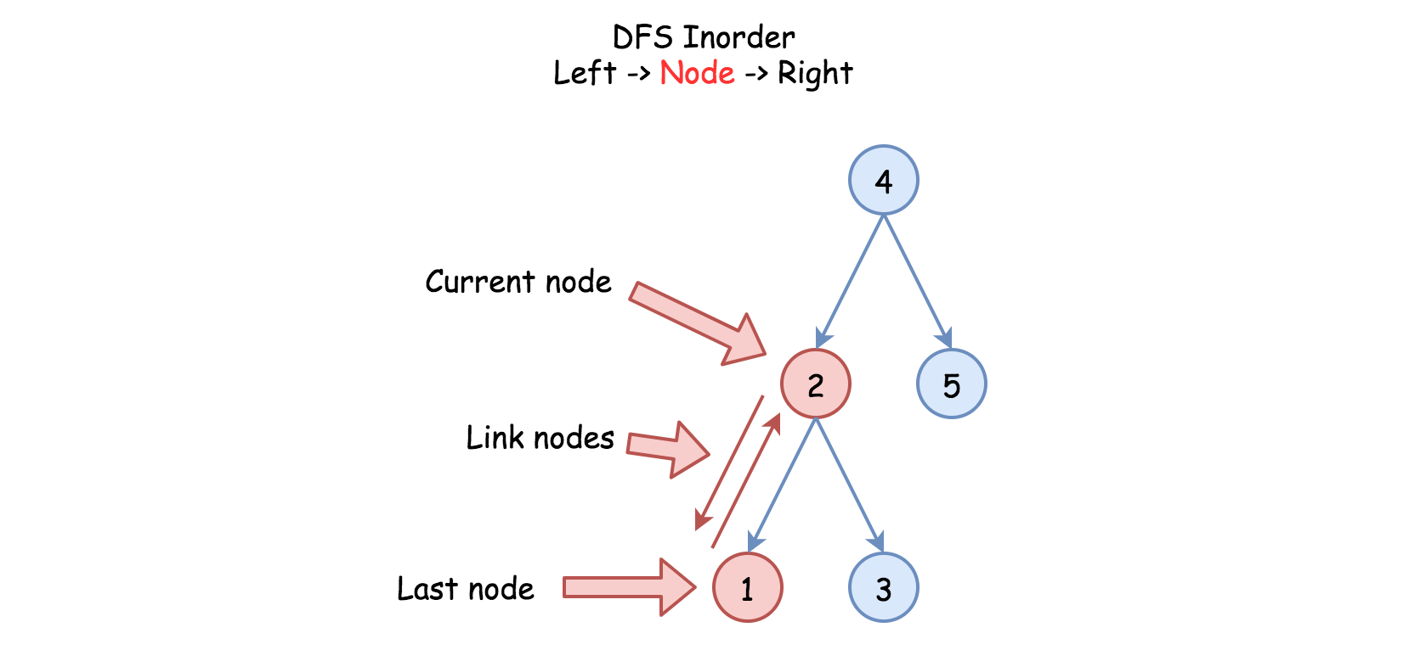

One more detail : one has to keep the first, or the smallest, node as well to close the ring of doubly linked list.

Here is the algorithm :

* Initiate the first and the last nodes as nulls.
* Call the standard inorder recursion helper(root) :
  + If node is not null :
    - Call the recursion for the left subtree helper(node.left).
    - If the last node is not null, link the last and the current node nodes.
    - Else initiate the first node.
    - Mark the current node as the last one : last = node.
    - Call the recursion for the right subtree helper(node.right).
* Link the first and the last nodes to close DLL ring and then return the first node.

**Implementation**

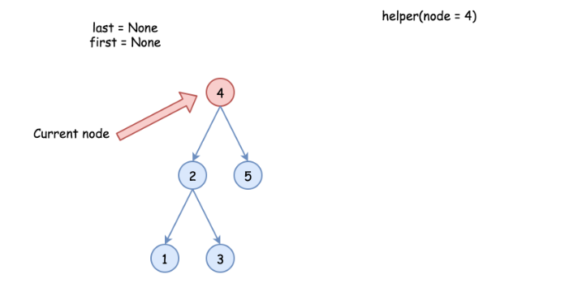

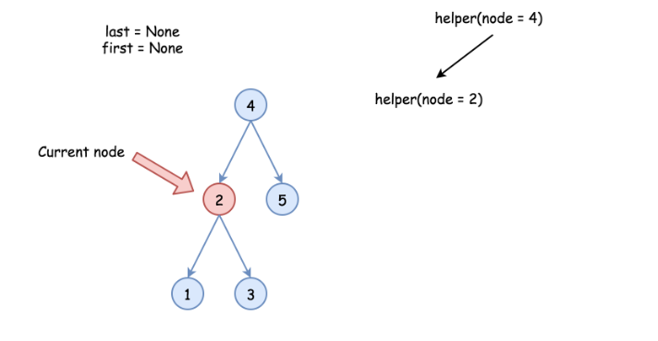

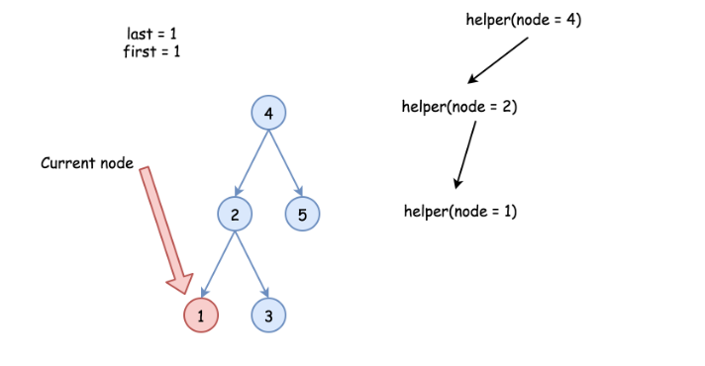

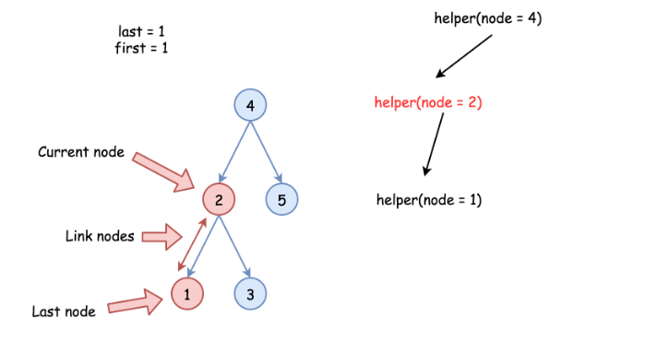

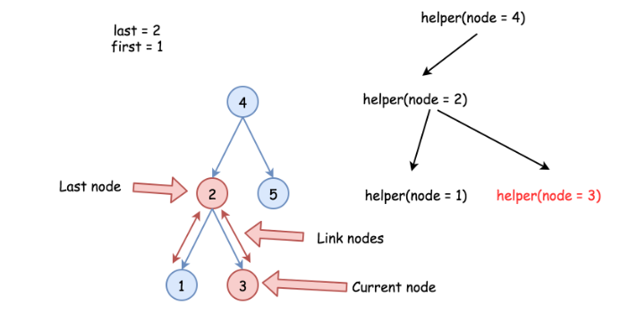

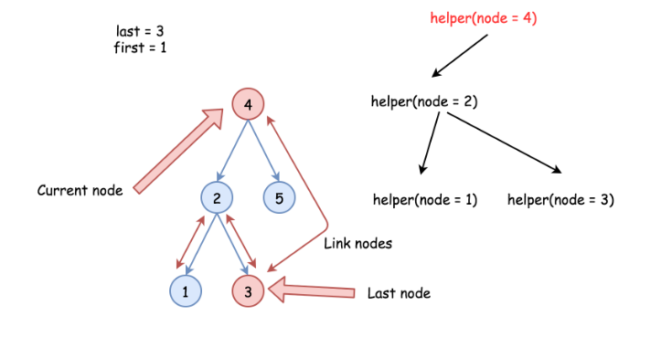

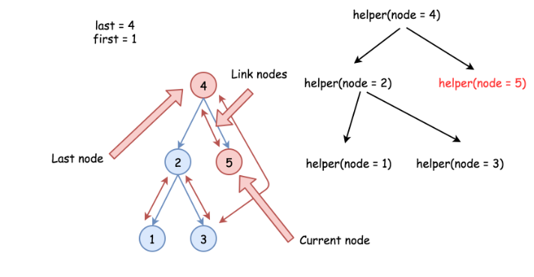

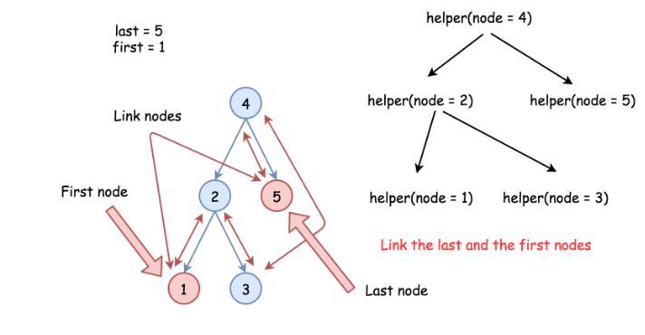

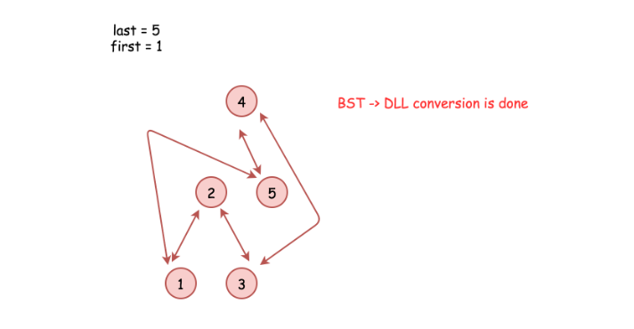

|  |
| --- |
| class Solution {  // the smallest (first) and the largest (last) nodes  Node first = null;  Node last = null;  public void helper(Node node) {  if (node != null) {  // left  helper(node.left);  // node  if (last != null) {  // link the previous node (last)  // with the current one (node)  last.right = node;  node.left = last;  }  else {  // keep the smallest node  // to close DLL later on  first = node;  }  last = node;  // right  helper(node.right);  }  }  public Node treeToDoublyList(Node root) {  if (root == null) return null;  helper(root);  // close DLL  last.right = first;  first.left = last;  return first;  }  } |

**Complexity Analysis**

* Time complexity : O(*N*) since each node is processed exactly once.
* Space complexity : O(*N*). We have to keep a recursion stack of the size of the tree height, which is O(log*N*) for the best case of completely balanced tree and O(*N*) for the worst case of completely unbalanced tree.

**Largest Rectangle in Histogram**

Given *n* non-negative integers representing the histogram's bar height where the width of each bar is 1, find the area of largest rectangle in the histogram.

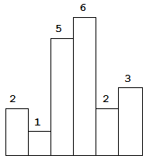  
Above is a histogram where width of each bar is 1, given height = [2,1,5,6,2,3].

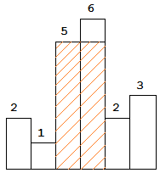  
The largest rectangle is shown in the shaded area, which has area = 10 unit.

**Example:**

**Input:** [2,1,5,6,2,3]

**Output:** 10

**Example 1:**

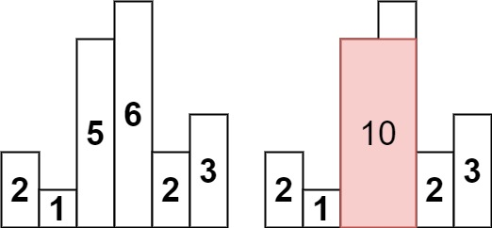

**Input:** heights = [2,1,5,6,2,3]

**Output:** 10

**Explanation:** The above is a histogram where width of each bar is 1.

The largest rectangle is shown in the red area, which has an area = 10 units.

**Example 2:**

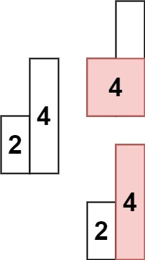

**Input:** heights = [2,4]

**Output:** 4

**Constraints:**

* 1 <= heights.length <= 105
* 0 <= heights[i] <= 104

## Solution Article

We need to find the rectangle of largest area that can be formed by using the given bars of histogram.

#### **Approach 1: Brute Force**

Firstly, we need to take into account the fact that the height of the rectangle formed between any two bars will always be limited by the height of the shortest bar lying between them which can be understood by looking at the figure below:

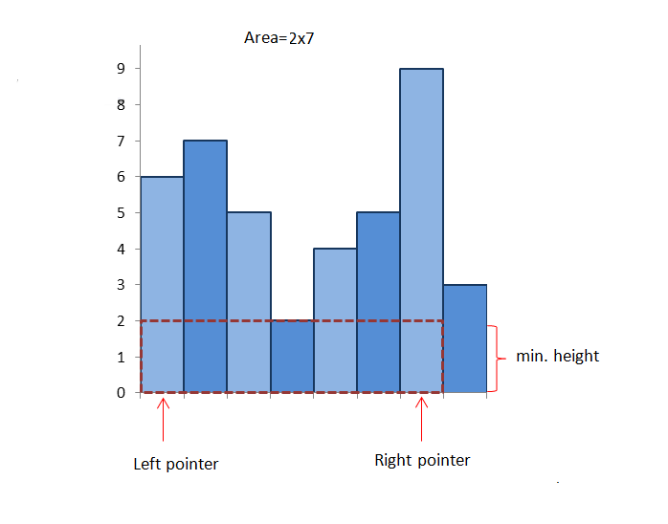

Thus, we can simply start off by considering every possible pair of bars and finding the area of the rectangle formed between them using the height of the shortest bar lying between them as the height and the spacing between them as the width of the rectangle. We can thus, find the required rectangle with the maximum area.

|  |
| --- |
| public class Solution {  public int largestRectangleArea(int[] heights) {  int maxarea = 0;  for (int i = 0; i < heights.length; i++) {  for (int j = i; j < heights.length; j++) {  int minheight = Integer.MAX_VALUE;  for (int k = i; k <= j; k++)  minheight = Math.min(minheight, heights[k]);  maxarea = Math.max(maxarea, minheight * (j - i + 1));  }  }  return maxarea;  }  } |

**Complexity Analysis**

* Time complexity : O(n^3). We have to find the minimum height bar *O*(*n*) lying between every pair O(n^2).
* Space complexity : *O*(1). Constant space is used.

#### **Approach 2: Better Brute Force**

**Algorithm**

We can do one slight modification in the previous approach to optimize it to some extent. Instead of taking every possible pair and then finding the bar of minimum height lying between them everytime, we can find the bar of minimum height for current pair by using the minimum height bar of the previous pair.

In mathematical terms,  *minheight*=min(*minheight*,*heights*(*j*)), where *heights*(*j*) refers to the height of the *j*th bar.

|  |
| --- |
| public class Solution {  public int largestRectangleArea(int[] heights) {  int maxArea = 0;  int length = heights.length;  for (int i = 0; i < length; i++) {  int minHeight = Integer.MAX_VALUE;  for (int j = i; j < length; j++) {  minHeight = Math.min(minHeight, heights[j]);  maxArea = Math.max(maxArea, minHeight * (j - i + 1));  }  }  return maxArea;  }  } |

**Complexity Analysis**

* Time complexity : O(n^2). Every possible pair is considered
* Space complexity : *O*(1). No extra space is used.

#### **Approach 3: Divide and Conquer Approach**

**Algorithm**

This approach relies on the observation that the rectangle with maximum area will be the maximum of:

1. The widest possible rectangle with height equal to the height of the shortest bar.
2. The largest rectangle confined to the left of the shortest bar(subproblem).
3. The largest rectangle confined to the right of the shortest bar(subproblem).

Let's take an example:

[6, 4, 5, 2, 4, 3, 9]

Here, the shortest bar is of height 2. The area of the widest rectangle using this bar as height is 2x8=16. Now, we need to look for cases 2 and 3 mentioned above. Thus, we repeat the same process to the left and right of 2. In the left of 2, 4 is the minimum, forming an area of rectangle 4x3=12. Further, rectangles of area 6x1=6 and 5x1=5 exist in its left and right respectively. Similarly we find an area of 3x3=9, 4x1=4 and 9x1=9 to the left of 2. Thus, we get 16 as the correct maximum area. See the figure below for further clarification:

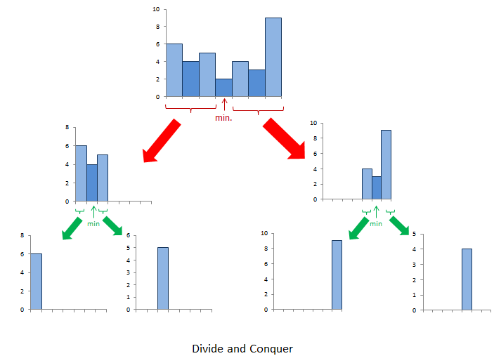

|  |
| --- |
| public class Solution {  public int calculateArea(int[] heights, int start, int end) {  if (start > end)  return 0;  int minindex = start;  for (int i = start; i <= end; i++)  if (heights[minindex] > heights[i])  minindex = i;  return Math.max(heights[minindex] * (end - start + 1), Math.max(calculateArea(heights, start, minindex - 1), calculateArea(heights, minindex + 1, end)));  }  public int largestRectangleArea(int[] heights) {  return calculateArea(heights, 0, heights.length - 1);  }  } |

**Complexity Analysis**

* Time complexity :

Average Case: *O*(*n*log*n*).

Worst Case: O(n^2). If the numbers in the array are sorted, we don't gain the advantage of divide and conquer.

* Space complexity : *O*(*n*). Recursion with worst case depth *n*.

#### **Approach 4: Better Divide and Conquer**

**Algorithm**

You can observe that in the Divide and Conquer Approach, we gain the advantage, since the large problem is divided into substantially smaller subproblems. But, we won't gain much advantage with that approach if the array happens to be sorted in either ascending or descending order, since every time we need to find the minimum number in a large subarray *O*(*n*). Thus, the overall complexity becomes O(n^2) in the worst case. We can reduce the time complexity by using a Segment Tree to find the minimum every time which can be done in *O*(log*n*) time.

For implementation, click [here](https://leetcode.com/problems/largest-rectangle-in-histogram/discuss/28941/segment-tree-solution-just-another-idea-onlogn-solution).

**Complexity Analysis**

* Time complexity : *O*(*n*log*n*). Segment tree takes log*n* for a total of *n* times.
* Space complexity : *O*(*n*). Space required for Segment Tree.

#### **Approach 5: Using Stack**

**Algorithm**

In this approach, we maintain a stack. Initially, we push a -1 onto the stack to mark the end. We start with the leftmost bar and keep pushing the current bar's index onto the stack until we get two successive numbers in descending order, i.e. until we get *a*[*i*]<*a*[*i*−1]. Now, we start popping the numbers from the stack until we hit a number *stack*[*j*] on the stack such that *a*[*stack*[*j*]]≤*a*[*i*]. Every time we pop, we find out the area of rectangle formed using the current element as the height of the rectangle and the difference between the the current element's index pointed to in the original array and the element *stack*[*top*−1]−1 as the width i.e. if we pop an element *stack*[*top*] and i is the current index to which we are pointing in the original array, the current area of the rectangle will be considered as:

(*i*−*stack*[*top*−1]−1)×*a*[*stack*[*top*]].

Further, if we reach the end of the array, we pop all the elements of the stack and at every pop, this time we use the following equation to find the area:  *stack*[*top*]−*stack*[*top*−1])×*a*[*stack*[*top*]], where *stack*[*top*] refers to the element just popped. Thus, we can get the area of the of the largest rectangle by comparing the new area found everytime.

The following example will clarify the process further:

[6, 7, 5, 2, 4, 5, 9, 3]

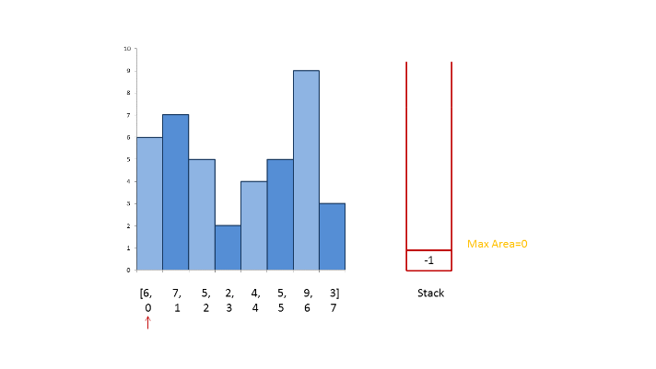

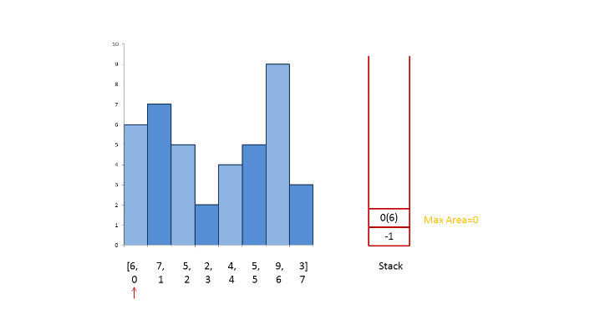

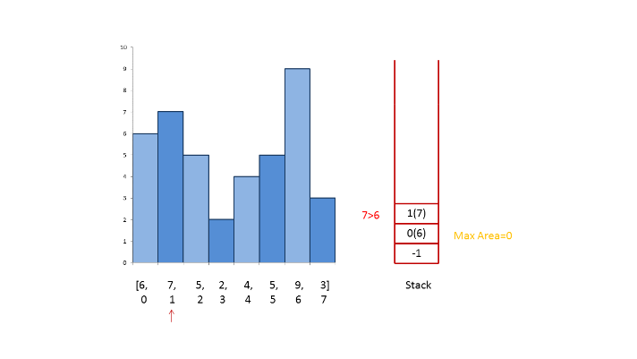

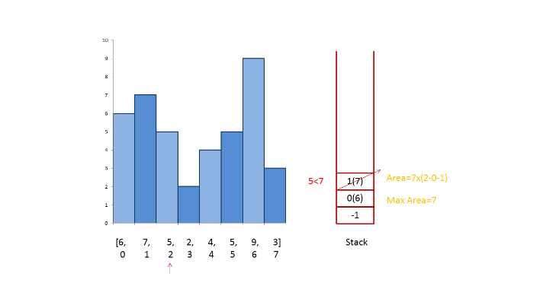

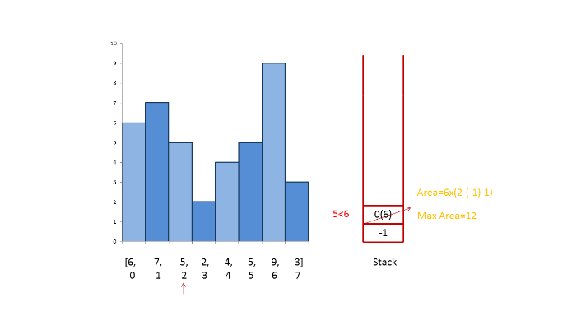

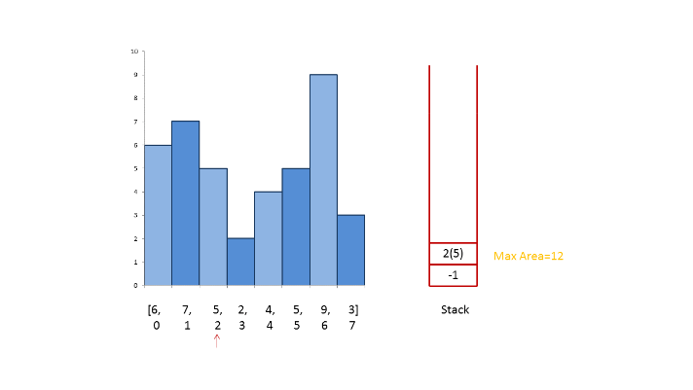

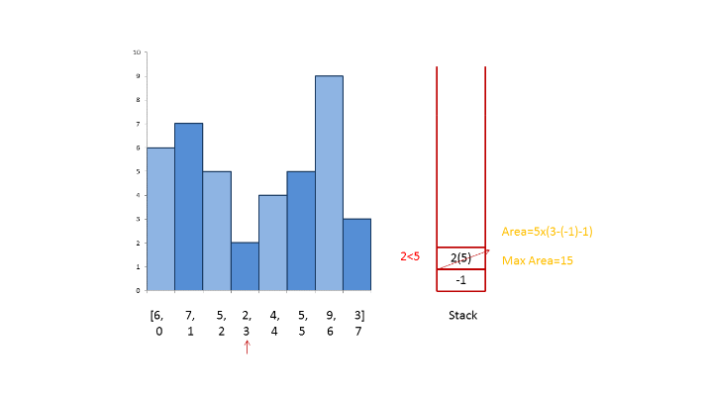

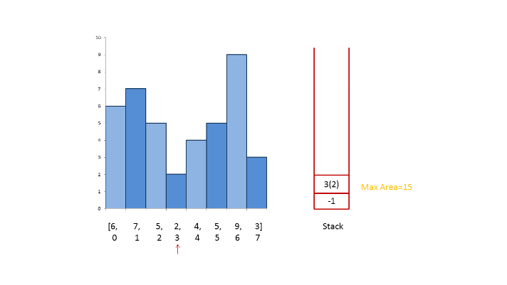

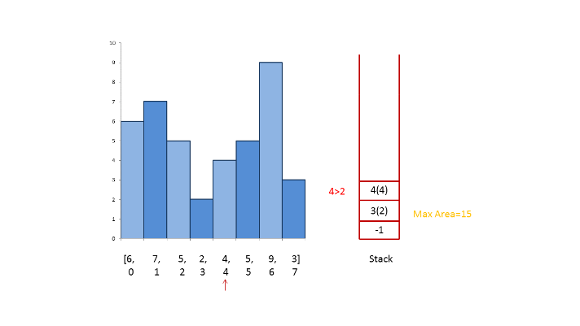

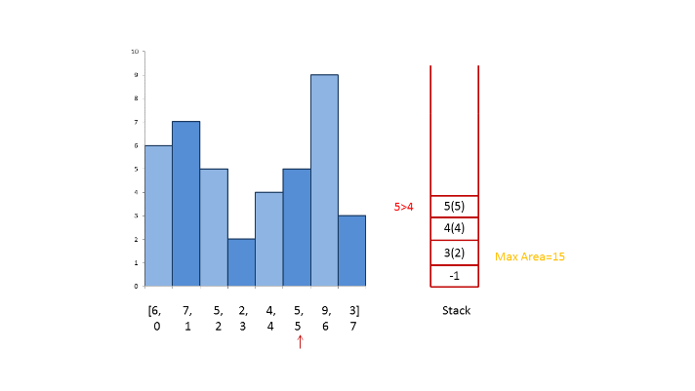

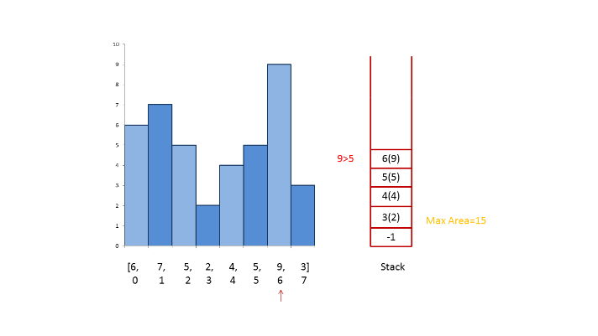

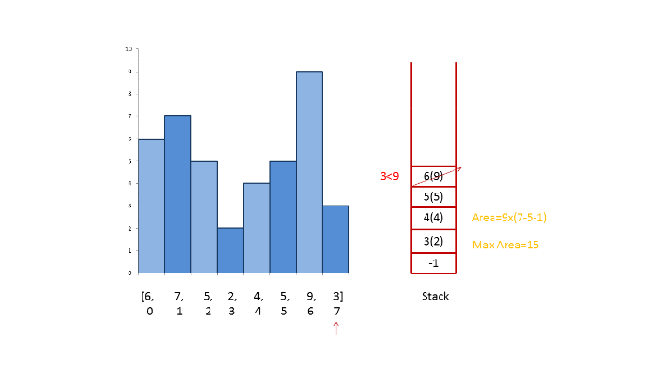

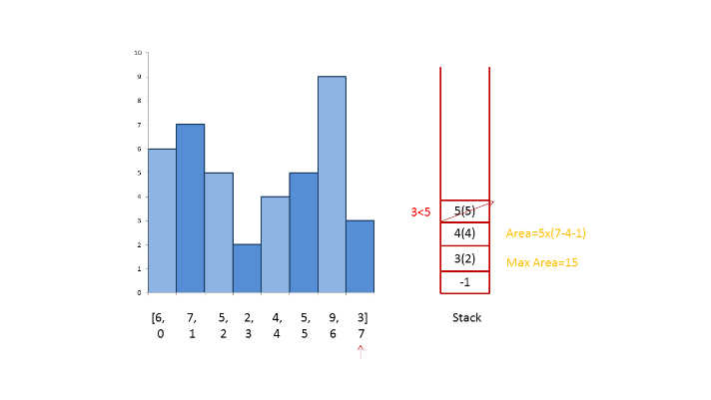

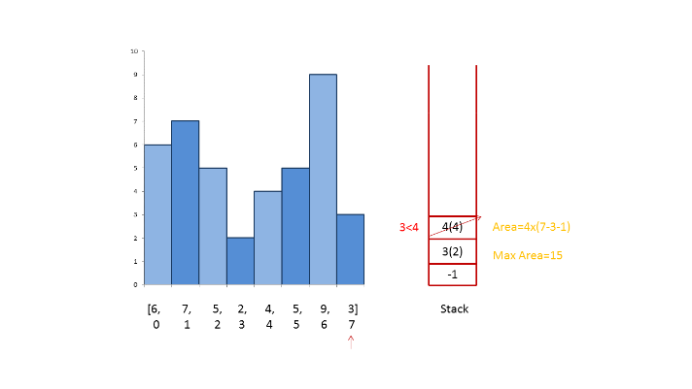

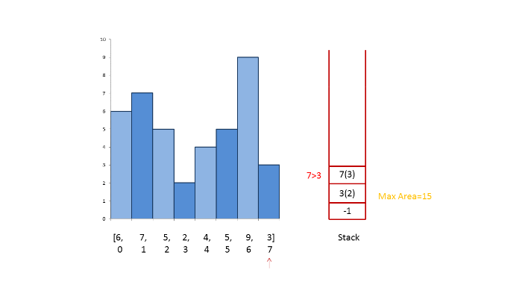

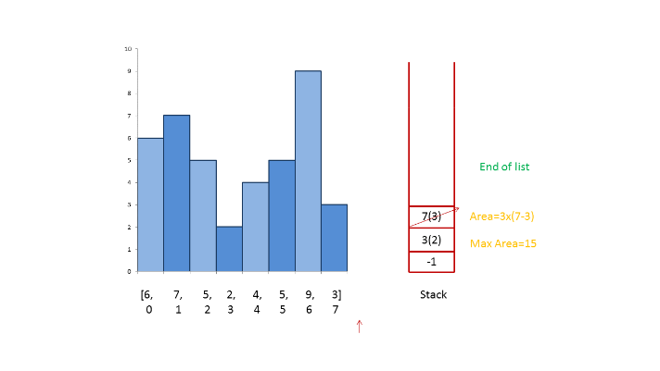

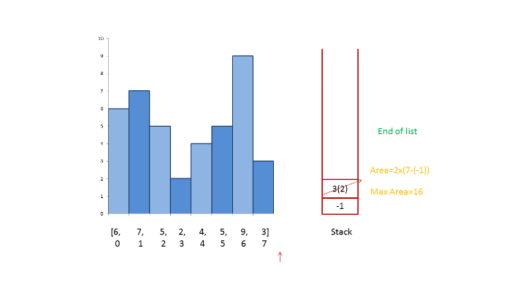

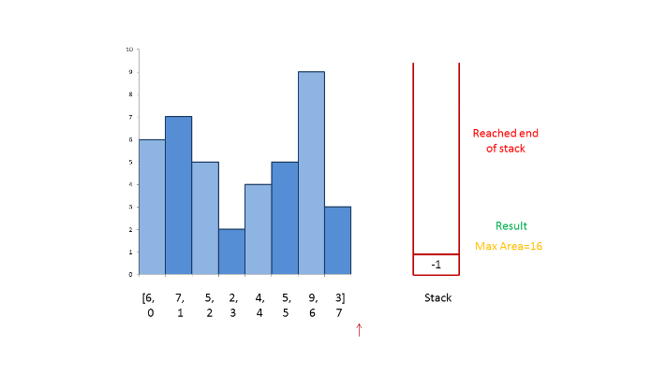

|  |
| --- |
| public class Solution {  public int largestRectangleArea(int[] heights) {  Deque<Integer> stack = new ArrayDeque<>();  stack.push(-1);  int length = heights.length;  int maxArea = 0;  for (int i = 0; i < length; i++) {  while ((stack.peek() != -1)  && (heights[stack.peek()] >= heights[i])) {  int currentHeight = heights[stack.pop()];  int currentWidth = i - stack.peek() - 1;  maxArea = Math.max(maxArea, currentHeight * currentWidth);  }  stack.push(i);  }  while (stack.peek() != -1) {  int currentHeight = heights[stack.pop()];  int currentWidth = length - stack.peek() - 1;  maxArea = Math.max(maxArea, currentHeight * currentWidth);  }  return maxArea;  }  } |

**Complexity Analysis**

* Time complexity : *O*(*n*). *n* numbers are pushed and popped.
* Space complexity : *O*(*n*). Stack is used.

**Permutations**

Given an array nums of distinct integers, return *all the possible permutations*. You can return the answer in **any order**.

**Example 1:**

**Input:** nums = [1,2,3]

**Output:** [[1,2,3],[1,3,2],[2,1,3],[2,3,1],[3,1,2],[3,2,1]]

**Example 2:**

**Input:** nums = [0,1]

**Output:** [[0,1],[1,0]]

**Example 3:**

**Input:** nums = [1]

**Output:** [[1]]

**Constraints:**

* 1 <= nums.length <= 6
* -10 <= nums[i] <= 10
* All the integers of nums are **unique**.

## Solution

#### **Approach 1: Backtracking**

[Backtracking](https://en.wikipedia.org/wiki/Backtracking) is an algorithm for finding all solutions by exploring all potential candidates. If the solution candidate turns to be not a solution (or at least not the last one), backtracking algorithm discards it by making some changes on the previous step, i.e. backtracks and then try again.

Here is a backtrack function which takes the index of the first integer to consider as an argument backtrack(first).

* If the first integer to consider has index n that means that the current permutation is done.
* Iterate over the integers from index first to index n - 1.
  + Place i-th integer first in the permutation, i.e. swap(nums[first], nums[i]).
  + Proceed to create all permutations which starts from i-th integer : backtrack(first + 1).
  + Now backtrack, i.e. swap(nums[first], nums[i]) back.



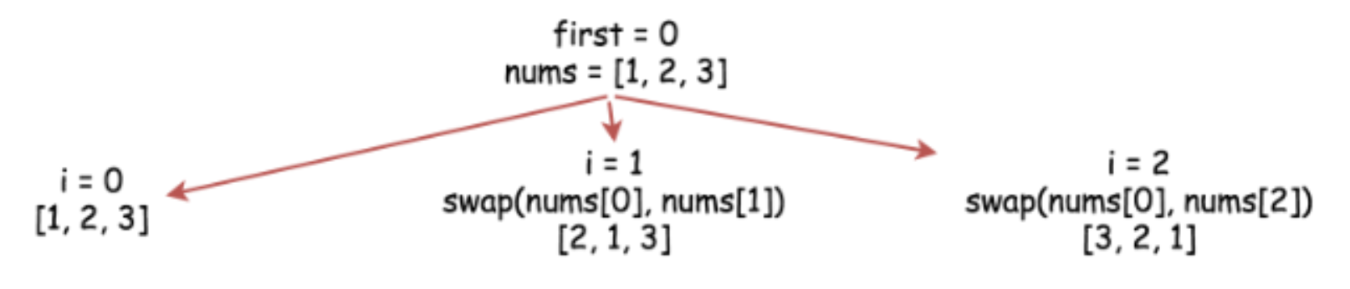

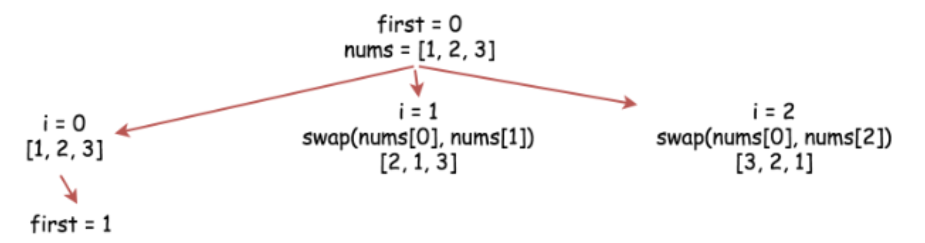

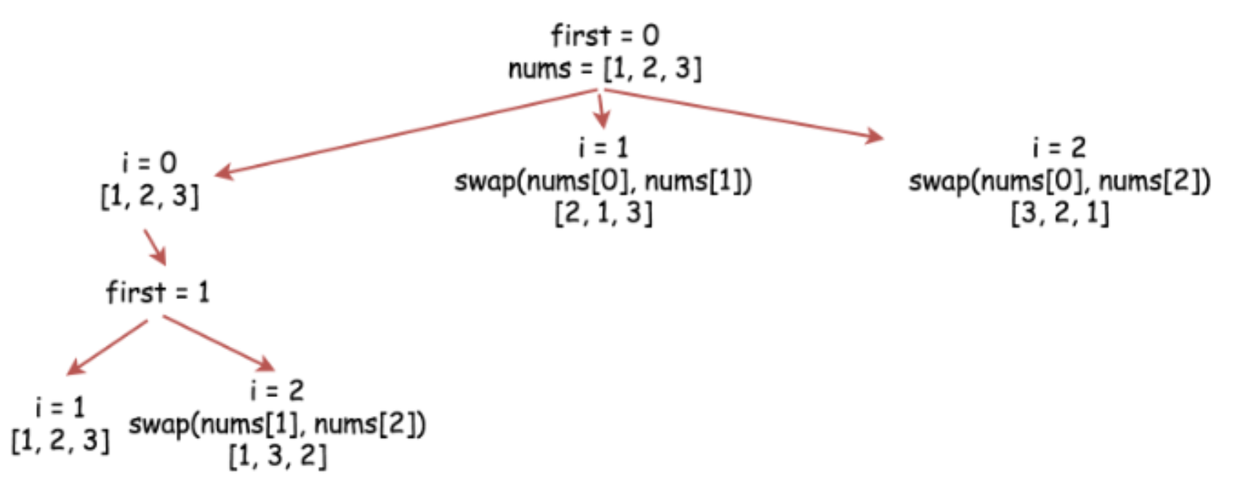

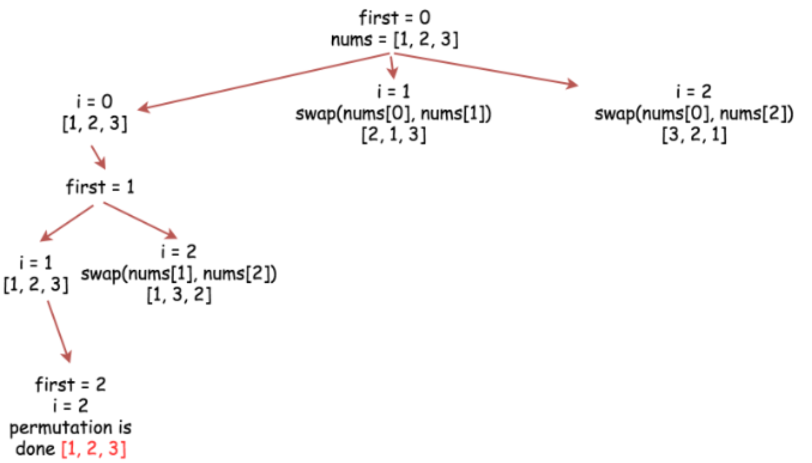

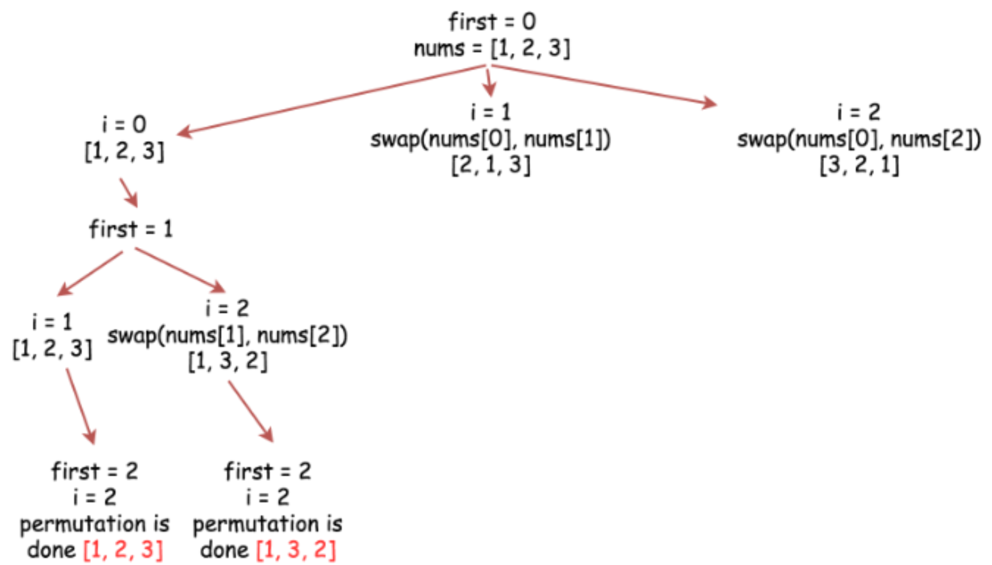

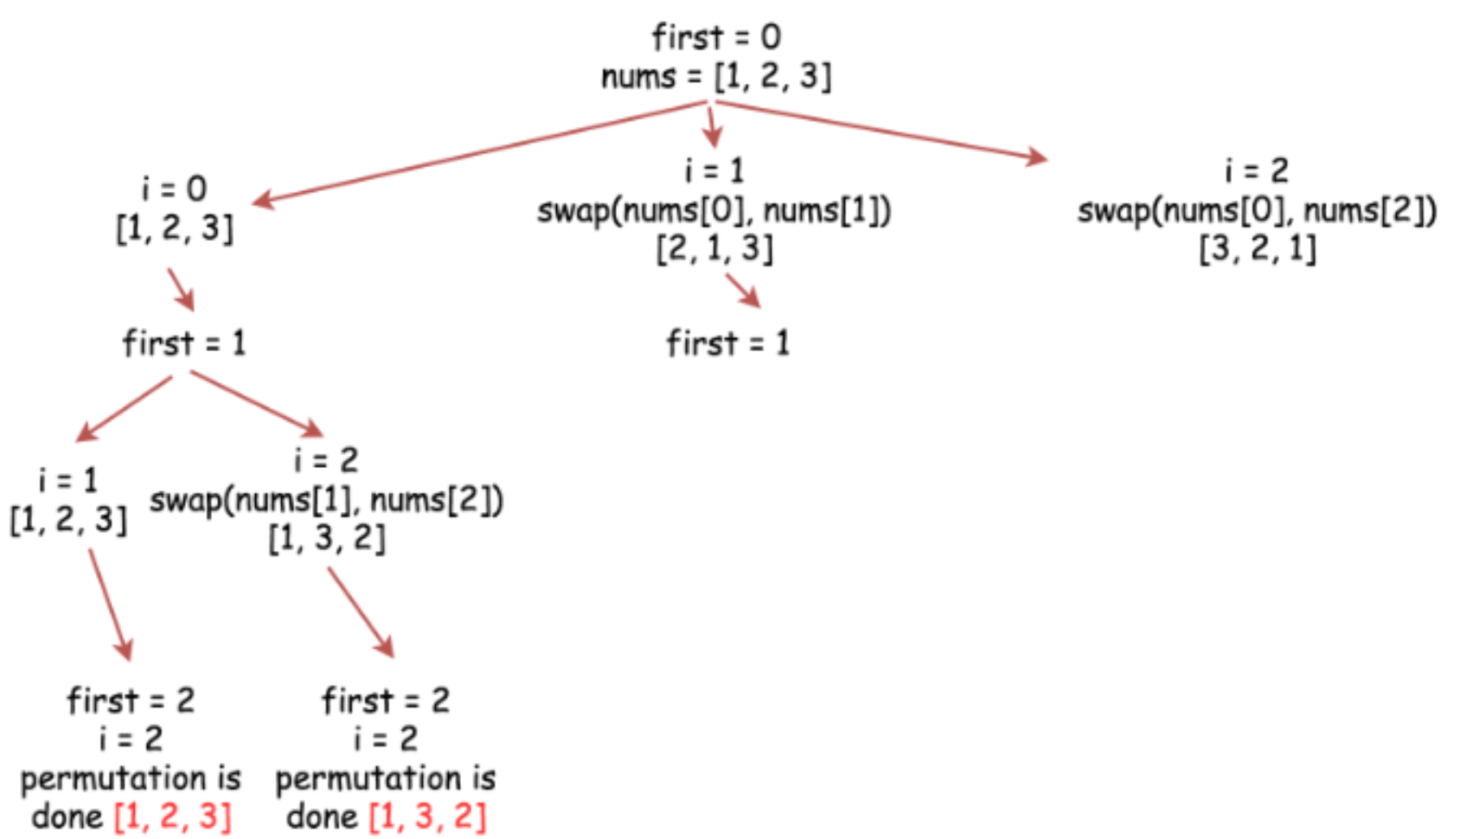

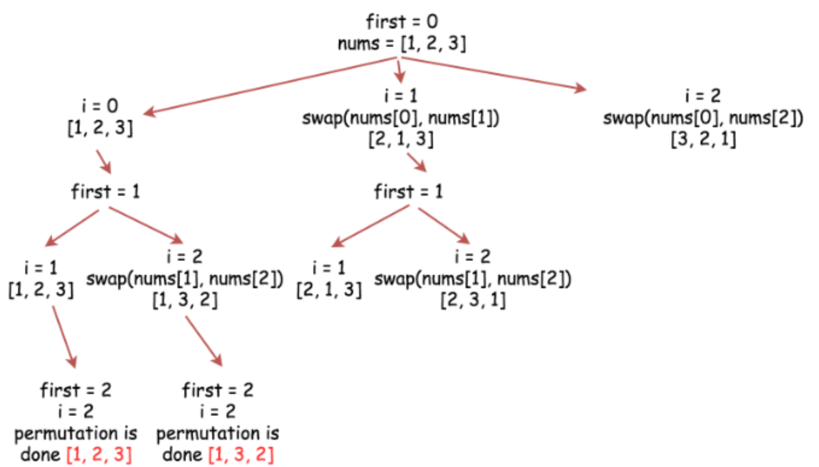

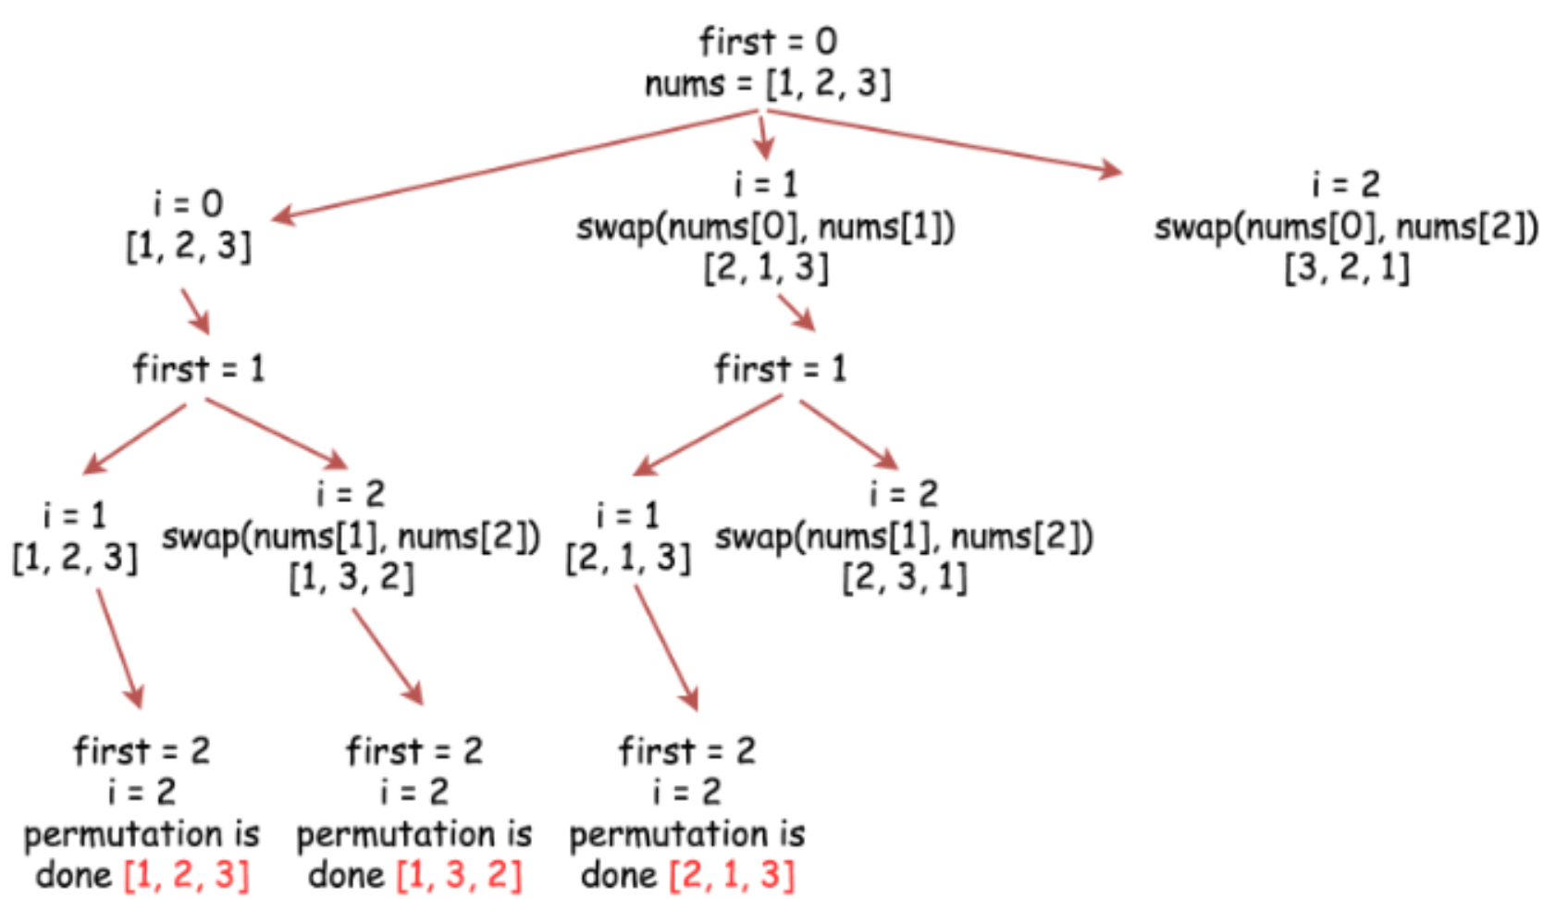

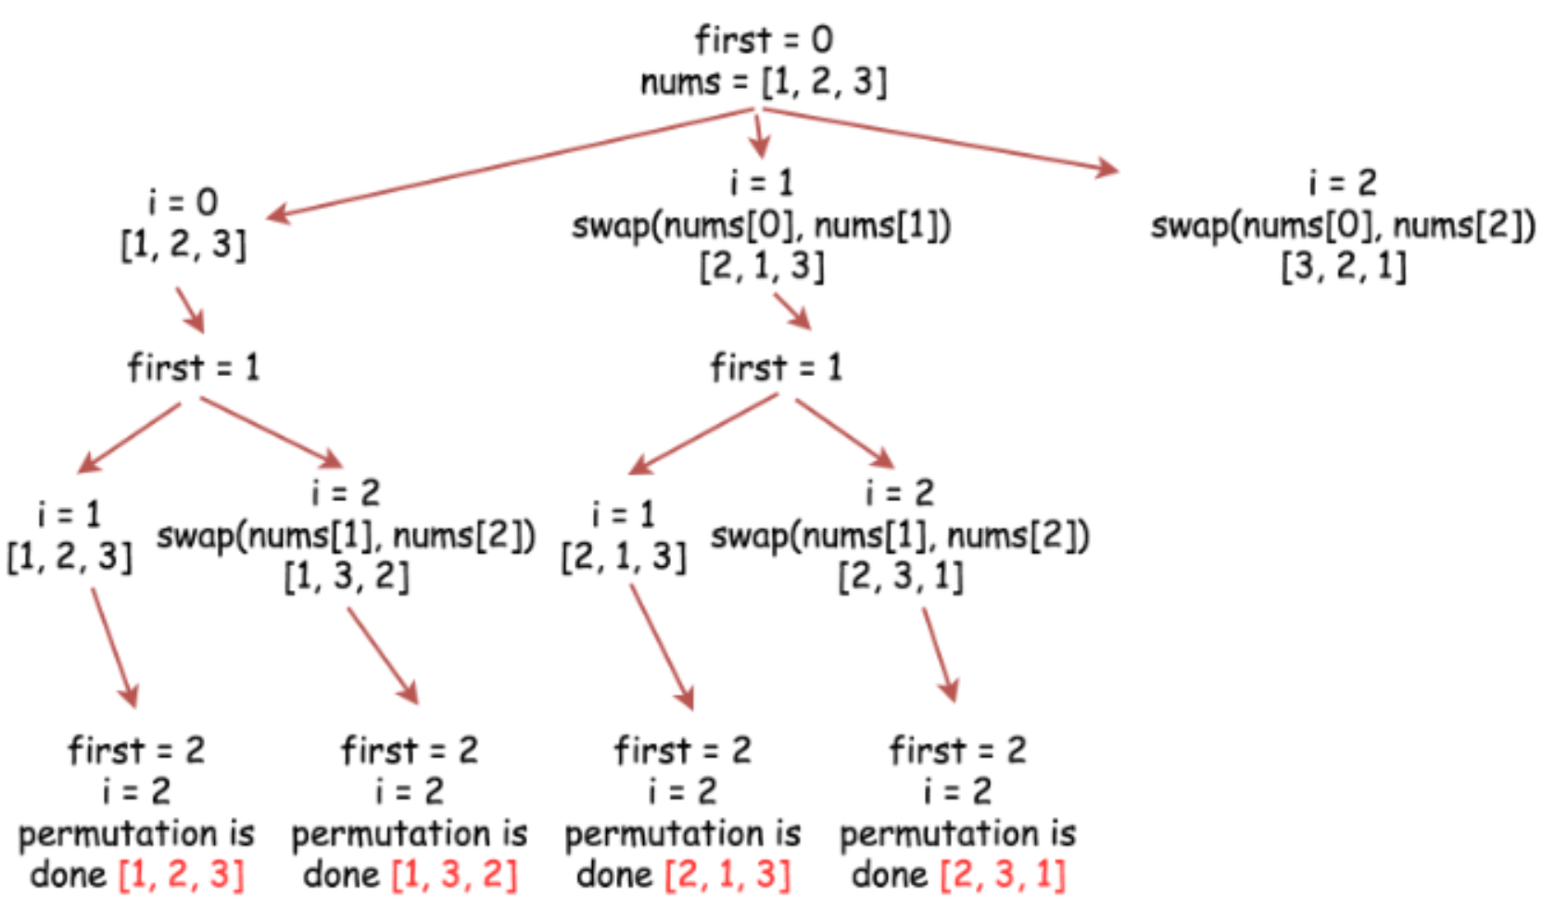

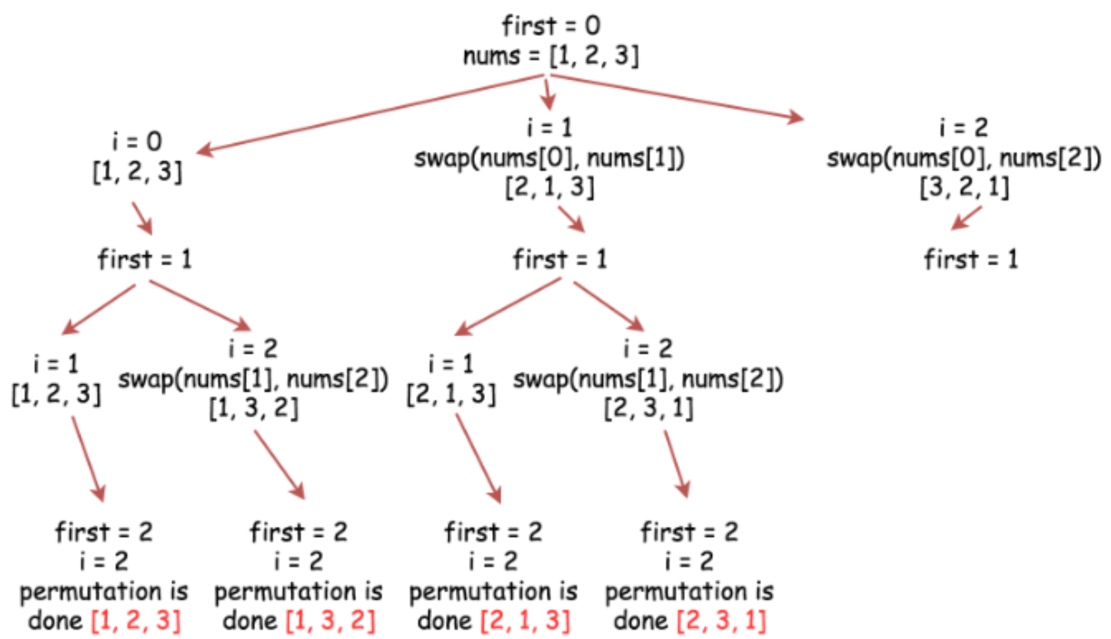

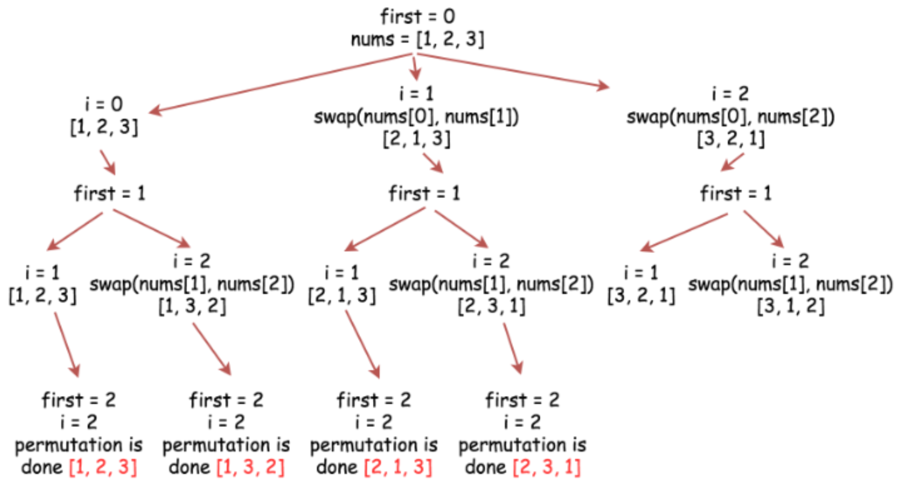

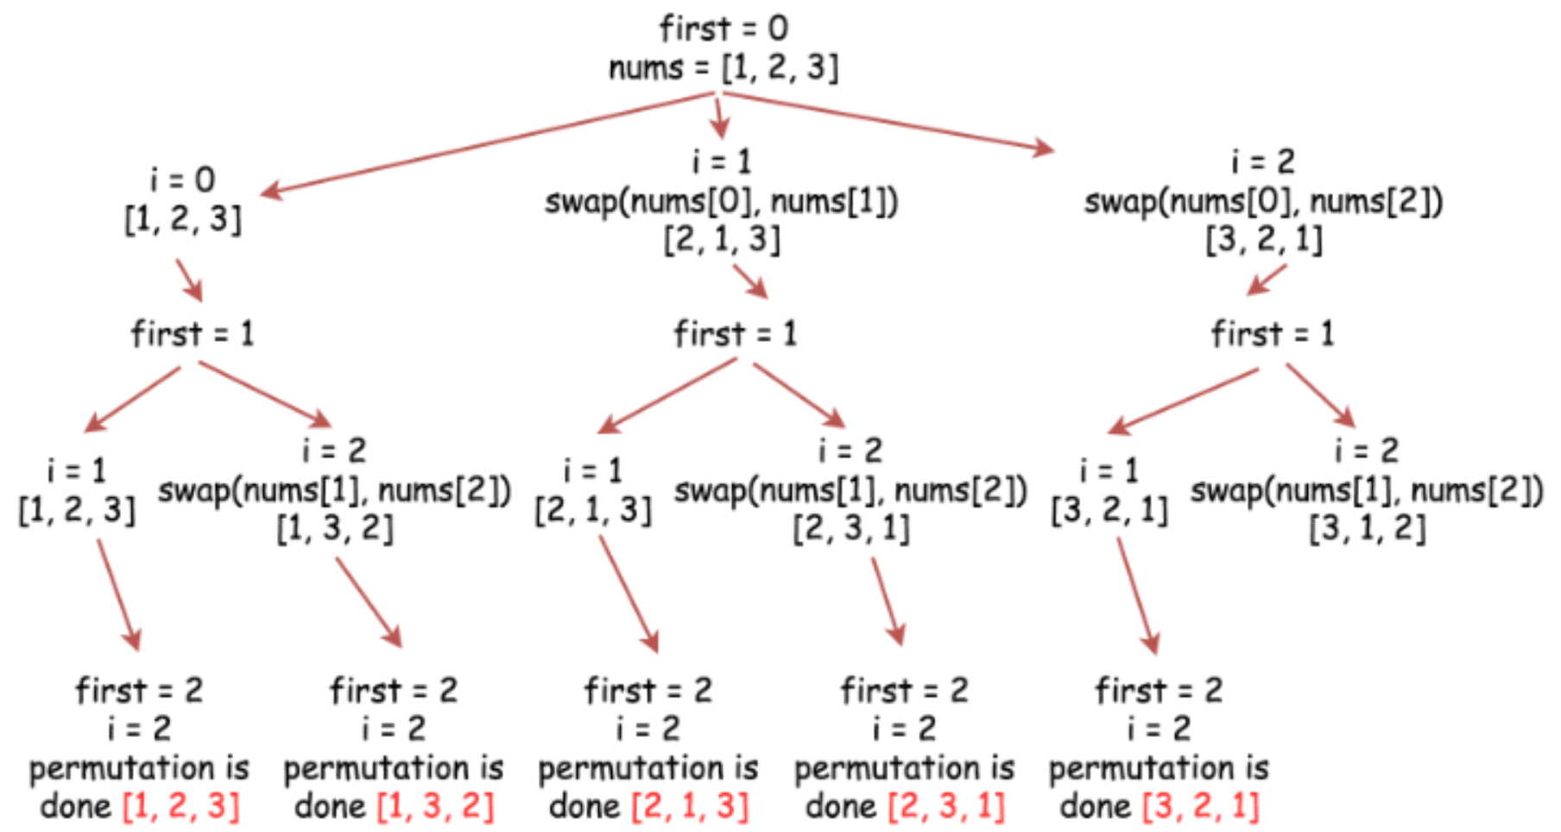

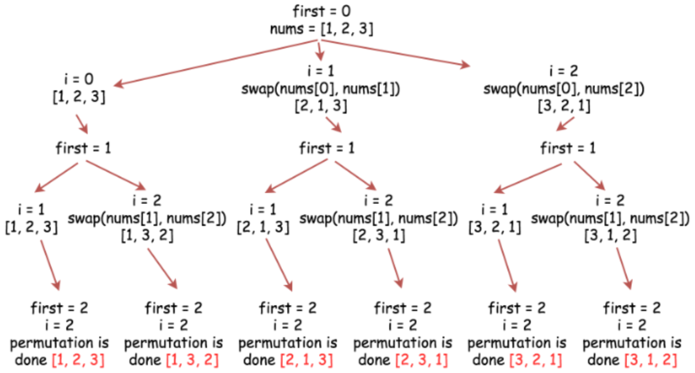

|  |
| --- |
| class Solution {  public void backtrack(int n,  ArrayList<Integer> nums,  List<List<Integer>> output,  int first) {  // if all integers are used up  if (first == n)  output.add(new ArrayList<Integer>(nums));  for (int i = first; i < n; i++) {  // place i-th integer first  // in the current permutation  Collections.swap(nums, first, i);  // use next integers to complete the permutations  backtrack(n, nums, output, first + 1);  // backtrack  Collections.swap(nums, first, i);  }  }  public List<List<Integer>> permute(int[] nums) {  // init output list  List<List<Integer>> output = new LinkedList();  // convert nums into list since the output is a list of lists  ArrayList<Integer> nums_lst = new ArrayList<Integer>();  for (int num : nums)  nums_lst.add(num);  int n = nums.length;  backtrack(n, nums_lst, output, 0);  return output;  }  } |

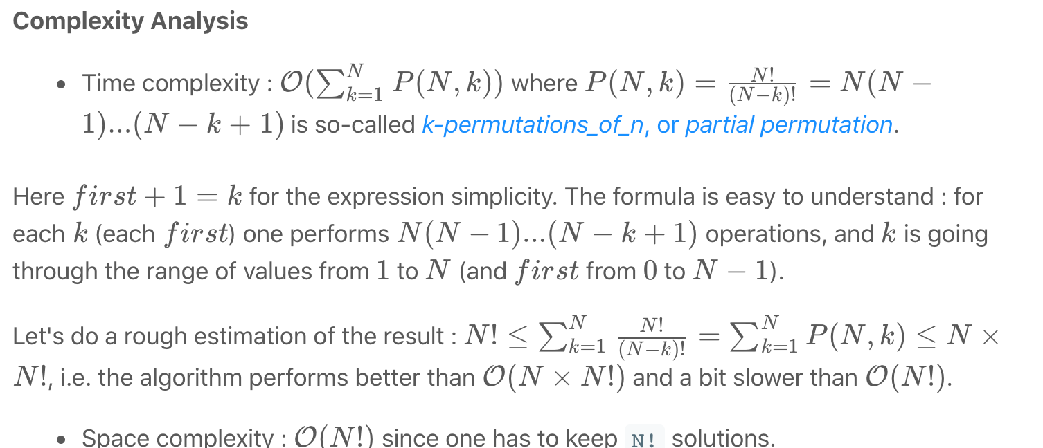

**Letter Combinations of a Phone Number**

Given a string containing digits from 2-9 inclusive, return all possible letter combinations that the number could represent. Return the answer in **any order**.

A mapping of digit to letters (just like on the telephone buttons) is given below. Note that 1 does not map to any letters.

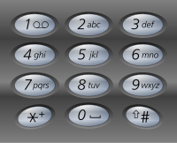

**Example 1:**

**Input:** digits = "23"

**Output:** ["ad","ae","af","bd","be","bf","cd","ce","cf"]

**Example 2:**

**Input:** digits = ""

**Output:** []

**Example 3:**

**Input:** digits = "2"

**Output:** ["a","b","c"]

**Constraints:**

* 0 <= digits.length <= 4
* digits[i] is a digit in the range ['2', '9'].

## Solution

#### **Approach 1: Backtracking**

[Backtracking](https://en.wikipedia.org/wiki/Backtracking) is an algorithm for finding all solutions by exploring all potential candidates. If the solution candidate turns to be not a solution (or at least not the last one), backtracking algorithm discards it by making some changes on the previous step, i.e. backtracks and then try again.

Here is a backtrack function backtrack(combination, next_digits) which takes as arguments an ongoing letter combination and the next digits to check.

* If there is no more digits to check that means that the current combination is done.
* If there are still digits to check :
  + Iterate over the letters mapping the next available digit.
    - Append the current letter to the current combination combination = combination + letter.
    - Proceed to check next digits : backtrack(combination + letter, next_digits[1:]).

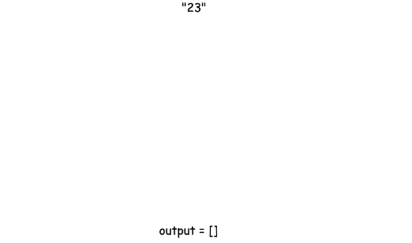

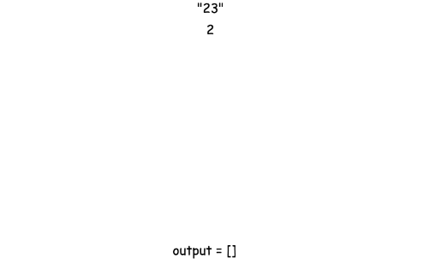

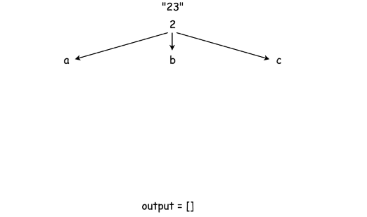

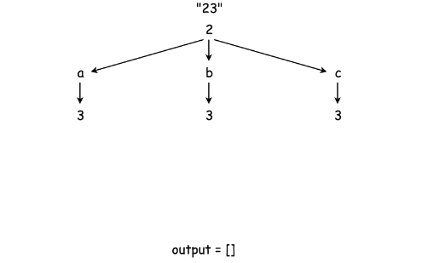

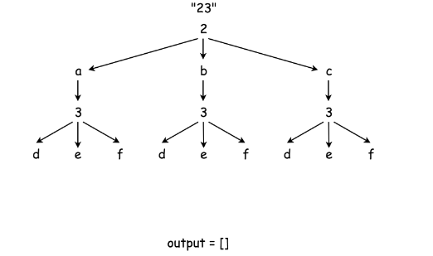

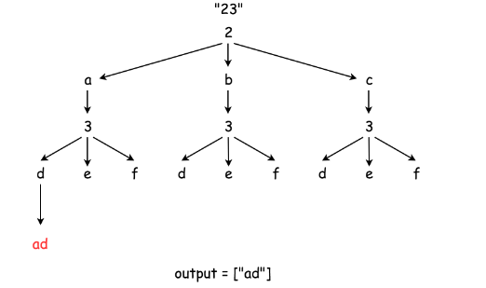

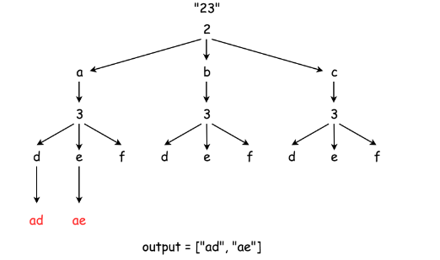

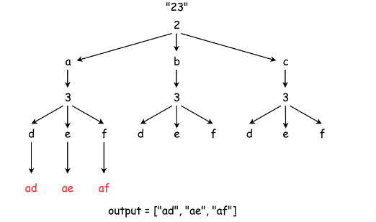

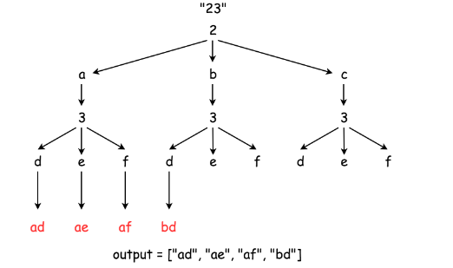

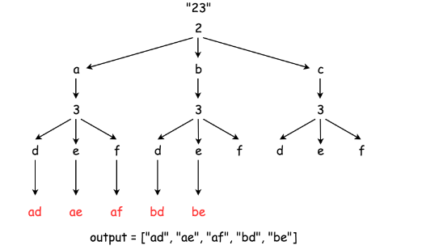

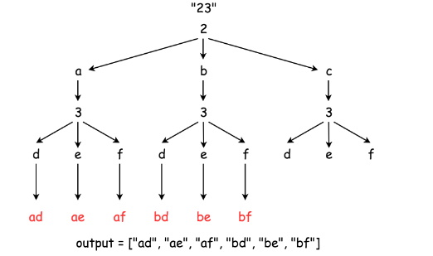

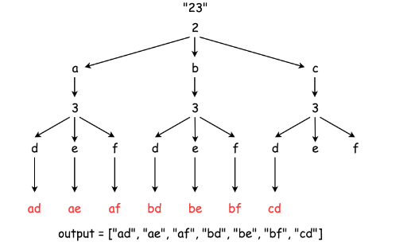

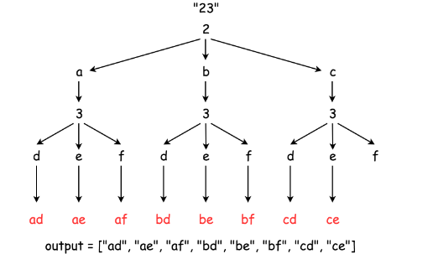

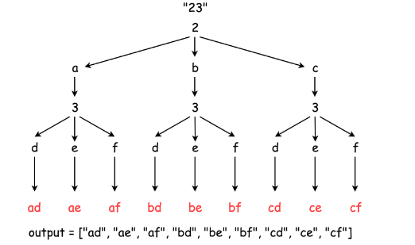

|  |
| --- |
| class Solution {  Map<String, String> phone = new HashMap<String, String>() {{  put("2", "abc");  put("3", "def");  put("4", "ghi");  put("5", "jkl");  put("6", "mno");  put("7", "pqrs");  put("8", "tuv");  put("9", "wxyz");  }};  List<String> output = new ArrayList<String>();  public void backtrack(String combination, String next_digits) {  // if there is no more digits to check  if (next_digits.length() == 0) {  // the combination is done  output.add(combination);  }  // if there are still digits to check  else {  // iterate over all letters which map  // the next available digit  String digit = next_digits.substring(0, 1);  String letters = phone.get(digit);  for (int i = 0; i < letters.length(); i++) {  String letter = phone.get(digit).substring(i, i + 1);  // append the current letter to the combination  // and proceed to the next digits  backtrack(combination + letter, next_digits.substring(1));  }  }  }  public List<String> letterCombinations(String digits) {  if (digits.length() != 0)  backtrack("", digits);  return output;  }  } |

**Complexity Analysis**

* Time complexity : O(3^N * 4^M where N is the number of digits in the input that maps to 3 letters (e.g. 2, 3, 4, 5, 6, 8) and M is the number of digits in the input that maps to 4 letters (e.g. 7, 9), and N+M is the total number digits in the input.
* Space complexity : O(3^N * 4^M)O(3*N*×4*M*) since one has to keep 3^N * 4^Msolutions.

**The Skyline Problem**

A city's **skyline** is the outer contour of the silhouette formed by all the buildings in that city when viewed from a distance. Given the locations and heights of all the buildings, return *the****skyline****formed by these buildings collectively*.

The geometric information of each building is given in the array buildings where buildings[i] = [lefti, righti, heighti]:

* lefti is the x coordinate of the left edge of the ith building.
* righti is the x coordinate of the right edge of the ith building.
* heighti is the height of the ith building.

You may assume all buildings are perfect rectangles grounded on an absolutely flat surface at height 0.

The **skyline** should be represented as a list of "key points" **sorted by their x-coordinate** in the form [[x1,y1],[x2,y2],...]. Each key point is the left endpoint of some horizontal segment in the skyline except the last point in the list, which always has a y-coordinate 0 and is used to mark the skyline's termination where the rightmost building ends. Any ground between the leftmost and rightmost buildings should be part of the skyline's contour.

**Note:** There must be no consecutive horizontal lines of equal height in the output skyline. For instance, [...,[2 3],[4 5],[7 5],[11 5],[12 7],...] is not acceptable; the three lines of height 5 should be merged into one in the final output as such: [...,[2 3],[4 5],[12 7],...]

**Example 1:**

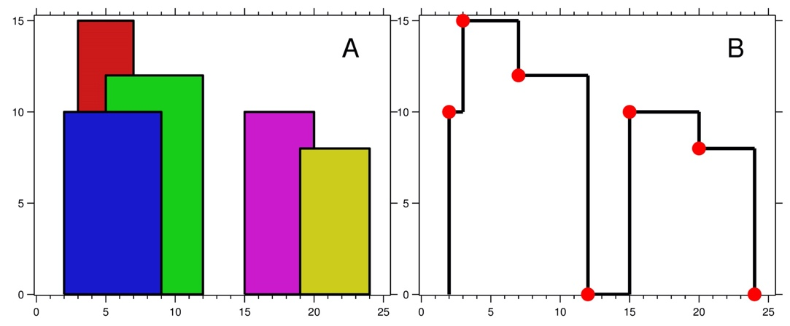

**Input:** buildings = [[2,9,10],[3,7,15],[5,12,12],[15,20,10],[19,24,8]]

**Output:** [[2,10],[3,15],[7,12],[12,0],[15,10],[20,8],[24,0]]

**Explanation:**

Figure A shows the buildings of the input.

Figure B shows the skyline formed by those buildings. The red points in figure B represent the key points in the output list.

**Example 2:**

**Input:** buildings = [[0,2,3],[2,5,3]]

**Output:** [[0,3],[5,0]]

**Constraints:**

* 1 <= buildings.length <= 104
* 0 <= lefti < righti <= 231 - 1
* 1 <= heighti <= 231 - 1
* buildings is sorted by lefti in non-decreasing order.

## Solution

#### **Approach 1: Divide and Conquer**

**Solution Template**

The problem is a classical example of divide and conquer approach, and typically implemented exactly the same way as merge sort algorithm.

Let's follow here a solution template for divide and conquer problems :

* Define the base case(s).
* Split the problem into subproblems and solve them recursively.
* Merge the subproblems solutions into the problem solution.

**Algorithm**

getSkyline for n buildings :

* If n == 0 : return an empty list.
* If n == 1 : return the skyline for one building (it's straightforward).
* leftSkyline = getSkyline for the first n/2 buildings.
* rightSkyline = getSkyline for the last n/2 buildings.
* Merge leftSkyline and rightSkyline.

Now let's discuss each step in more details.

**Base Cases**

The first base case is an empty buildings list. Then the skyline is an empty list, too.

The second base case is the only one building in the list, when the skyline construction is quite straightforward.

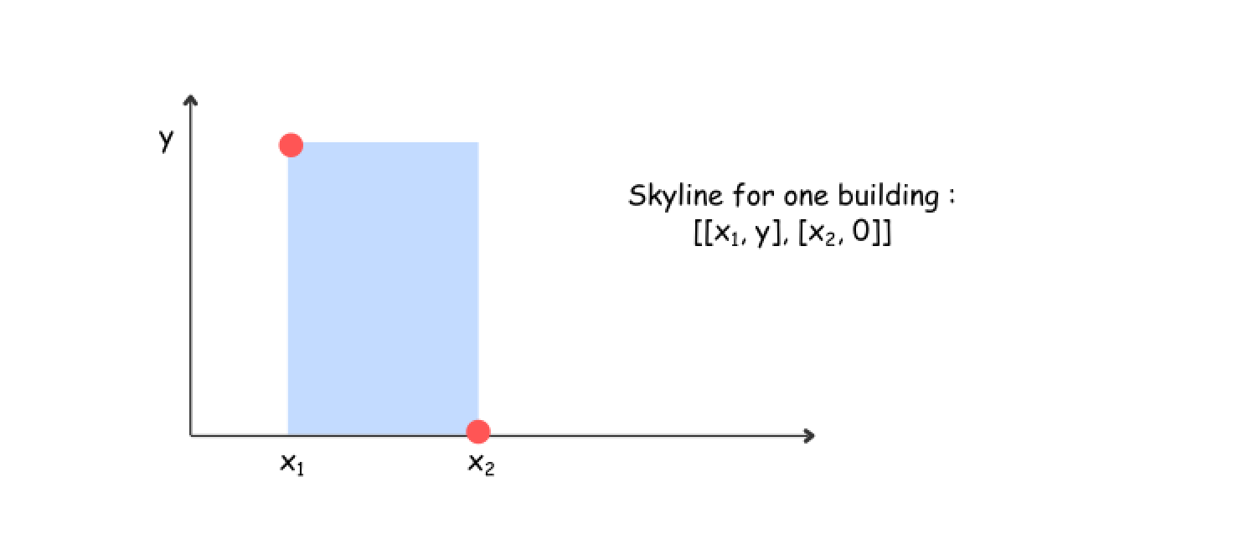

**How to split the problem**

The idea is the same as for merge sort : at each step split the list exactly in two parts : from 0 to n/2 and from n/2 to n, and then construct the skylines recursively for each part.

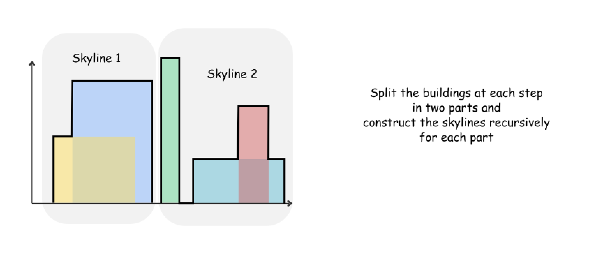

**How to merge two skylines**

The algorithm for merge function is quite straightforward and based on the same merge sort logic : the height of an output skyline is always a maximum between the left and right skylines.

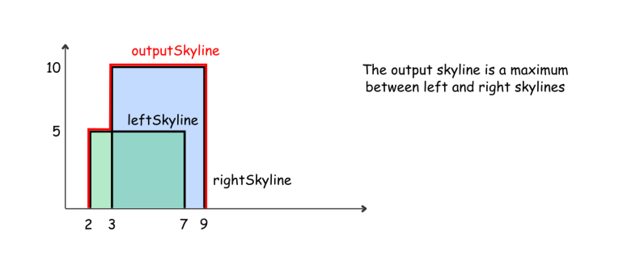

Let's use here two pointers pR and pL to track the current element index in both skylines, and three integers leftY, rightY, and currY to track the current height for the left skyline, right skyline and the merged skyline.

mergeSkylines (left, right) :

* currY = leftY = rightY = 0
* While we're in the region where both skylines are present (pR < nR and pL < nL) :
  + Pick up the element with the smallest x coordinate. If it's an element from the left skyline, move pL and update leftY. If it's an element from the right skyline, move pR and update rightY.
  + Compute the largest height at the current point : maxY = max(leftY, rightY).
  + Update an output skyline by (x, maxY) point, if maxY is not equal to currY.
* While there are still elements in the left skyline (pL < nL), process them following the same logic as above.
* While there are still elements in the right skyline (pR < nR), process them following the same logic as above.
* Return output skyline.

Here are three usecases to illustrate the merge algorithm execution

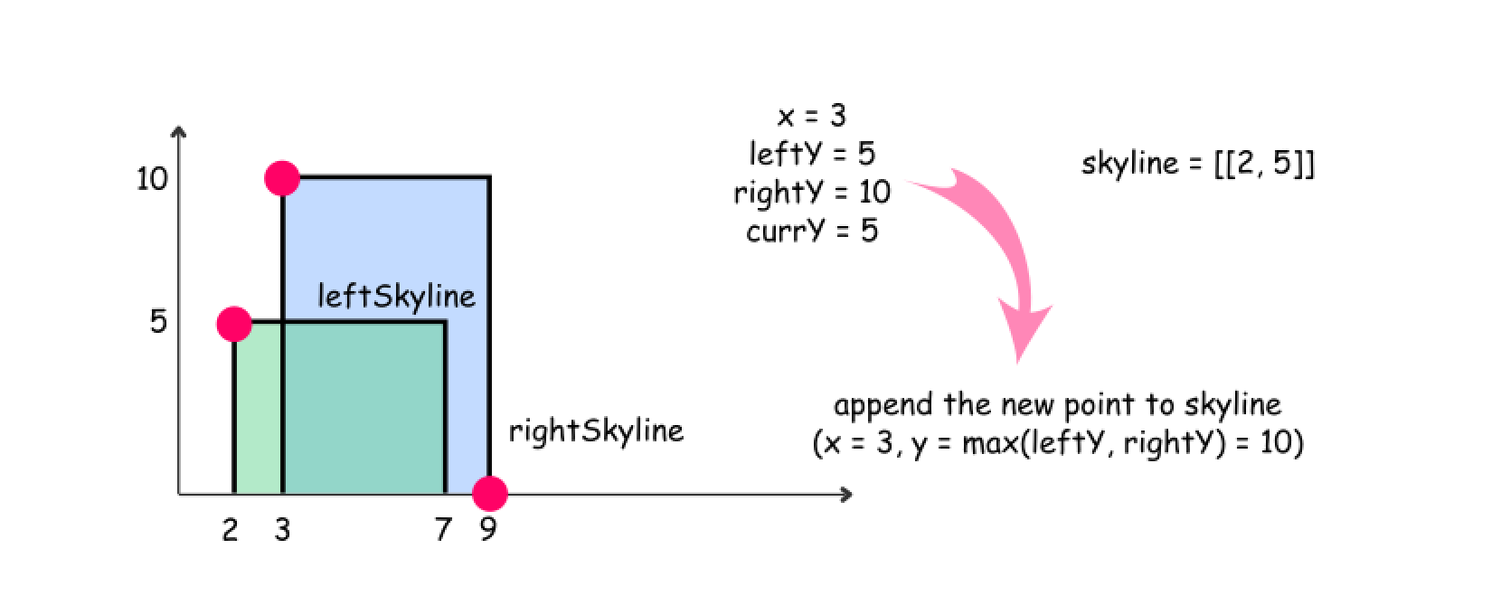

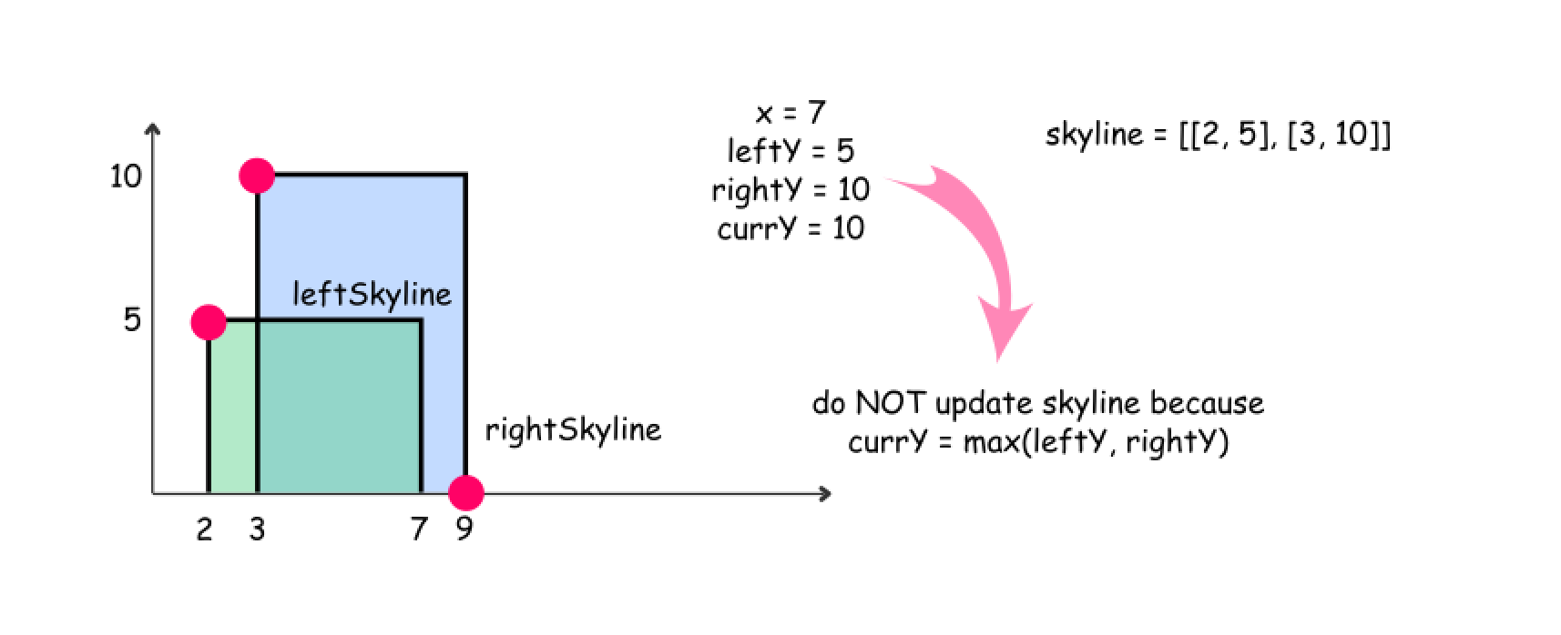

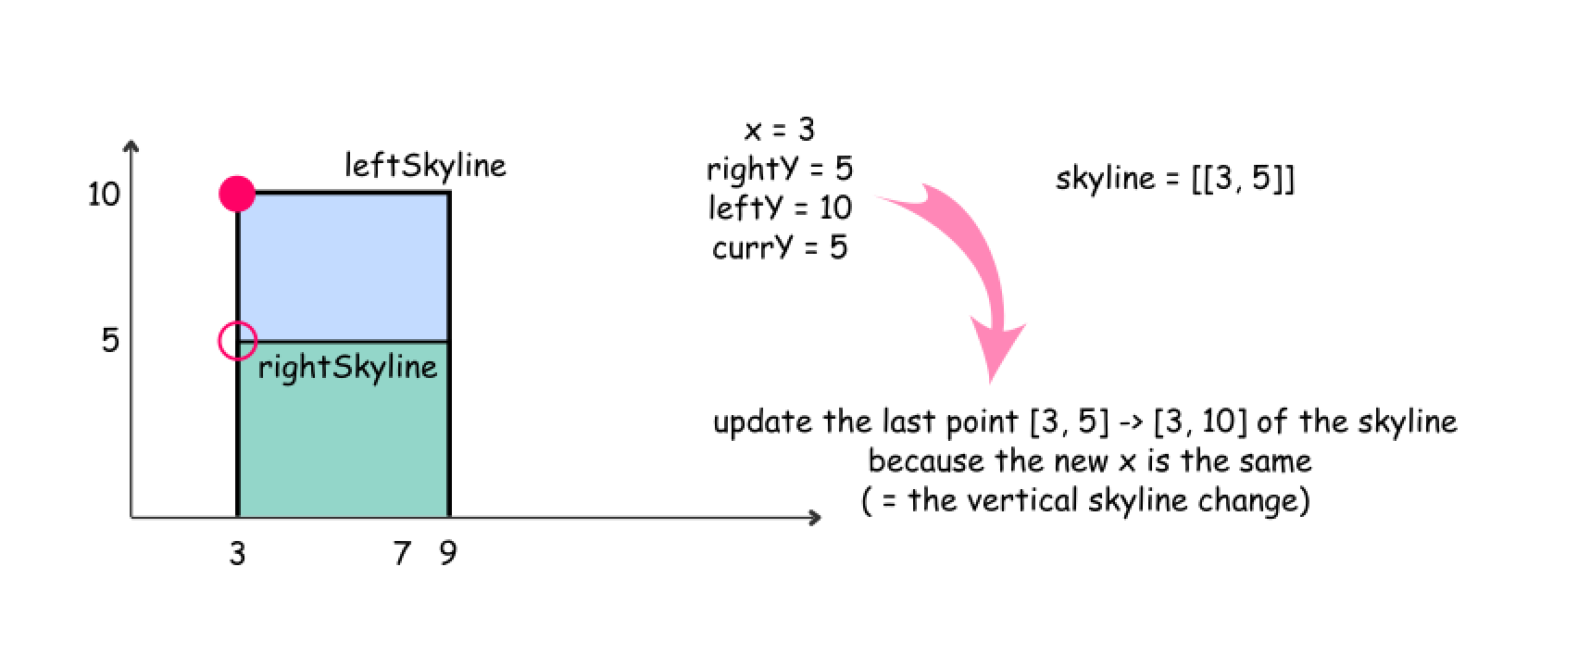

**Implementation**

|  |
| --- |
| class Solution {  /**  * Divide-and-conquer algorithm to solve skyline problem,  * which is similar with the merge sort algorithm.  */  public List<List<Integer>> getSkyline(int[][] buildings) {  int n = buildings.length;  List<List<Integer>> output = new ArrayList<List<Integer>>();  // The base cases  if (n == 0) return output;  if (n == 1) {  int xStart = buildings[0][0];  int xEnd = buildings[0][1];  int y = buildings[0][2];  output.add(new ArrayList<Integer>() {{add(xStart); add(y); }});  output.add(new ArrayList<Integer>() {{add(xEnd); add(0); }});  // output.add(new int[]{xStart, y});  // output.add(new int[]{xEnd, 0});  return output;  }  // If there is more than one building,  // recursively divide the input into two subproblems.  List<List<Integer>> leftSkyline, rightSkyline;  leftSkyline = getSkyline(Arrays.copyOfRange(buildings, 0, n / 2));  rightSkyline = getSkyline(Arrays.copyOfRange(buildings, n / 2, n));  // Merge the results of subproblem together.  return mergeSkylines(leftSkyline, rightSkyline);  }  /**  * Merge two skylines together.  */  public List<List<Integer>> mergeSkylines(List<List<Integer>> left, List<List<Integer>> right) {  int nL = left.size(), nR = right.size();  int pL = 0, pR = 0;  int currY = 0, leftY = 0, rightY = 0;  int x, maxY;  List<List<Integer>> output = new ArrayList<List<Integer>>();  // while we're in the region where both skylines are present  while ((pL < nL) && (pR < nR)) {  List<Integer> pointL = left.get(pL);  List<Integer> pointR = right.get(pR);  // pick up the smallest x  if (pointL.get(0) < pointR.get(0)) {  x = pointL.get(0);  leftY = pointL.get(1);  pL++;  }  else {  x = pointR.get(0);  rightY = pointR.get(1);  pR++;  }  // max height (i.e. y) between both skylines  maxY = Math.max(leftY, rightY);  // update output if there is a skyline change  if (currY != maxY) {  updateOutput(output, x, maxY);  currY = maxY;  }  }  // there is only left skyline  appendSkyline(output, left, pL, nL, currY);  // there is only right skyline  appendSkyline(output, right, pR, nR, currY);  return output;  }  /**  * Update the final output with the new element.  */  public void updateOutput(List<List<Integer>> output, int x, int y) {  // if skyline change is not vertical -  // add the new point  if (output.isEmpty() || output.get(output.size() - 1).get(0) != x)  output.add(new ArrayList<Integer>() {{add(x); add(y); }});  // if skyline change is vertical -  // update the last point  else {  output.get(output.size() - 1).set(1, y);  }  }  /**  * Append the rest of the skyline elements with indice (p, n)  * to the final output.  */  public void appendSkyline(List<List<Integer>> output, List<List<Integer>> skyline,  int p, int n, int currY) {  while (p < n) {  List<Integer> point = skyline.get(p);  int x = point.get(0);  int y = point.get(1);  p++;  // update output  // if there is a skyline change  if (currY != y) {  updateOutput(output, x, y);  currY = y;  }  }  }  } |

